💧Water Emoji💧: **Water Towers**

Abby Kostukovsky, Grant Foster, Meliza Ramos, Miguel Puzon, Kevin Sy, Jerry Shu

**Table of Contents:**

[**Introduction**](https://docs.google.com/document/d/1QPGQBwWdwMz-g4lsYwJmj5AcyfcS4r6S_ZyOQ3WQLVI/edit#heading=h.3at5g14irf6i)  **3**

[**Problem Discussion**](https://docs.google.com/document/d/1QPGQBwWdwMz-g4lsYwJmj5AcyfcS4r6S_ZyOQ3WQLVI/edit#heading=h.a40zu1npulij)  **4**

[**Design Process**](https://docs.google.com/document/d/1QPGQBwWdwMz-g4lsYwJmj5AcyfcS4r6S_ZyOQ3WQLVI/edit#heading=h.lem4e18govy5)  **[6](https://docs.google.com/document/d/1QPGQBwWdwMz-g4lsYwJmj5AcyfcS4r6S_ZyOQ3WQLVI/edit#heading=h.lem4e18govy5)**

[**Key Insights, Roadblocks, Lessons Learned**](https://docs.google.com/document/d/1QPGQBwWdwMz-g4lsYwJmj5AcyfcS4r6S_ZyOQ3WQLVI/edit#heading=h.qwldb945bn4)  **[8](https://docs.google.com/document/d/1QPGQBwWdwMz-g4lsYwJmj5AcyfcS4r6S_ZyOQ3WQLVI/edit#heading=h.qwldb945bn4)**

[**Ideation Process**](https://docs.google.com/document/d/1QPGQBwWdwMz-g4lsYwJmj5AcyfcS4r6S_ZyOQ3WQLVI/edit#heading=h.9e10824fxdpl) [**1**](https://docs.google.com/document/d/1QPGQBwWdwMz-g4lsYwJmj5AcyfcS4r6S_ZyOQ3WQLVI/edit#heading=h.9e10824fxdpl)**1**

[**Final Design Solution**](https://docs.google.com/document/d/1QPGQBwWdwMz-g4lsYwJmj5AcyfcS4r6S_ZyOQ3WQLVI/edit#heading=h.54bx5q2v12x1)  **17**

[**Evaluation**](https://docs.google.com/document/d/1QPGQBwWdwMz-g4lsYwJmj5AcyfcS4r6S_ZyOQ3WQLVI/edit#heading=h.36nirmhy0yh9)  **18**

[**Future Work**](https://docs.google.com/document/d/1QPGQBwWdwMz-g4lsYwJmj5AcyfcS4r6S_ZyOQ3WQLVI/edit#heading=h.udd44ca1p14o)  **2****0**

[**Conclusion 2**](https://docs.google.com/document/d/1QPGQBwWdwMz-g4lsYwJmj5AcyfcS4r6S_ZyOQ3WQLVI/edit#heading=h.hissygtsu9mq)**1**

[**Portfolio 2**](https://docs.google.com/document/d/1QPGQBwWdwMz-g4lsYwJmj5AcyfcS4r6S_ZyOQ3WQLVI/edit#heading=h.2bklestd18sa)**2**

# Introduction

Our context was sustainable hydration on UCSD campus. We chose this topic because we didn’t think the current programs, like hydration stations, were doing enough to promote hydration on campus and we wanted to learn more about the hydration and plastic bottle purchasing habits of students at UCSD. We also chose this context because sustainability is a topic that Housing, Dining and Hospitality (HDH) often prioritizes in their campaigns, and we thought they might be helpful stakeholders since our problem context closely aligns with theirs.

The primary stakeholders for our project are students on campus. Students make up the vast majority of the population on campus and as such are the largest group that purchases water bottles. There are a large number of ways to access drinking water on campus available to all students, including both HDH and not HDH-run hydration stations, water fountains, soda fountains that provide water, and bottled water at most markets and dining halls. Students that live on campus have Dining Dollars, which provides an extremely easy way to purchase beverages for consumption with cost not typically being strongly considered. Secondary stakeholders include organizations that facilitate hydration efforts on campus or are currently making efforts to increase sustainability among the student population, which are Housing, Dining and Hospitality (HDH), groups like the Student Sustainability Collective (SSC), and to an extent vendors that supply beverages to campus like Coke and Pepsi. The main people we were in contact with at HDH were Mona Powell (Wellness and Engagement Manager) and Jonathan Biltucci (Project Planning Analyst). The main people from SSC that we were in contact with were Nhat Nguyen (Internal Development) and Brian Mi (Water). While students are the group that we want to make the biggest impact on, the secondary stakeholders are the groups that have the resources to influence and change how hydration is delivered to the students. Lastly because the project’s goal is to reduce plastic waste, tertiary stakeholders would be the likes of the environment and those impacted by plastic waste.

# 

# 

# Problem Discussion

As previously mentioned an option for refilling water bottles on campus is already widely available through hydration stations, but students choose not to use them over purchasing disposable plastic bottles from store. The crux of our problem context lies in figuring out what drives student's decisions when choosing beverages and why hydration stations are not more widely utilized as a more sustainable choice. Our initial research revealed that students did not like hydration stations primarily because they are often difficult to find or too far out of the way, not chilled well enough and/or not clean enough. By determining that students valued convenience and taste over other factors our solution needed to emphasize those factors while also not creating plastic waste (See Section Misc. Data/Field Observations, Figure 1).

*Convenience:*

We found that students would go into markets to get water, and because there isn’t an immediate alternative right at the market, they would buy a plastic water bottle instead of filling up their bottle. A lot of hydration stations are hard to find and inconvenient to use, so students default to buying bottles instead because it is more convenient.

*Taste:*

Taste was another important factor for students. Elements of taste such as temperature, flavor and how clean the water tastes were particularly emphasized (See Section Misc. Data/Field Observations, Figure 1). Hydration Stations do not currently capture these elements which is why they are underutilized.

*Sustainability:*

Ultimately we are trying to change the behavior of students to adopt more sustainable hydration habits and make healthier beverage choices by refilling reusable water bottles more often instead of purchasing bottled beverages. Even though this didn’t appear to be a priority for some of our primary stakeholders, it was a value that we and HDH, our secondary stakeholders, wanted to promote. There is no current option that is both convenient and sustainable, so we wanted to find a solution that students wanted to use but would also be better for the environment.

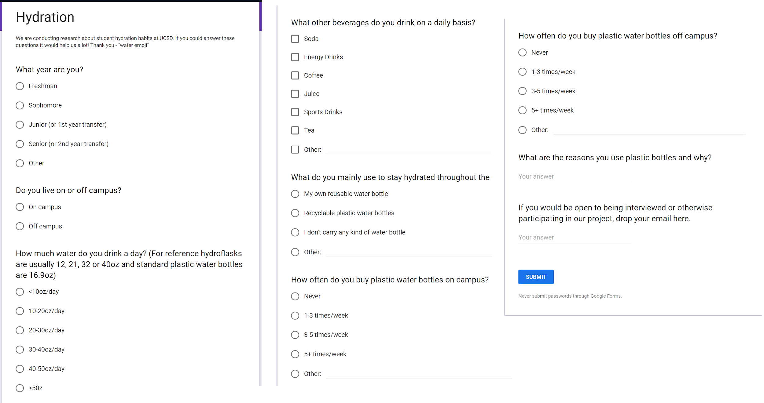

*(Figure 10)*

# 

# 

# 

# 

# 

# 

# 

# 

# Design Process

We began our project with a focus on student nutrition habits on campus. As we zoned in on what we wanted to do, we started to focus on hydration. We initially decided to focus on the nutrition aspect to it. After our first milestone, we developed interview protocol questions to ask our users about their experiences with water consumption and hydration stations on campus.

As we asked questions for milestone 2, we zeroed in on some issues with hydration stations that people might have possibly had, as well as collected the usage numbers on the hydration stations to get an idea of which locations were being utilized more than others (See Section Misc. Data/Field Observations, Figure 2). Having questions to ask, between milestones 2 and 3, we began collecting field data and observations and continued interviewing students about their everyday hydration habits.

For milestone 3, we looked to parallel contexts to observe the hydration habits of our extreme users and how hydration is approached in different environments. We started looking into various outside sources for how they dealt with a hydration problem. We found that at one event in Covina, California called MafiaCon, there were no bottled water sales (but other beverages were sold) and the event gave out reusable water bottles with water fountains. We also discussed a previous experience with infused water towers available at cafeterias in the Google Sunnyvale campus, as well as Audrey's cafe on campus which informed and advised a lot of our subsequent design process. We also expanded our pool of interview subjects to include student athletes and people who almost never drink water throughout the day. Between milestones 3 and 4 we began interpretation sessions and our affinity diagram based on the data we had gathered and the outside research that we had and began putting together our identity model.

For milestone 4, we reached out to and were able to speak with HDH staff regarding bottle sales as well as their interest in incorporating our designs. After our discussions with HDH and our interpretation sessions we decided to pivot to a sustainability aspect of hydration. HDH had already had a strong focus on sustainability and the data from our research showed that it would be more important to focus on sustainability because students were already considering hydration on a nutritional level. Since our primary stakeholders were such a large and widespread group, working with HDH allowed us to test our ideas on a bigger scale, so we chose to switch our context to be more in line with HDH’s goals. We had already discussed how nutrition and sustainability go hand in hand, so we decided to change our scope because we didn’t think it would deter us too far from our original problem space. As we analyzed what would get people to be more sustainable, we found that convenience, cleanliness and flavor were big parts of plastic bottle usage. People prioritized sustainability on its own less, so we decided to encourage sustainability by focusing on the priorities of our users. Between milestones 4 and 5, we further refined our affinity diagram to focus on key factors we wanted to prioritize.

For milestone 5, we started talking more with HDH and started working with them on their timeline for their sustainability initiative (See Section Pilot Program, Figures 3.1-3.4). We presented the idea of infused water towers based off of a combination of previous experiences and the data that we had gathered. HDH immediately jumped on this idea and provided us with resources and access to the Village Market to prototype this. They wanted to work with us because the problem context that we were gathering data about matched the problem context that they were already working on an infographic proposal for. They thought that combining our efforts could improve both projects. At this point we started storyboarding the water tower process and hashing out the details with HDH to see what resources were available to us (See Section Design Prototyping, Figures 4.1-4.9). Between milestones 5 and 6, we were able to finalize the details of the water tower pilot program.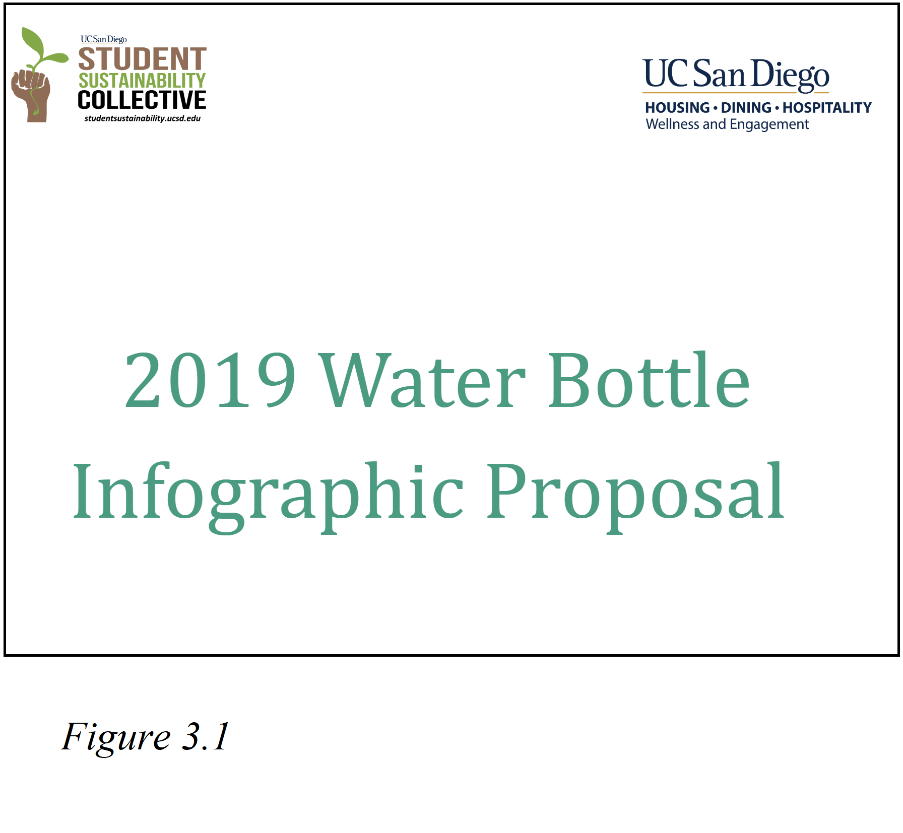

For milestone 6, we began testing the program at the Village Market, with one normal water tower and one infused water tower that would change flavors over the two week trial period (See Section Pilot Program, Figure 5.1). We then began prototyping other ideas that would fit into the sustainability timeline that HDH had, because at this point we found a clear partnership with a large body that had great reach for us to get access to more of the student body and test possible solutions. Between milestones 6 and 7, we worked on other potential prototypes of stickers and infographics.

For milestone 7, we tried changing up the second week of the water tower pilot program. We incorporated physical surveys to get more direct feedback (and because the online surveys were not getting results) and used our water emoji themed stickers to entice students to take our surveys (See Section Pilot Program, Figure 5.2). From this, we found that people were more willing to things when they had free things to gain, and that this could be incorporated in some way in a future sustainability program.

Since milestone 7, we analyzed the data that we collected from our test, including the survey results and bottles sales numbers that we received from HDH, and conducted validation interviews and received feedback from our key stakeholders. We finalized changes and iterations in our water tower designs, incorporating the feedback and information that we had gathered.

# Key Insights, Roadblocks, Lessons Learned

While doing research, we found some key insights into hydration station usage. We found that despite the availability and purported cleanliness of hydration stations, people had several issues with hydration stations, including the inconvenient locations, not water not being cold, and water that tastes bad, or did not feel clean. Despite efforts by HDH and student services over recent years to implement more hydration stations, water bottle sales haven’t gone down much, meaning that students are still buying plastic bottles despite having other options (See Section Misc. Data/Field Observations, Figure 1). Looking into market and dining hall water bottle sales, we found that people often bought water from markets out of convenience: It would not be as bad if they lost the water bottles compared to expensive hydroflasks, they were already at the market getting other things, they didn’t have to keep track of the bottles, the water was already cold (See Section Misc. Data/Field Observations, Figure 1). One challenge with interviewing the student body is that we weren’t interview the same people multiple times through our design process. This meant we were simply collecting survey responses or one time interview responses from any one student. There was no continuity from student feedback.

Working with HDH was another challenge we faced because we had to work within their timeframe, and we were limited in the ideas we could prototype because their interest was a big factor in our ability to execute a test. They were immediately interested in our infused water tower idea, and they agreed to help us run a test before we even began ideation, so we were restricted to testing that idea if we wanted to have a partnership with them. As we rolled out our water tower tests, we found that people would use the water towers if they were available. Some of the reasons that they gave: it was free, tasty, and cold (See Section Data, Figure 6). Initially, a lot of people that showed up to the market did not bring their water bottles with them even if they had them, because they were planning on buying a drink. However, as the experiment progressed, we found that people started bringing their water bottles to fill them at the towers.

We encountered a couple roadblocks during our prototyping. Due to the short duration of the experiment, a lot of people did not realize that water towers were available at the Village Market. Once people got the hint, water tower usage steadily increased (See Section Data, Figure 7). The timing of the testing also posed a roadblock in the form of a confound because by the end of Spring quarter most students either run out of dining dollars or sell them, there might not be as many students buying plastic water bottles as there would be during the middle of the school year. While we observed water bottle sales going down over the course of our test, we were unsure if it was actually because of the water towers or if it was because of the quarter winding down or just general sales fluctuations. Another roadblock we experienced with our test was that the Village Market was more residential than most other markets, and didn’t have as much cross-campus foot traffic, so most students that came in lived in the Village and didn’t carry a water bottle or the rest of their stuff with them.

Through this, we learned that it would be important to implement changes one at a time for longer periods of time in order to figure out exactly what needs to be changed to bring about improvement. Our pilot program taught us that people would likely try something if it was free without much hassle, and that a lot of people are interested in a clean and tastier alternative to hydration stations at the very least. As far as plastic bottles go, despite sales decreases, we think that it would require further testing to know for sure if the water towers work as an alternative to plastic bottles as well. We also learned that it is important to collect data that answers a specific question or targets a specific concern in order to get feedback that is valuable for iteration. Our initial survey that we sent out was more open ended, and while it gave us good feedback, it could have been more targeted to get better insights. We also learned the importance of field observations and interviews in comparison with short paper or online surveys. We conducted both observations and interviews during the water tower test and got better insight watching people use the towers than we did asking questions because we got to see the habits that students might not even know they have.

One other challenge that we encountered was having to work on different timelines with our secondary stakeholders at HDH. We had settled on testing the water towers well before the prototyping phase of the design process, giving us a solution ahead of schedule. While the testing phase of the design process lined up with the scheduled pilot phase, our prototyping process was more centered on our sticker idea and augmenting/iterating on the water towers rather than coming up with the water towers at that point in time. It was challenging to continue to develop and find insights due to us waiting for the pilot program to begin.

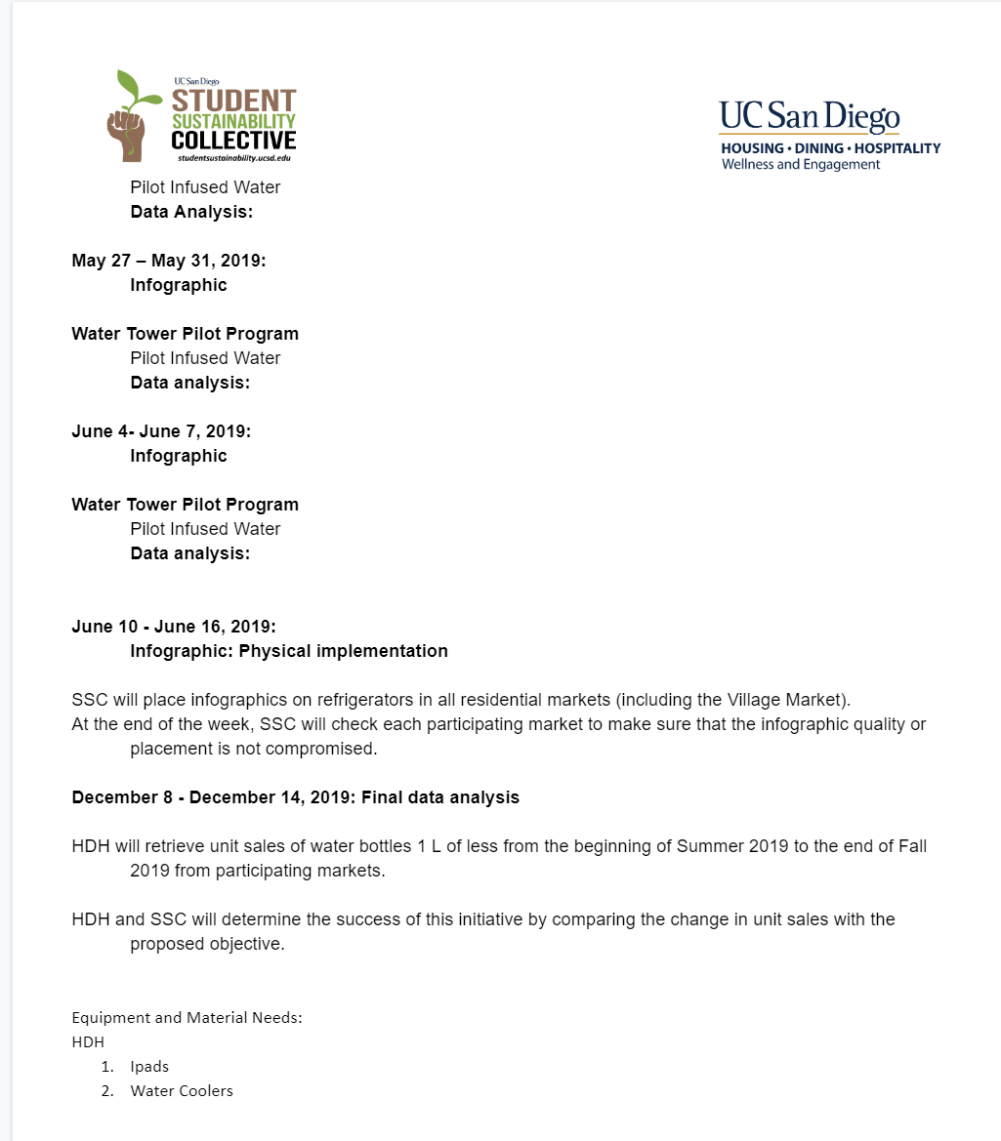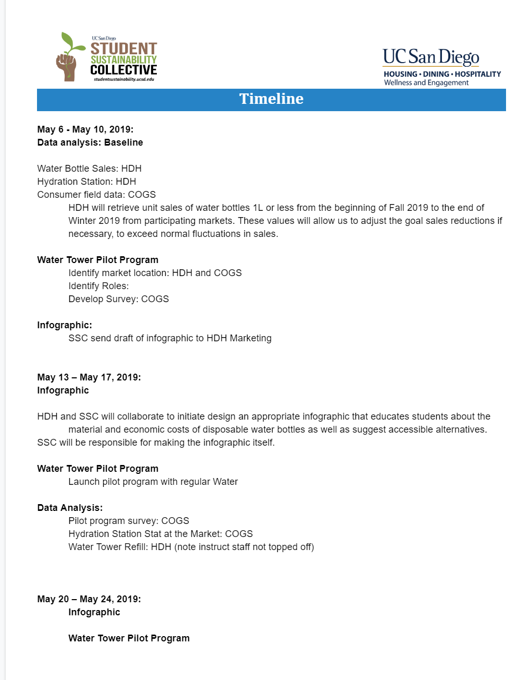

*Figures 3.3 and 3.4*

# Ideation Process

## 

We wanted to progress a culture of sustainable hydration habits on campus. When working with Mona from HDH and SSC (Student Sustainability Collective), we included aspects of environmental sustainability as being the focus of our overarching improvement of hydration habits.

## After the initial brief interviews with some primary stakeholders, we sent out a general hydration habit survey to the COGS 102C classroom on piazza. This survey was meant to gauge the general hydration habits of the student body and asked questions both about how much students hydrate, and their habits buying plastic bottles (See Section Pilot Program, Figure 10). We used all the data that we collected to begin the process of making our affinity diagram. The affinity diagram was used to reveal any salient information about hydration habits. After collecting data from our initial interviews, observations, and survey, we wrote down any relevant information on the sticky notes, including direct quotes from stakeholders. We conducted interpretation sessions as a group so that everyone understood each piece of data that we included in our affinity diagram. During the affinity diagramming process, the general steps we took were as follows. After amassing all the sticky notes, we began to organize them based on similar areas of relationships. We started with categories like “bottle preference”, “laziness”, and “hydration station access”. From there we grouped categories that we thought were similar, under headings like “personal diet habits”, and finally overarching categories like “purchasing factors”. One area that we found to be challenging was coming up with succinct and clear subcategory headers that were clear and detailed enough to be unique, but still vague enough to fit multiple pieces of data. If it was too vague, it didn’t capture the essence of the notes clearly. If it’s too detailed, the grouping would be too specific. We also found that because of how large our population of primary stakeholders was, we had a lot of contradicting data. For example, some people said they drink tap water, others never do; some people would drink lots of water and some people barely drank water at all. Once the affinity diagram was complete, we presented it to a meeting with Mona, Nhat, and Brian. We used the insight that we gained from the affinity diagram to inform our other design model and design solution. Our design solution would be focused on water accessibility, taste/quality of the water, and ease of use.

*(See Section Design Prototyping, Figures 9.1-9.15)*

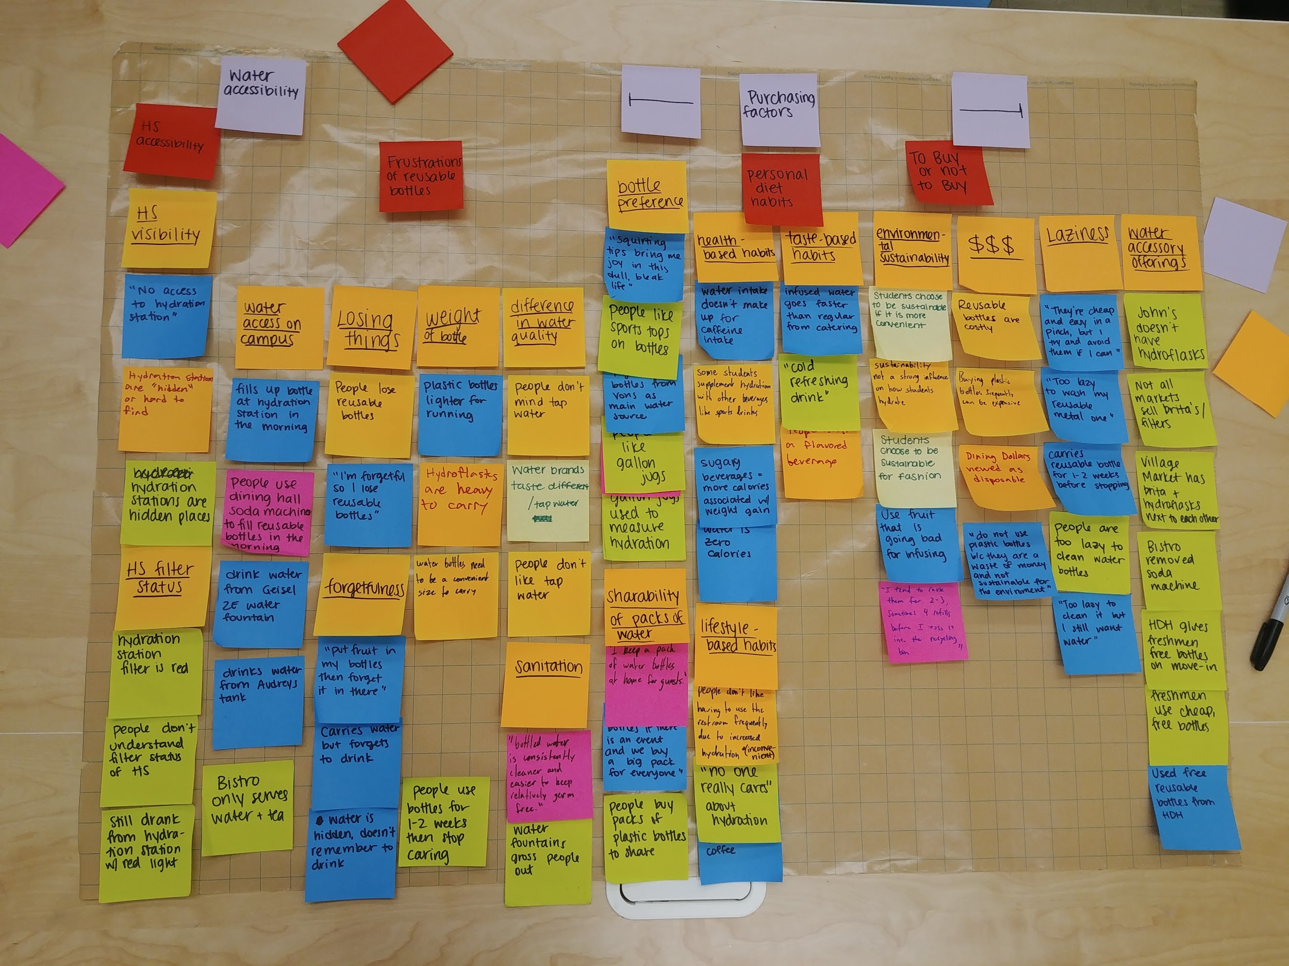

*The completed affinity diagram. The underlined orange headers were the subcategories. The red post it notes were the main categories. The light purple post it notes were the overarching theme.*

After finishing our affinity diagram, we created user personas and an identity model to help us get more insight into the motivation of our stakeholders. We created six different personas to cover a range of stakeholders, including specific cases like student athletes and freshman students who have unique perspectives and experiences with hydration on campus. The personas helped us identify what different students might prioritize, and what kind of solutions would be most effective for a variety of people (See Section Design Prototypes, Figure 13.1-13.6). We used the personas and affinity diagram to guide our creation of an identity model. We chose to make an identity model because we were interested in understanding the personal values of users. While the affinity diagram told us what they think, the identity model helped us understand how they think, and particularly how they make decisions about hydration (See Section Design Prototyping, Figure 14).

All of the insights we gained helped guide our ideation. Since we were already working on setting up the water tower pilot program while going through the ideation process, a lot of our ideas were focused on augmenting the water towers. For example, we had ideas like offering stickers as an incentive for using a reusable bottle, having reusable bottle options at markets for different price values, and washing stations where students could rinse their bottles. We storyboarded several ideas, and had our peers evaluate the different ideas to get immediate feedback (See Section Design Prototyping, Figures 4.1-4.9).

While also conducting ideation, we were primarily focusing on having infused water towers as our design solution due mostly in part to our partnership with HDH. The location would be at markets as it would increase water accessibility more so than dining halls. At dining halls there are already soda fountains that are able to dispense cold, filtered water whereas the markets do not have refill options in-house. The water towers would be free for people to refill their bottles (no plastic cups are given for the usage of water towers as it would defeat the purpose of sustainability). In terms of health, infused water is low on calories and helps people properly hydrate as opposed to other sugary bottled beverages. Since taste was an important factor, we wanted to address it through the flavoring of water. With ice, the water could be cold and chilled. At Village and Rogers market, Jon told us there was easy access to filtered water. To tie this solution back to environmental sustainability, we hypothesized that if people were drinking more water from these water towers, they would be further disincentivized to pay for plastic water bottles when infused water is free. There is a bit of friction involved in that people have to bring their reusable bottle, but we hoped that the incentives to do so would be greater the hassle. In the end, we were trying to provide a hydration alternative that promoted the use of reusable bottles.

Jonathan Biltuci, Project Planning Analyst from HDH, was a big help in getting our Water program set up. Originally, it was discussed that the water tower idea be set up at Rogers Market. However, after some discussion with Jon, we set up the test at the Village Market because it was logistically more feasible for the staff at that market to run the test. Some of the initial ideation regarding the water tower pilot program was in how to structure the testing parameters. Jon initially had the pilot program set up for 2 weeks in which one week would offer ice water and the next week would offer fruit infused water. We then asked him if 3 water towers could be set up. Jon responded by saying that he didn’t want to pile on too much work for the HDH workers to maintain the water towers. So, we factored in the labor concerns of HDH workers.

The final execution of the pilot program ended up being 2 water towers: 1 regular water and 1 infused water for both weeks (5/20/19 - 6/1/19). In this way, it could accommodate the amount of labor on the part of HDH workers. At the same time, we had regular water and infused water offered at the same time because we were testing to see if the full water tower station would improve hydration habit and reduce plastic bottle beverage sales. We weren’t testing to see if offering just regular or just infused water was better than the other.

One of the main reasons we had the water tower set up was to gather insights and observations on what factors were important in improving people’s hydration habits. The main ways in which collected this data was through field observations and through surveys. At first, we had a QR code on the flier that HDH put out explaining the pilot program, but we only got a few responses, so during the second week of the test we made paper surveys and collected responses in person. The bottle sales data for the Village Market were given to us by Jon, which we used to analyze after the pilot program ended. The staff at the market also tracked how many times they refilled the water tanks so we could judge how much they were being used. (See Sections Data Figure 7 and Misc. Data/Field Observations Figures 8.1-8.3)

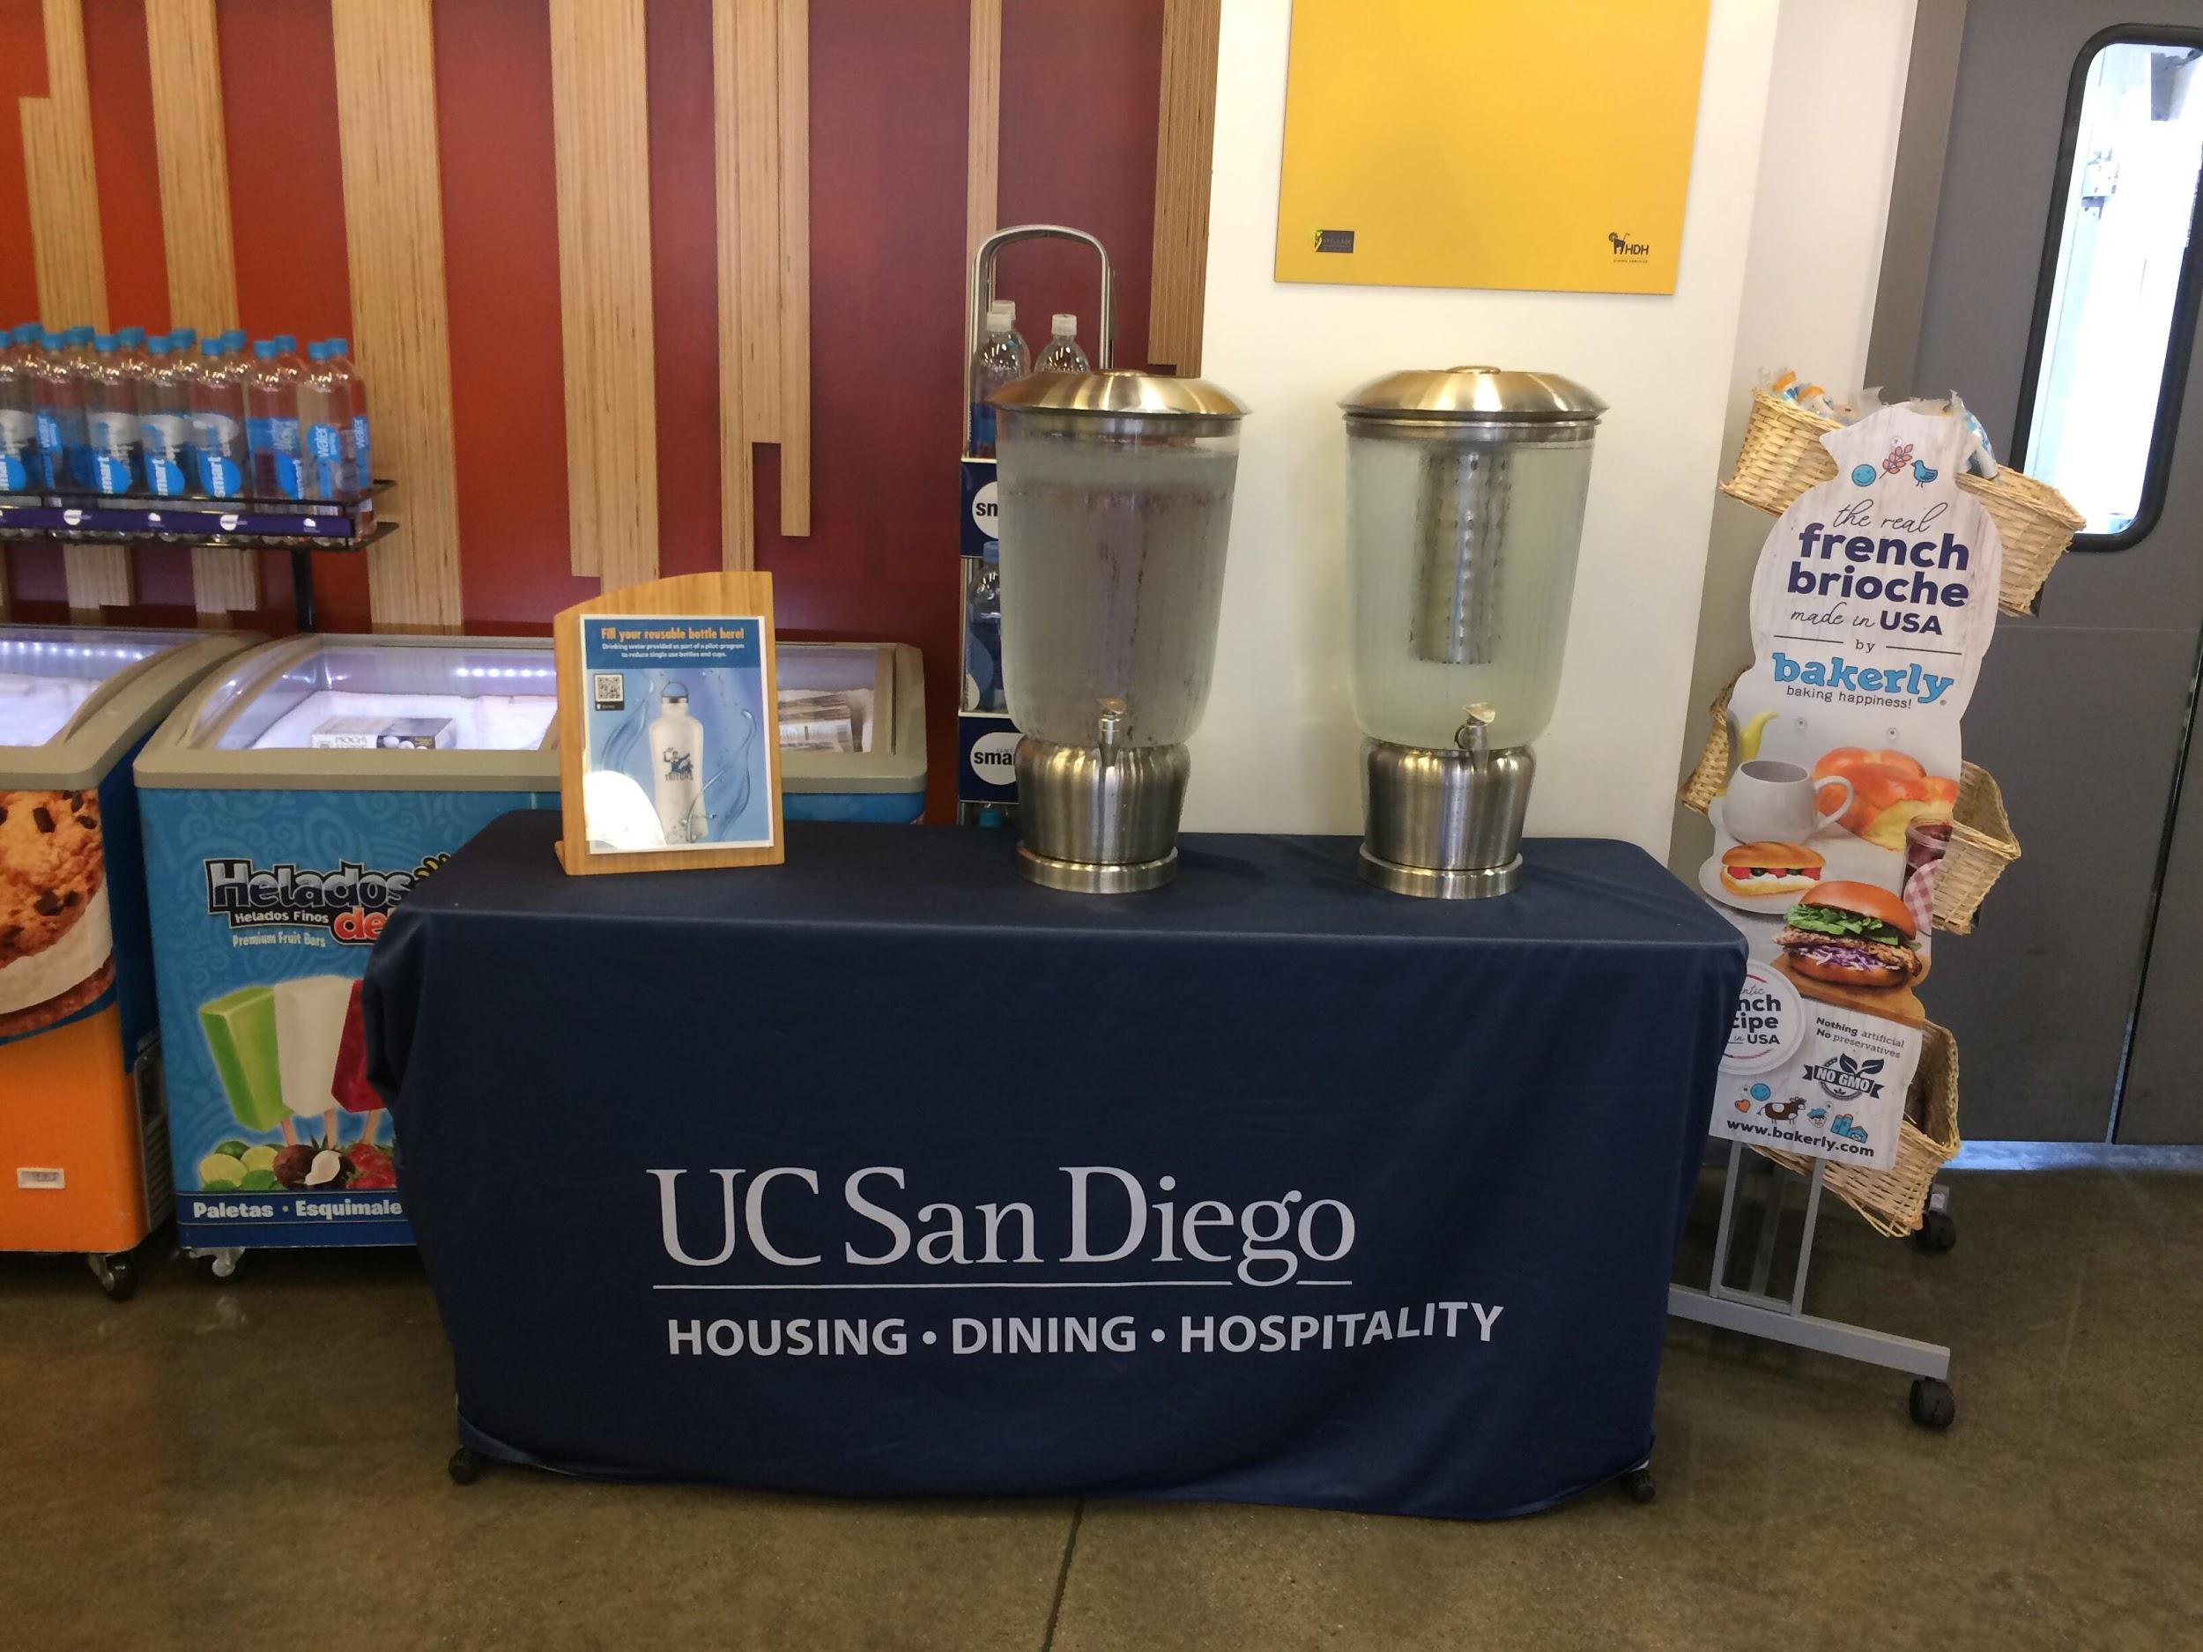

*The Water Tower Pilot Program at Village Market. The water tower on the left is regular and the water tower on the right is infused water.*

When we were setting up the pilot program, we created an online Google Form survey. Through multiple iterations of the survey, we refined the type of questions asked, the format of the questions, and the length of the survey (See Section Misc Data/Field Observations Figures 11.1-11.3). The iterations of our survey ranged from having many open ended questions to a balance of some short answers with rankings. The specific data we were trying to collect from the surveys was once again how highly students rated factors such as cost, taste, etc., what flavors of infused water they tried and liked, and then left room for general thoughts and feedback on the towers. This water tower survey was presented on a flyer accompanying the water tower station in the form of the QR code. One of the main issues we found with the QR code was that no one would answer the online survey. We only amounted 4 survey responses from the QR code. This was quickly remedied by printing out paper surveys that people could easily fill out on the spot. We took the base foundation of the old QR survey and adapted it to a more condensed version in the paper survey. 1 logistical question, 1 rating question about the importance of certain factors, and one open ended question (See Section Misc Data/Field Observations Figures 12.1-12.2). We also gave people a sticker if they filled out the form. This combination of paper surveys and a sticker at the end, worked and we got 33 responses within 2 days.

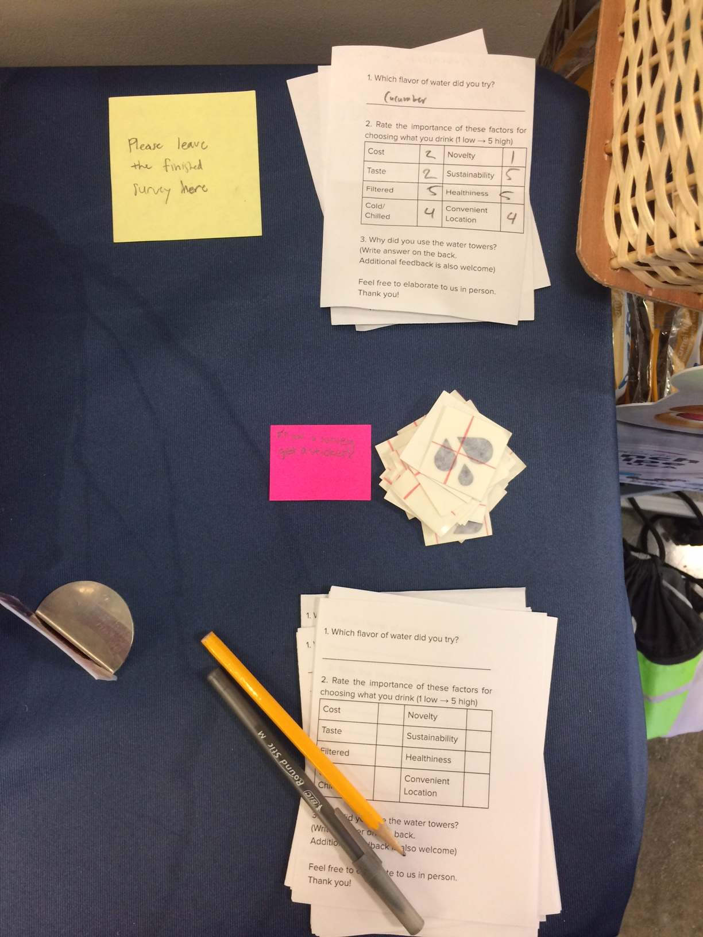

*Paper surveys that were placed at the water tower station. Water emoji stickers were rewarded if the person filled out the survey.*

While running the water tower pilot program, we also decided to prototype ideas that could work alongside the water towers. We were interested in utilizing stickers as an incentive to encourage people to practice more sustainable options. During our research, we found that some students buy Hydroflask bottles because of the social status they have, and the ability to customize them with stickers. We thought that offering stickers as an incentive would encourage students to use their own reusable bottles more. Some ideas included giving stickers to those who bought hydro flasks or reusable bottles. Other ideas were to test to see if people would be willing to put in some effort required to get one. To test this, we offered people a sticker if they would fill out our survey. What we found is that when we asked people to fill out a survey for a sticker, we wouldn’t even get to the sticker part and that people would be willing to fill out a survey just because we asked. So, the sticker program got transformed into a reward for filling out the paper survey. *(See Section Design Prototyping, Figures 15.1-15.14)*

# 

# Final Design Solution

Based on the information we got in our final stage of testing, we came up with a final iteration of our water tower project. Our final proposal involves what a non-pilot version of the program would look like rolled out by HDH. This would be water tower setups in various high traffic market and dining hall areas with three towers: one normal water, two rotating infused flavors. We came to the conclusion of using the two infused flavors because of the feedback that we recorded suggesting that people would try out different flavors, and that different people had different preferences for flavors. The rotating flavors presents variety as well as a slight gamification to the program, allowing people to prioritize visits for the flavors that they prefer. The full program would be rolled out with the other HDH initiatives such as their infographics that will inform people of the importance of sustainability in order to encourage students to use sustainable sources.

The towers would be located in high traffic places where accessing clean refillable water is difficult and there is access to plastic bottles. Primarily, this would include markets. We also considered certain dining halls such as OVT and Cafe V because their layout lends to placement of water towers, and it would be easy for staff to refill and manage the water towers. Also in consideration was the newly rebuilt Canyon Vista or any future built dining halls, as the water towers could be factored into the design.



*Figure 5.1*

# Evaluation

We conducted validation interviews in two ways, by having students fill out paper surveys while using the water towers and with the HDH admin that helped us set up and run the test. From the student surveys, we found that our water towers were positively received, and that many people enjoyed having the option of infused water (See Section Data, Figure 6). Many said that they wanted to see the water towers expanded to other locations, which told us that they enjoyed having the water towers and wanted to see more. In the online survey, one person said “More locations would be nice!” Several students also mentioned that since the implementation of the water towers, they had stopped buying water bottles and instead came to the market specifically to fill up their reusable bottles. In our validation interview with HDH, we delivered the data that we had collected from the test, and received positive feedback from them about the insights we had to give them. Though the final prototype that we were able to get to wasn’t the final design, HDH still valued the data that we were able to give them because it could be used in their future sustainability efforts. They said that they want to move forward with expanding our idea and implementing it as part of their current sustainability initiative.

Based on the feedback from students using the water towers, we believe that having an alternative to buying plastic bottles that is directly available at markets has an impact on students’ hydration habits. Even though the quantitative data that we gathered was inconclusive because of several confounds, the data we gathered through observations and paper surveys showed that we made an impact on the behavior of the students that used the water towers. We think that because this solution offers students a convenient and tasty alternative, it will get students to practice more sustainable hydration habits, even if sustainability isn’t a priority for them. In this way, we think our solution will lead to our goal of sustainability even that isn’t the motivation behind students using the water towers. This feedback is what motivated us to expand the idea to other locations in our final design because we think that having this alternative to plastic bottles will help reduce plastic bottle sales and improve sustainability efforts on campus.

In our validation interview with Mona, Nhat, and Brian, we discussed our data and insights we discovered through our water tower pilot program. From the data of bottle sales, we presented to them a decline in total bottle sales in the Village Market by ~10% (The end of the pilot program was compared to week 5). Although we cannot state a causality and say that our water towers were the reason for the massive decrease in bottle sales, the data is still useful. Some other factors that may have resulted in this drastic drop in bottle sales could be that people are running out of dining dollars due to the end of the quarter. Regardless, this correlation could be used as further evidence for SSC (Student Sustainability Collective) to propose a sustainability initiative to incorporate a healthy alternative to bottled beverages that would accompany the infographic section of their proposal. From the paper survey responses, we showed that the top 3 factors that were important about the water towers were: 1. Convenient location 2. Taste 3. Cost. Some of the concerns that were raised was the maintenance of the water towers cost in terms of labor to clean and the cost of fruits/vegetables for the infused water. Overall, they were extremely receptive to our findings and data. Mona said that this project could definitely be extended to future quarters and would work really well in tandem with SSC’s infographic. The infographic gets people to reconsider using plastic water bottles and the infographic could propose water towers as an alternative to buying plastic water bottles.

# 

# Future Work

Working with HDH, their sustainability initiative will continue to move forward using our data from our water tower pilot program as well as a new infographic that they are planning to roll out. If we had more time, we would have tried to do more testing, at other markets as well as dining halls. Further bottle sales data collection would also help us provide more context to the bottle sales data we have now. If we could compare the natural trend of bottle sales from last spring quarter, we could get a clearer idea of how our water towers affected bottle sales for this spring quarter. We would have tried other combinations of flavors, such as using three water towers or a rotating flavor schedule to get a clearer idea of the benefits of water towers. We briefly tried to give out stickers for people filling their reusable water bottles, but there is also future work that we could possibly do with handing out stickers to owners of reusable water bottles. We found that giving out free things was a powerful incentive for getting students to go out of their way to do things that they would normally find inconvenient. We also found that a large number of students with reusable water bottles that we asked owned water bottles so that they could decorate and personalize them.

If we had more time available to us, we would have seen the water towers as a temporary solution, with the long term goal being a clean and good-tasting refillable water solution available in more high traffic areas such as dining halls and markets. These high traffic areas would be wherever bottled beverages are sold so that a more sustainable alternative can be offered. The infographic would work in tandem with this as a pedagogical tool to help them understand the importance of hydration and sustainability. We would also like to introduce the idea of friction into the stickers and infographics by making people more aware of the impacts of plastic bottle usage on the environment. By forcing self-reflection we would like to get students to care about the impact of their actions rather than only reducing their personal waste because it is more convenient. Similar to how some cigarette packagings include photos showing the medical consequences of smoking cigarettes, we would want to show how animals are affected by waste pollution to try and deter students from buying plastic water bottles in favor of refilling a reusable one.

Further research that could be spawned from our findings is looking at how people think about water from a psychological and cognitive standpoint. Everybody needs water to survive, so what drives an individual’s perception of a vital resource depending on its source and availability? Why is it assumed that bottled water is cleaner than tap water? What makes it generally difficult to consider the everyday consumption of water on the environment as a whole? These questions are just a few examples of how one could begin to understand how to shift society to have sustainable mindset regarding hydration/water usage for the future?

# Conclusion

We learned many things throughout this quarter, especially about the importance of being intentional about our data collection and the insights we were trying to generate. We had two different surveys that we conducted, one during our initial contextual inquiry and one during our prototype test. We learned that it was very important to decide what kind of data we needed and what holes in insight we had so that the data we gathered was most effective. Our first survey had multiple questions aimed at gathering numerical data about hydration habits, and the one short answer question ended up giving us the most insight because we learned how students thought about hydration more than just what they did to hydrate. Knowing what insights we wanted to get before we began data collection was important to help us stay within our scope and make sure that what we were learning was relevant.

Asking why at any given point during the design process was key for determining that we were on track. By answering “why?” we could see if we understood the choices we were making and the basis for them. We kept this idea in mind throughout the entire design process to help ground our research and ideas, and if we began straying from actions that would progress our design, asking “why?” helped us stay within our scope. If we were unable to answer “why?” then we knew we had more work to do before moving forward.

Working with HDH really highlighted the top-down vs. bottom-up approaches to design. As we mentioned they jumped on the water tower idea immediately and wanted to test it right away without any real reasoning behind it other than it sounded good (top down). We made sure to follow the bottom-up design process and establish reasoning for using water towers and the best way to implement them to make sure they targeted what our stakeholders valued the most. While the bottom up process requires a lot of work up front and is a longer process overall, the payoff of having a design solution that really solves your stakeholder’s problem makes the effort early on worthwhile. We believe this difference in approaches is what gave us insights into student habits that HDH wasn’t aware of and that enabled us to design something that made a real impact and allowed us to design something with concrete reasoning rather than just hoping for the success of a project.

# 

# Portfolio

[**Design Prototyping 2**](https://docs.google.com/document/d/1QPGQBwWdwMz-g4lsYwJmj5AcyfcS4r6S_ZyOQ3WQLVI/edit#heading=h.sl3ohvjl2mf0)**3**

[Storyboards](https://docs.google.com/document/d/1QPGQBwWdwMz-g4lsYwJmj5AcyfcS4r6S_ZyOQ3WQLVI/edit#heading=h.y2rxqov5dmy5) (Figures 4.1-4.9) [2](https://docs.google.com/document/d/1QPGQBwWdwMz-g4lsYwJmj5AcyfcS4r6S_ZyOQ3WQLVI/edit#heading=h.y2rxqov5dmy5)3

[Personas (Figures 13.1-13.6) 2](https://docs.google.com/document/d/1QPGQBwWdwMz-g4lsYwJmj5AcyfcS4r6S_ZyOQ3WQLVI/edit#heading=h.qtj9ctnbtr18)4

Affinity Diagram Session (Figures 9.1-9.15) 25

Identity Model (Figure 14) 28

Sticker Prototyping (Figures 15.1-15.4) 30

[**Pilot-program 3**](https://docs.google.com/document/d/1QPGQBwWdwMz-g4lsYwJmj5AcyfcS4r6S_ZyOQ3WQLVI/edit#heading=h.x729dphawy3m)**2**

[Photos](https://docs.google.com/document/d/1QPGQBwWdwMz-g4lsYwJmj5AcyfcS4r6S_ZyOQ3WQLVI/edit#heading=h.whhcwaeswnu8) (Figures 5.1-5.2)  [3](https://docs.google.com/document/d/1QPGQBwWdwMz-g4lsYwJmj5AcyfcS4r6S_ZyOQ3WQLVI/edit#heading=h.whhcwaeswnu8)2

[HDH/SSC Partnership (Figures 3.1-3.4) 3](https://docs.google.com/document/d/1QPGQBwWdwMz-g4lsYwJmj5AcyfcS4r6S_ZyOQ3WQLVI/edit#heading=h.rx0yun854nr7)3

[Pilot-program Logistics 3](https://docs.google.com/document/d/1QPGQBwWdwMz-g4lsYwJmj5AcyfcS4r6S_ZyOQ3WQLVI/edit#heading=h.endcq1p1nv4w)4

[Survey Iterations](https://docs.google.com/document/d/1QPGQBwWdwMz-g4lsYwJmj5AcyfcS4r6S_ZyOQ3WQLVI/edit#heading=h.bcfg7ypefy1s) (Figures 10, 11.1-11.3, 12.1-12.2) 35

[**Data**](https://docs.google.com/document/d/1QPGQBwWdwMz-g4lsYwJmj5AcyfcS4r6S_ZyOQ3WQLVI/edit#heading=h.cpbsmzfl3ag2) [**3**](https://docs.google.com/document/d/1QPGQBwWdwMz-g4lsYwJmj5AcyfcS4r6S_ZyOQ3WQLVI/edit#heading=h.cpbsmzfl3ag2)**7**

[Pilot-program Bottle Sales Data 3](https://docs.google.com/document/d/1QPGQBwWdwMz-g4lsYwJmj5AcyfcS4r6S_ZyOQ3WQLVI/edit#heading=h.m1bwdddve1p9)7

[Survey Response Data (Figure 6) 3](https://docs.google.com/document/d/1QPGQBwWdwMz-g4lsYwJmj5AcyfcS4r6S_ZyOQ3WQLVI/edit#heading=h.9hyuxqa0g0bl)9

[Water Tower Recor](https://docs.google.com/document/d/1QPGQBwWdwMz-g4lsYwJmj5AcyfcS4r6S_ZyOQ3WQLVI/edit#heading=h.g4ai6wlopxk8)d Sheet [(Figure 7) 40](https://docs.google.com/document/d/1QPGQBwWdwMz-g4lsYwJmj5AcyfcS4r6S_ZyOQ3WQLVI/edit#heading=h.fy7gabxrcdfj)

[**Misc. Data/Field Observations 4**](https://docs.google.com/document/d/1QPGQBwWdwMz-g4lsYwJmj5AcyfcS4r6S_ZyOQ3WQLVI/edit#heading=h.7qsakqx68uyb)**0**

[Hydration Survey Response Data](https://docs.google.com/document/d/1QPGQBwWdwMz-g4lsYwJmj5AcyfcS4r6S_ZyOQ3WQLVI/edit#heading=h.i8njku7n3hu2) (Figure 1) [4](https://docs.google.com/document/d/1QPGQBwWdwMz-g4lsYwJmj5AcyfcS4r6S_ZyOQ3WQLVI/edit#heading=h.i8njku7n3hu2)0

[Village Market Bottle Sales Data](https://docs.google.com/document/d/1QPGQBwWdwMz-g4lsYwJmj5AcyfcS4r6S_ZyOQ3WQLVI/edit#heading=h.qq06yapci8k8) (Figures 8.1-8.3) [4](https://docs.google.com/document/d/1QPGQBwWdwMz-g4lsYwJmj5AcyfcS4r6S_ZyOQ3WQLVI/edit#heading=h.qq06yapci8k8)1

[Hydration Station Usage Data 4](https://docs.google.com/document/d/1QPGQBwWdwMz-g4lsYwJmj5AcyfcS4r6S_ZyOQ3WQLVI/edit#heading=h.8xs4h6l9ezuh)4

[Hydration Station Usage Numbers](https://docs.google.com/document/d/1QPGQBwWdwMz-g4lsYwJmj5AcyfcS4r6S_ZyOQ3WQLVI/edit#heading=h.ac1e7y11r57f) (Figure 2) [4](https://docs.google.com/document/d/1QPGQBwWdwMz-g4lsYwJmj5AcyfcS4r6S_ZyOQ3WQLVI/edit#heading=h.ac1e7y11r57f)5

[Village Market Reusable Bottle Stock 4](https://docs.google.com/document/d/1QPGQBwWdwMz-g4lsYwJmj5AcyfcS4r6S_ZyOQ3WQLVI/edit#heading=h.zddmi7ecv59c)7

[**Notes 4**](https://docs.google.com/document/d/1QPGQBwWdwMz-g4lsYwJmj5AcyfcS4r6S_ZyOQ3WQLVI/edit#heading=h.4krdbrj7k9xj)**8**

[Interview Protocol 4](https://docs.google.com/document/d/1QPGQBwWdwMz-g4lsYwJmj5AcyfcS4r6S_ZyOQ3WQLVI/edit#heading=h.3kb3p0eeil4w)8

[Meeting Notes 4/26](https://docs.google.com/document/d/1QPGQBwWdwMz-g4lsYwJmj5AcyfcS4r6S_ZyOQ3WQLVI/edit#heading=h.yi8hxjgvmqqq)  49

[Meeting Notes 4/30](https://docs.google.com/document/d/1QPGQBwWdwMz-g4lsYwJmj5AcyfcS4r6S_ZyOQ3WQLVI/edit#heading=h.scnxf4d452gx)  [5](https://docs.google.com/document/d/1QPGQBwWdwMz-g4lsYwJmj5AcyfcS4r6S_ZyOQ3WQLVI/edit#heading=h.scnxf4d452gx)0

[Meeting Notes 5/7](https://docs.google.com/document/d/1QPGQBwWdwMz-g4lsYwJmj5AcyfcS4r6S_ZyOQ3WQLVI/edit#heading=h.mstgg1locdfz)  [5](https://docs.google.com/document/d/1QPGQBwWdwMz-g4lsYwJmj5AcyfcS4r6S_ZyOQ3WQLVI/edit#heading=h.mstgg1locdfz)3

[Meeting Notes 5/8](https://docs.google.com/document/d/1QPGQBwWdwMz-g4lsYwJmj5AcyfcS4r6S_ZyOQ3WQLVI/edit#heading=h.pn5047yj20w7)  [5](https://docs.google.com/document/d/1QPGQBwWdwMz-g4lsYwJmj5AcyfcS4r6S_ZyOQ3WQLVI/edit#heading=h.pn5047yj20w7)4

[Meeting Notes 5/28](https://docs.google.com/document/d/1QPGQBwWdwMz-g4lsYwJmj5AcyfcS4r6S_ZyOQ3WQLVI/edit#heading=h.1hlbfh5lxv12)  [5](https://docs.google.com/document/d/1QPGQBwWdwMz-g4lsYwJmj5AcyfcS4r6S_ZyOQ3WQLVI/edit#heading=h.1hlbfh5lxv12)5

[Meeting Notes 6/6 (Validation Interview with HDH and SSC)](https://docs.google.com/document/d/1QPGQBwWdwMz-g4lsYwJmj5AcyfcS4r6S_ZyOQ3WQLVI/edit#heading=h.dnxp12ja6jy)  [5](https://docs.google.com/document/d/1QPGQBwWdwMz-g4lsYwJmj5AcyfcS4r6S_ZyOQ3WQLVI/edit#heading=h.dnxp12ja6jy)6

# Design Prototyping

# 

# Storyboards

# *(Figures 4.1-4.9)*

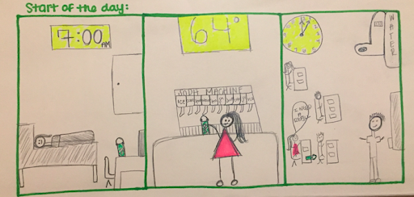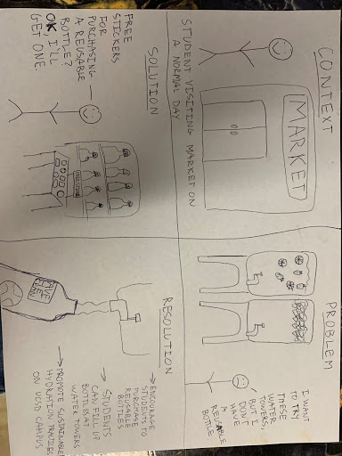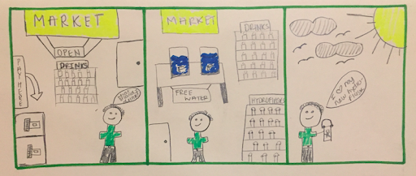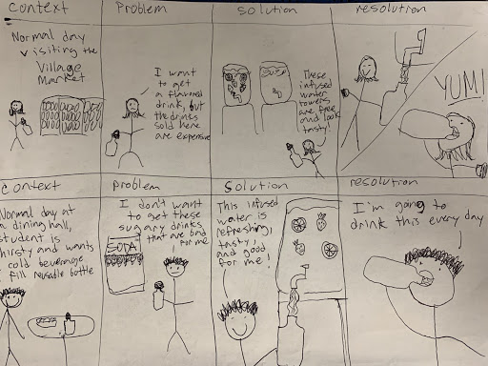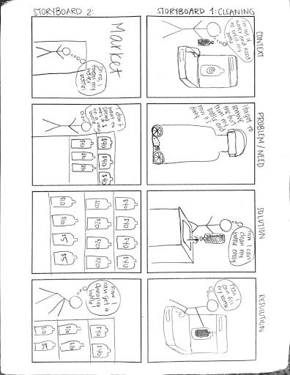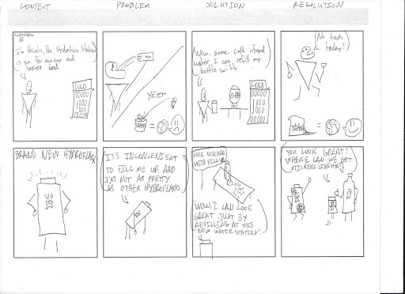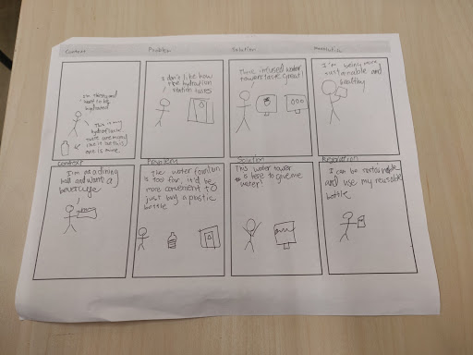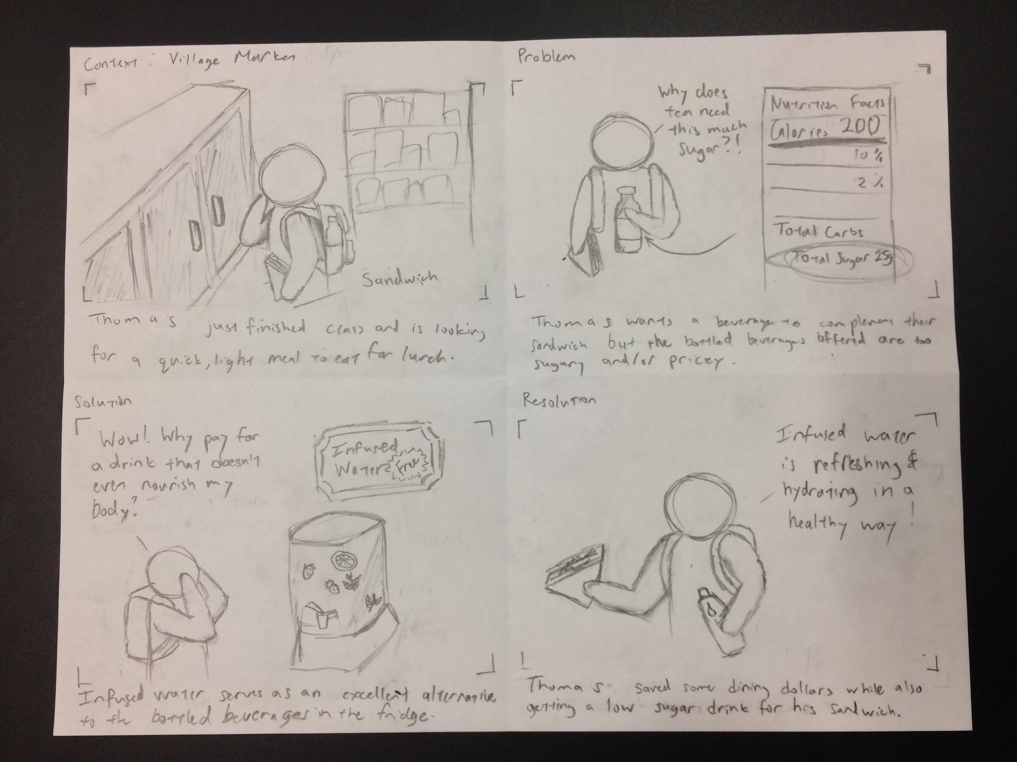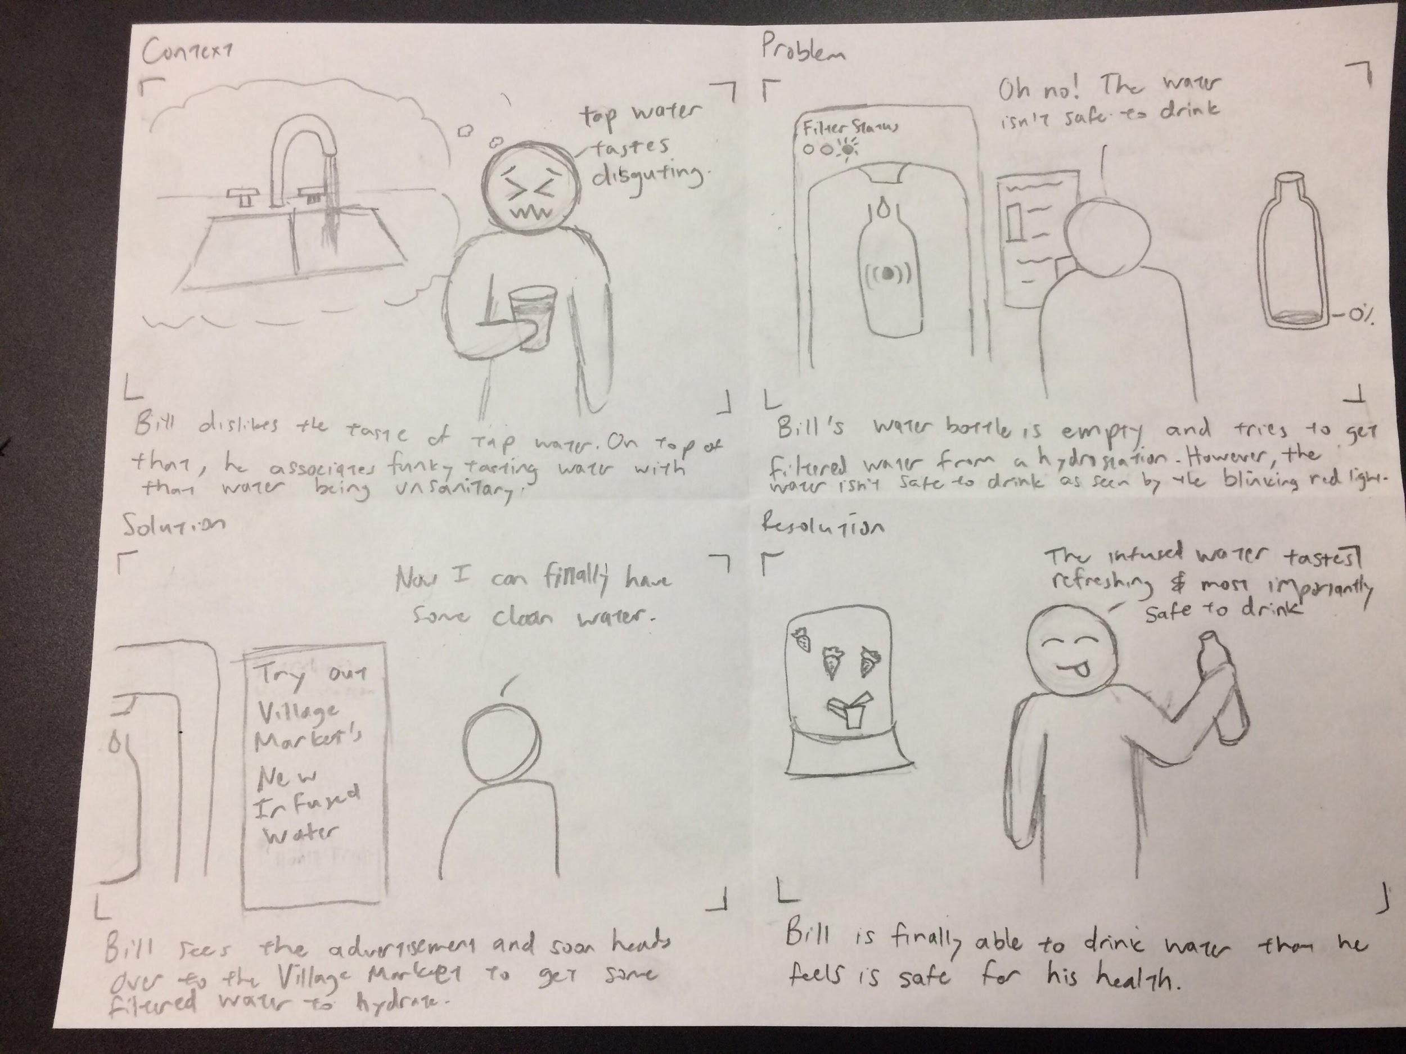

# Personas

*Figures 13.1-13.6*

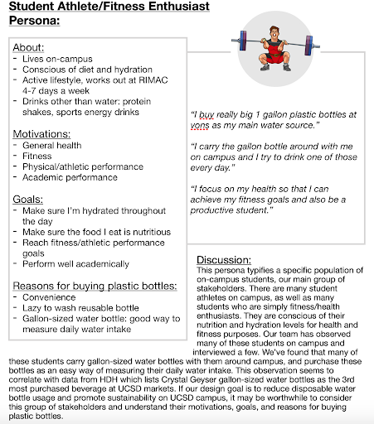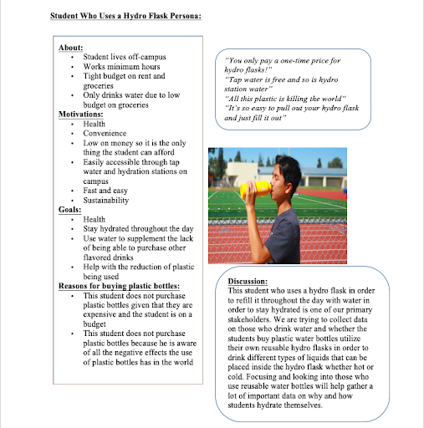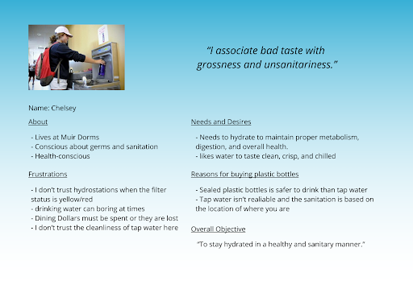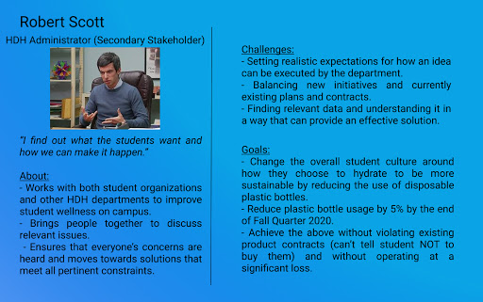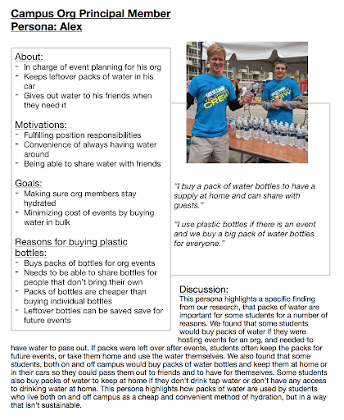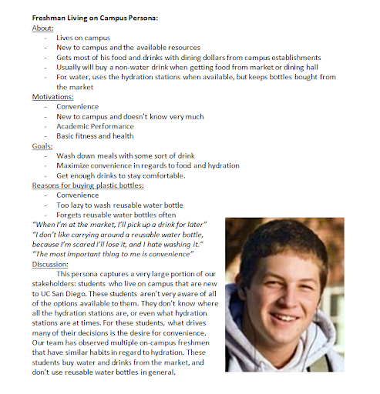**Affinity Diagram Sessions**

### 

*Figures 9.1-9.15*

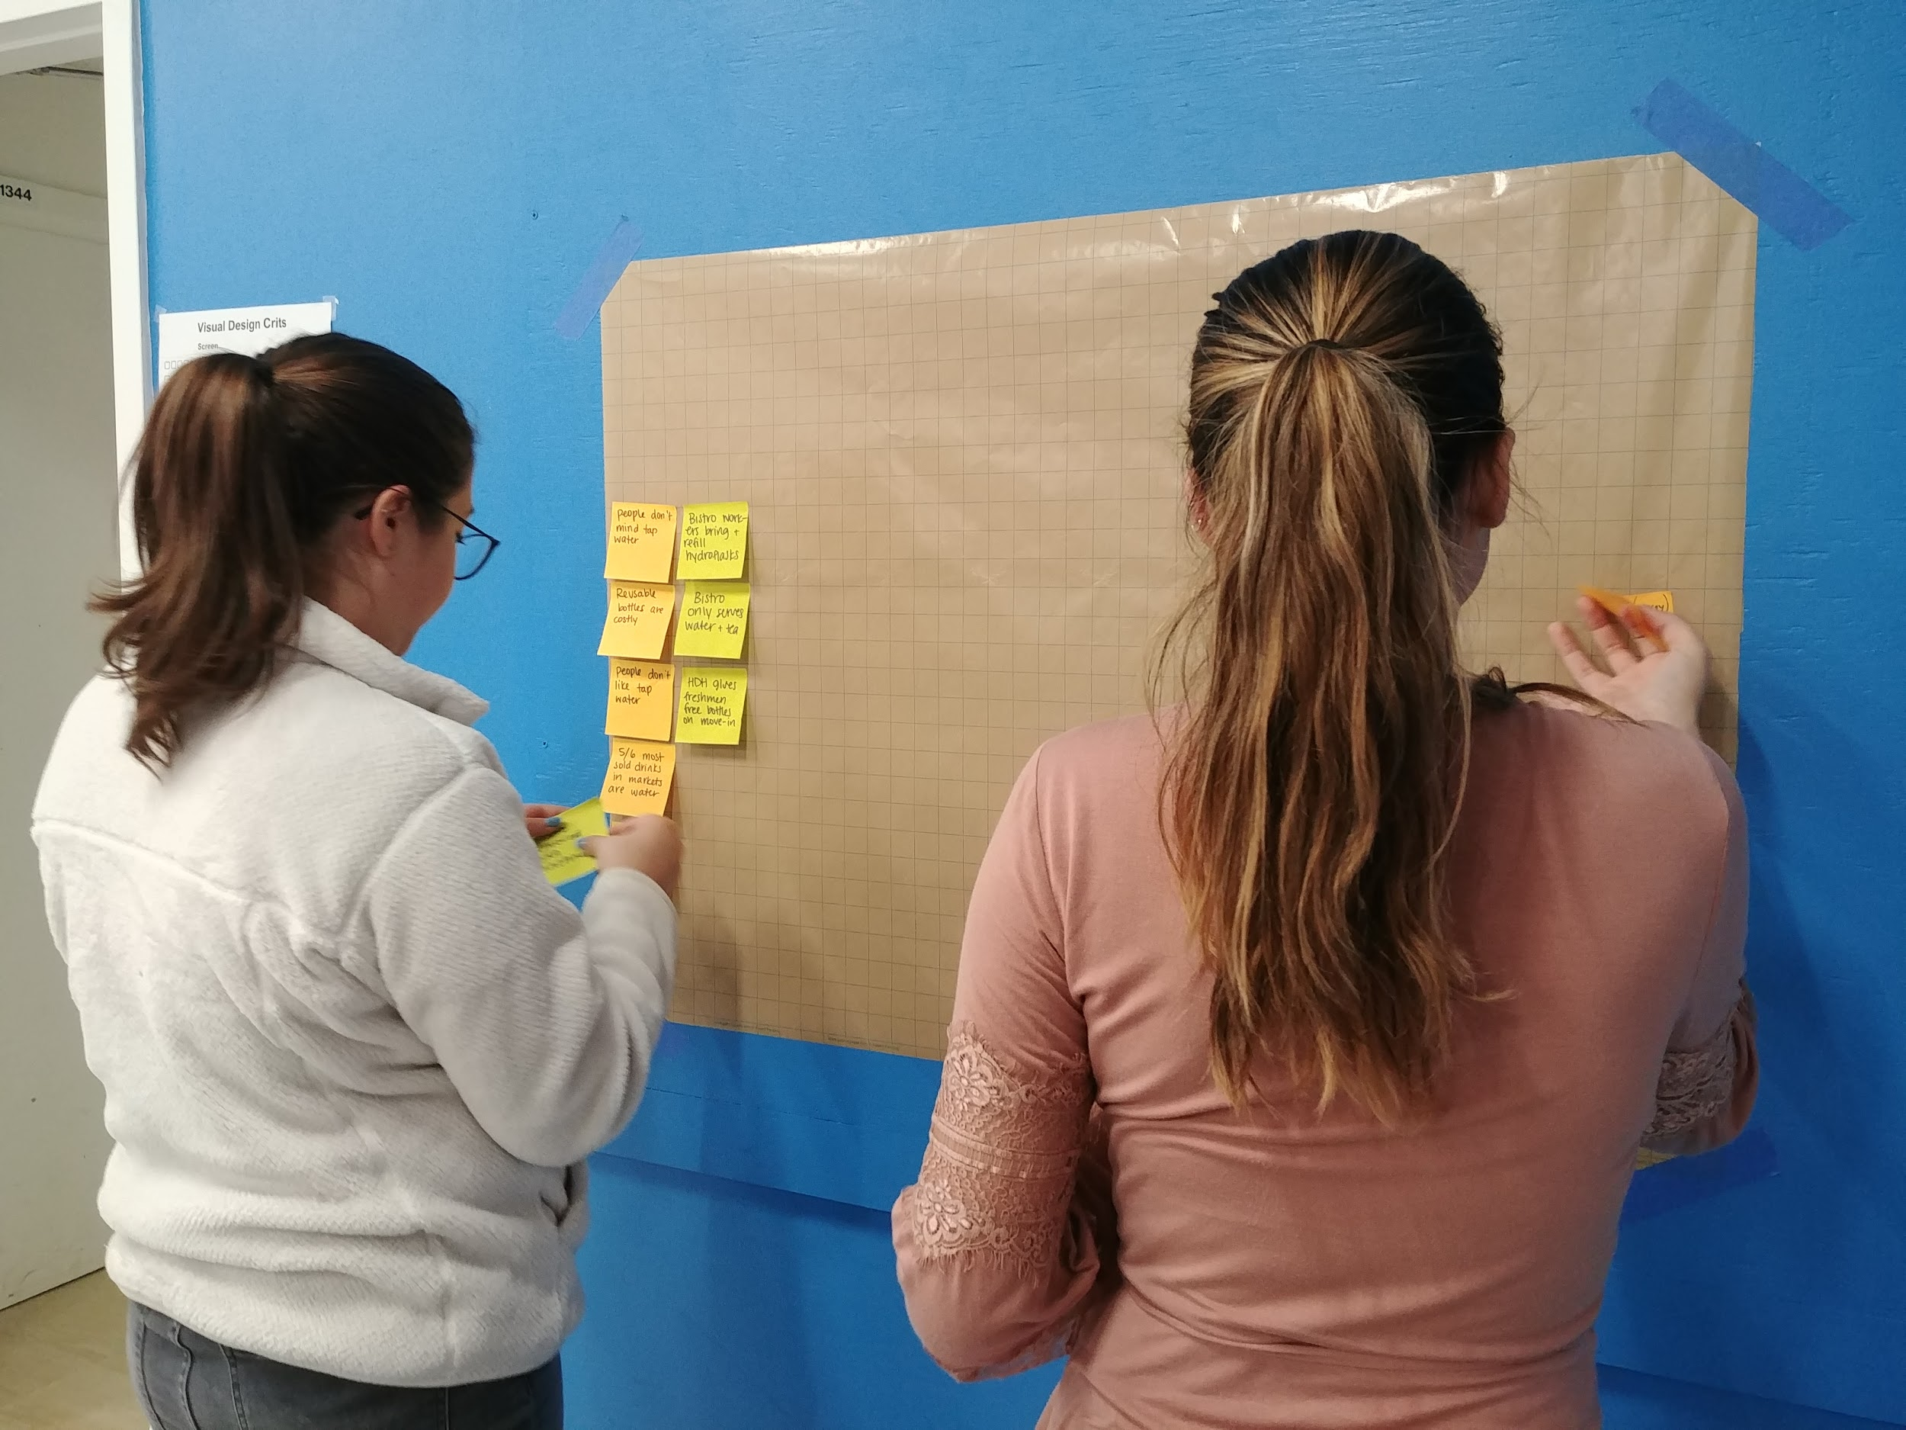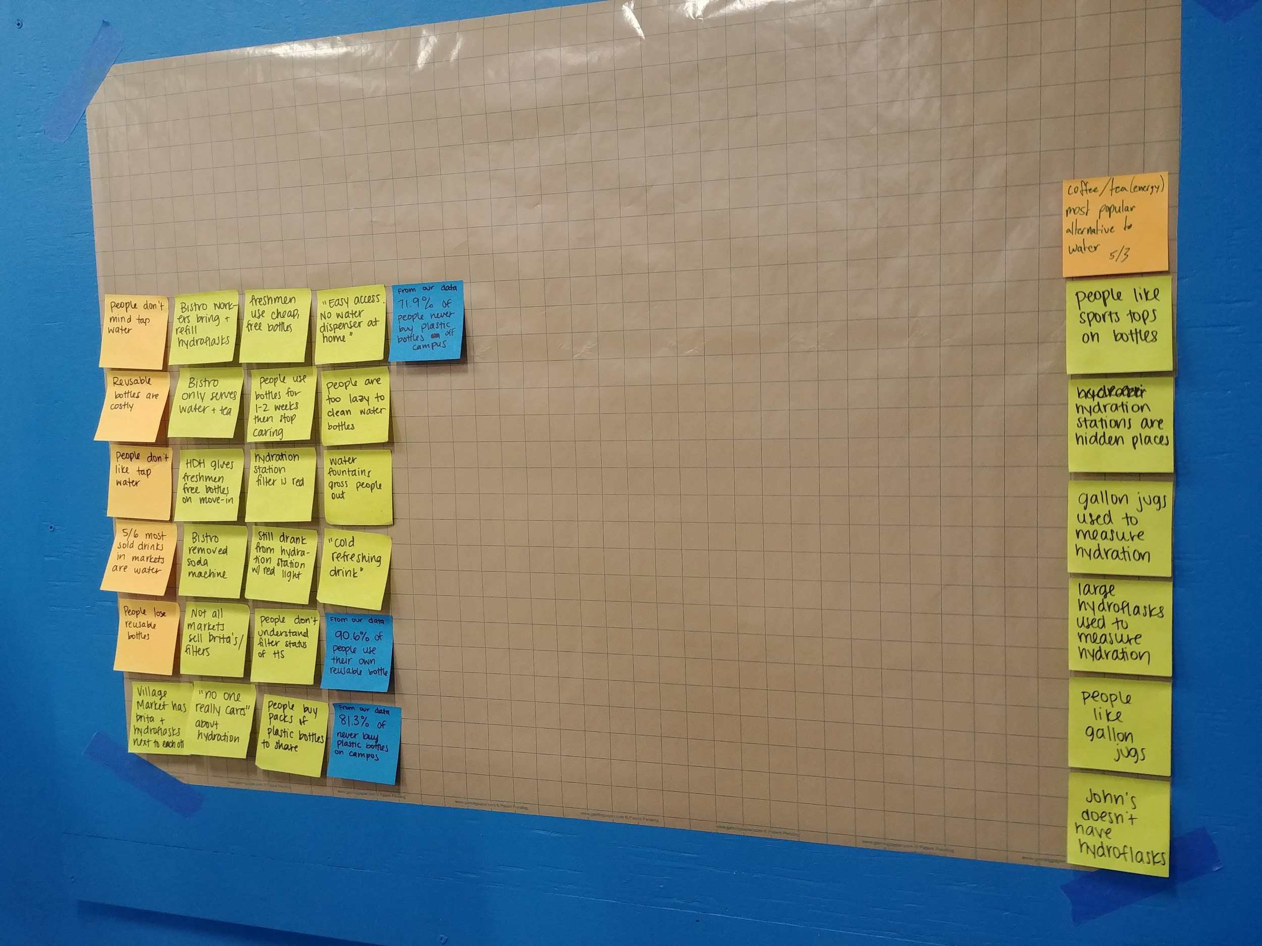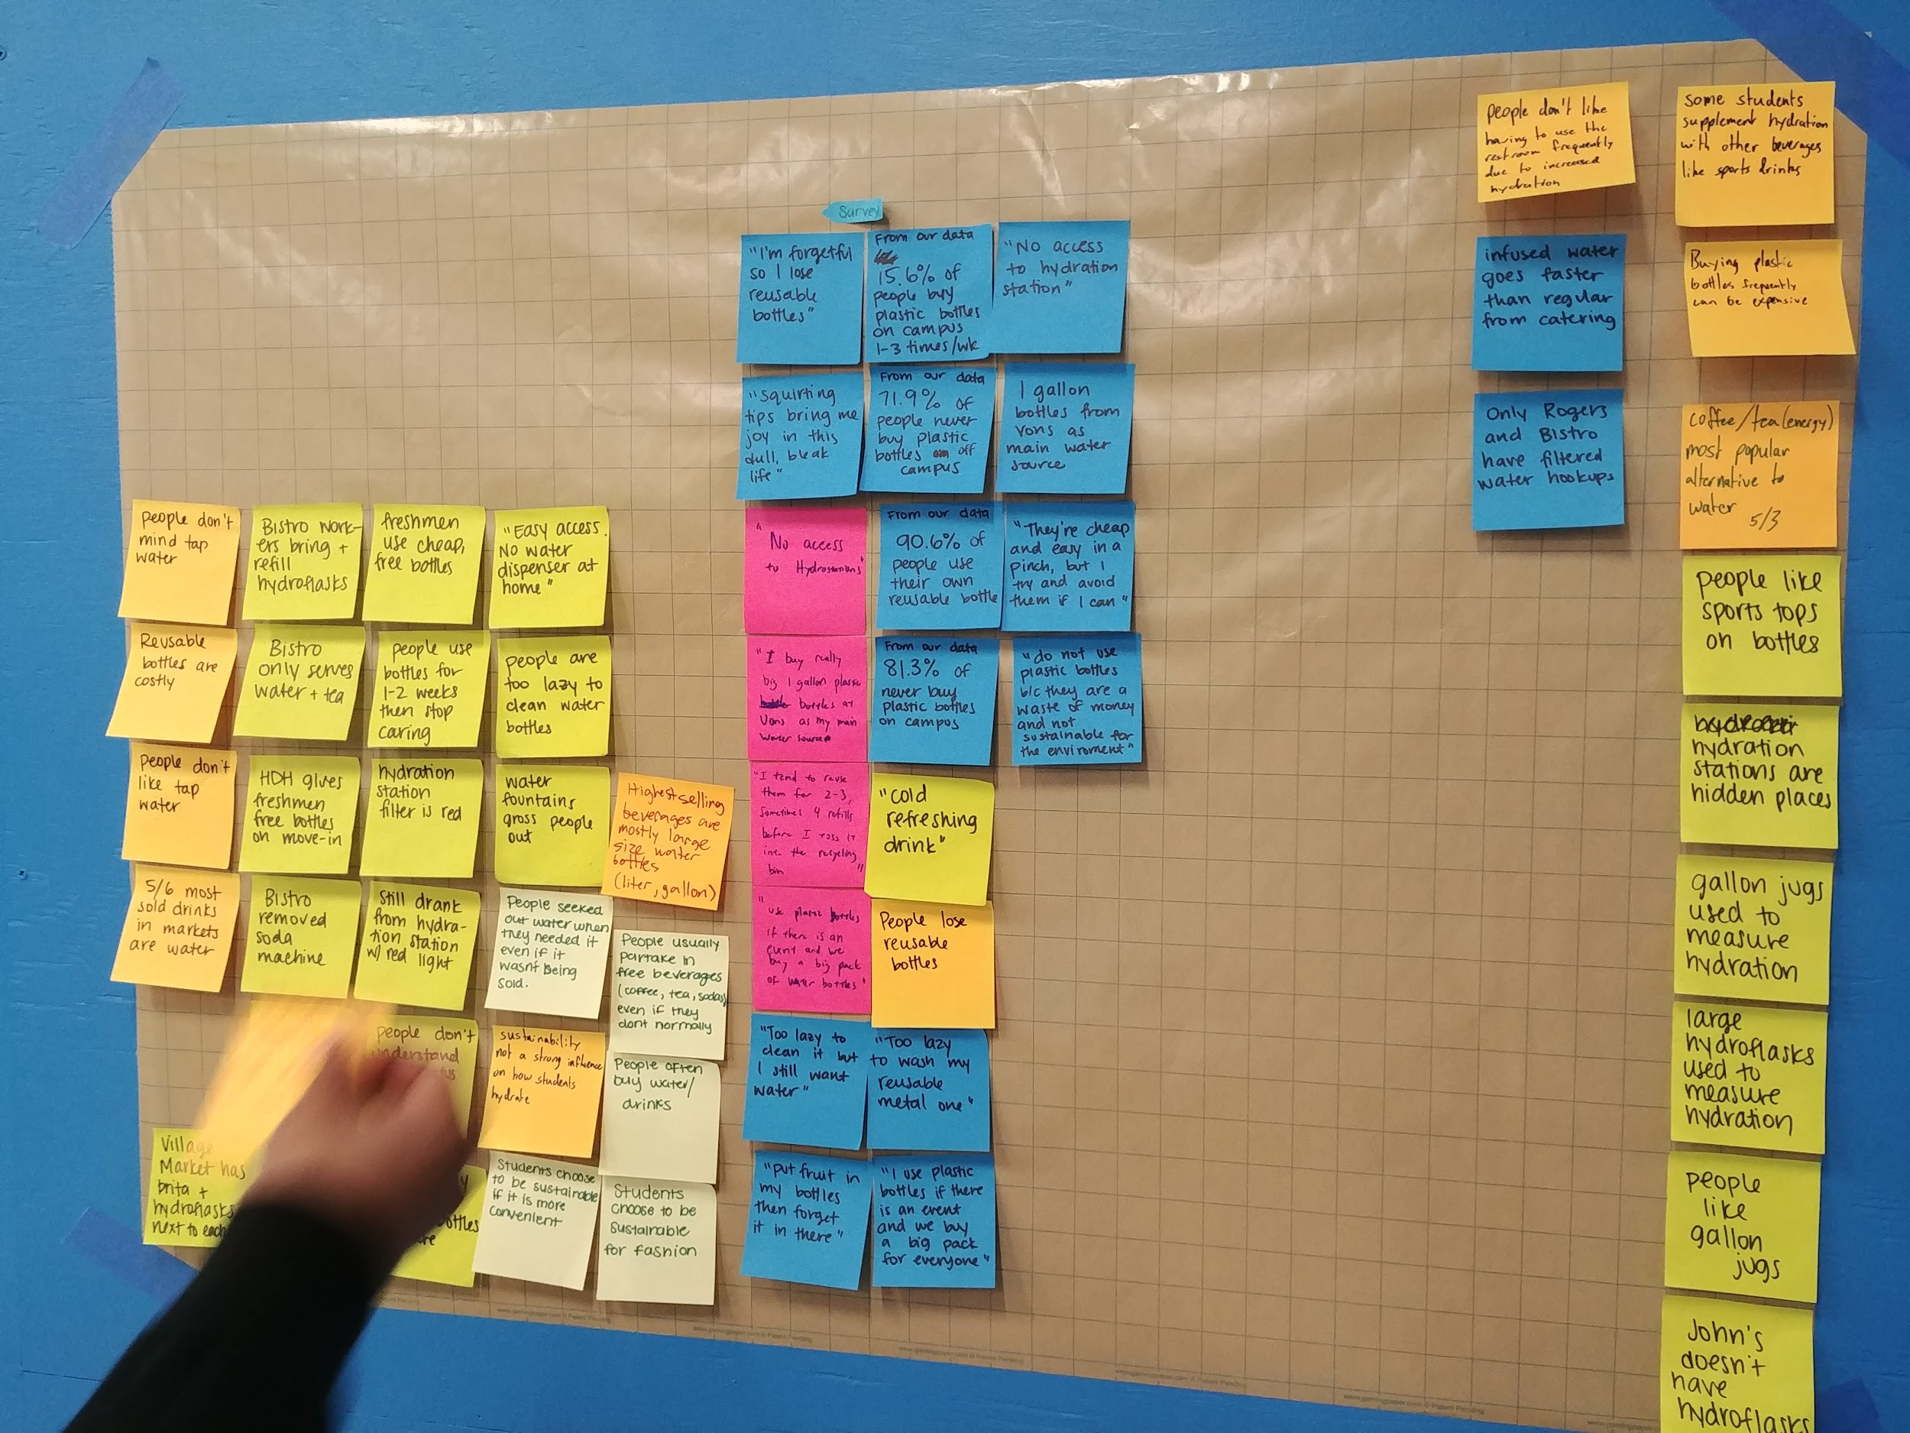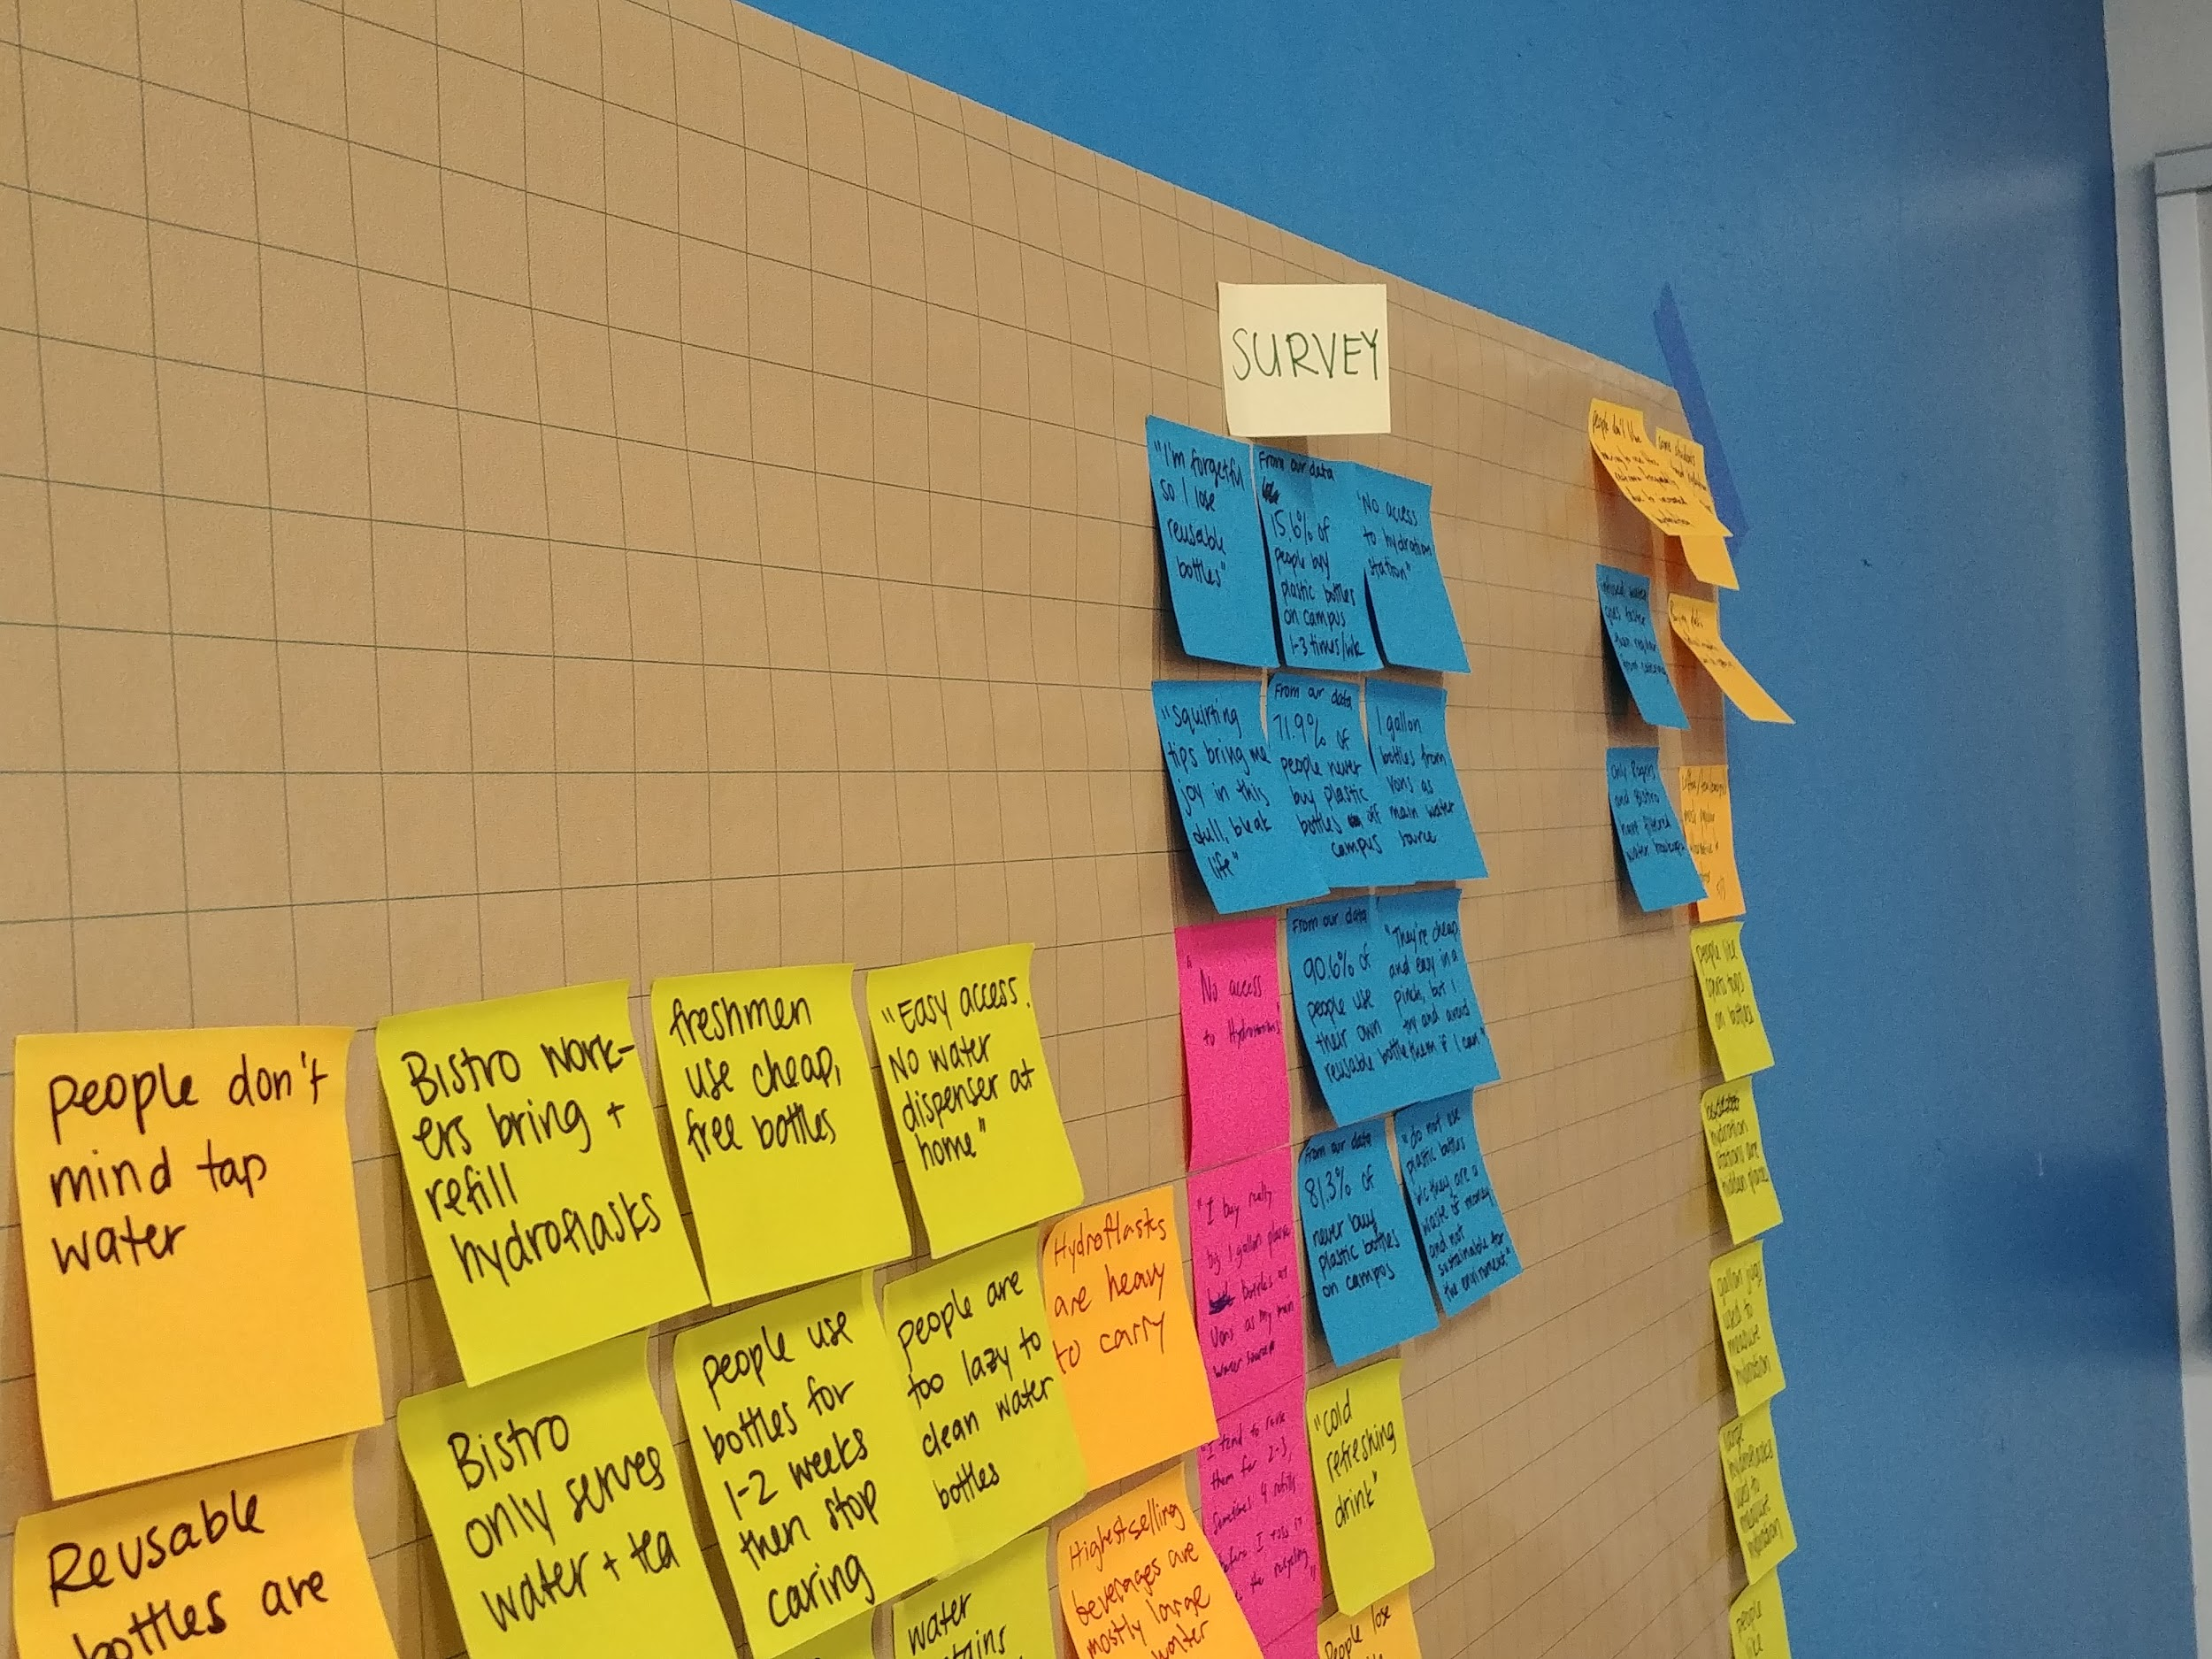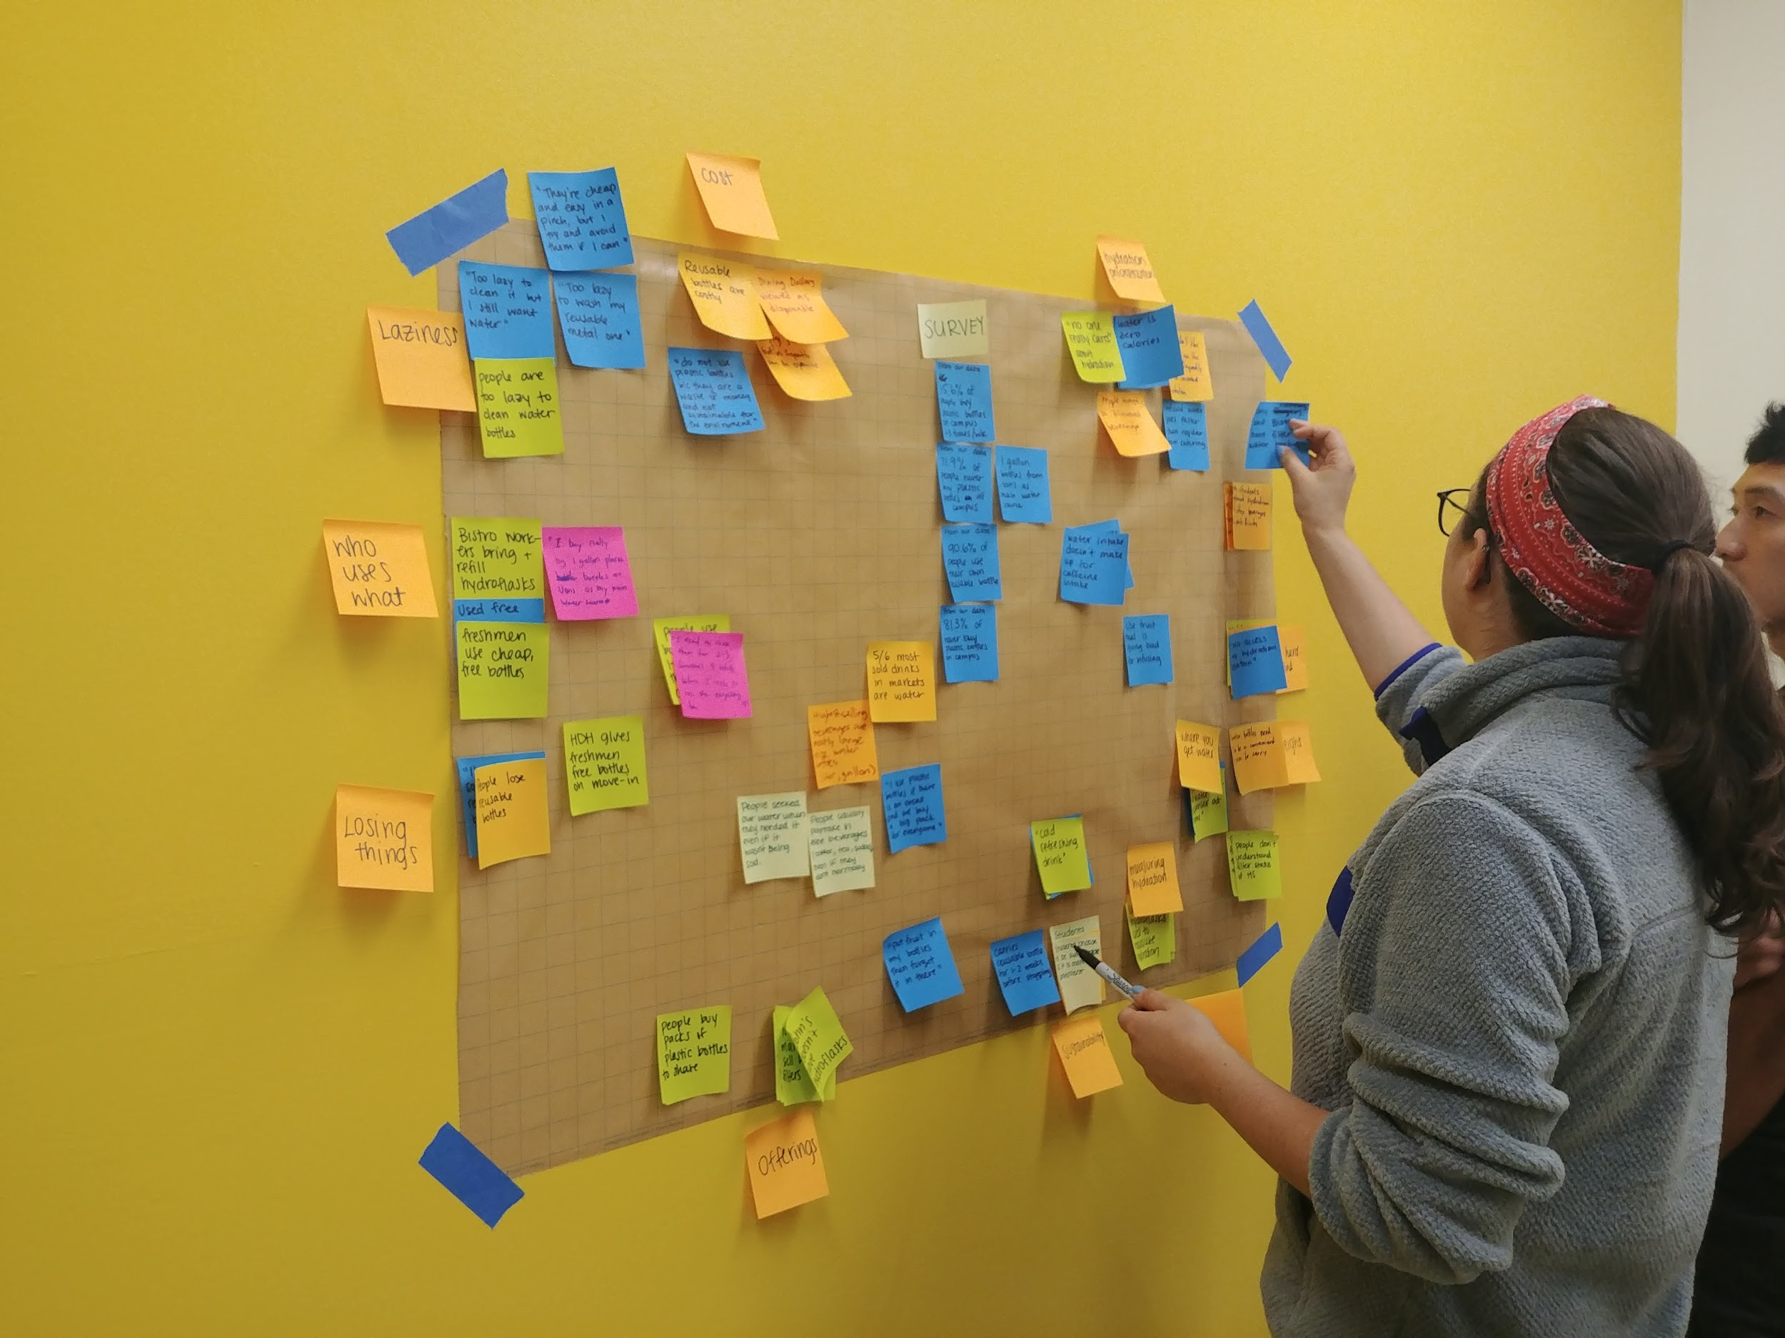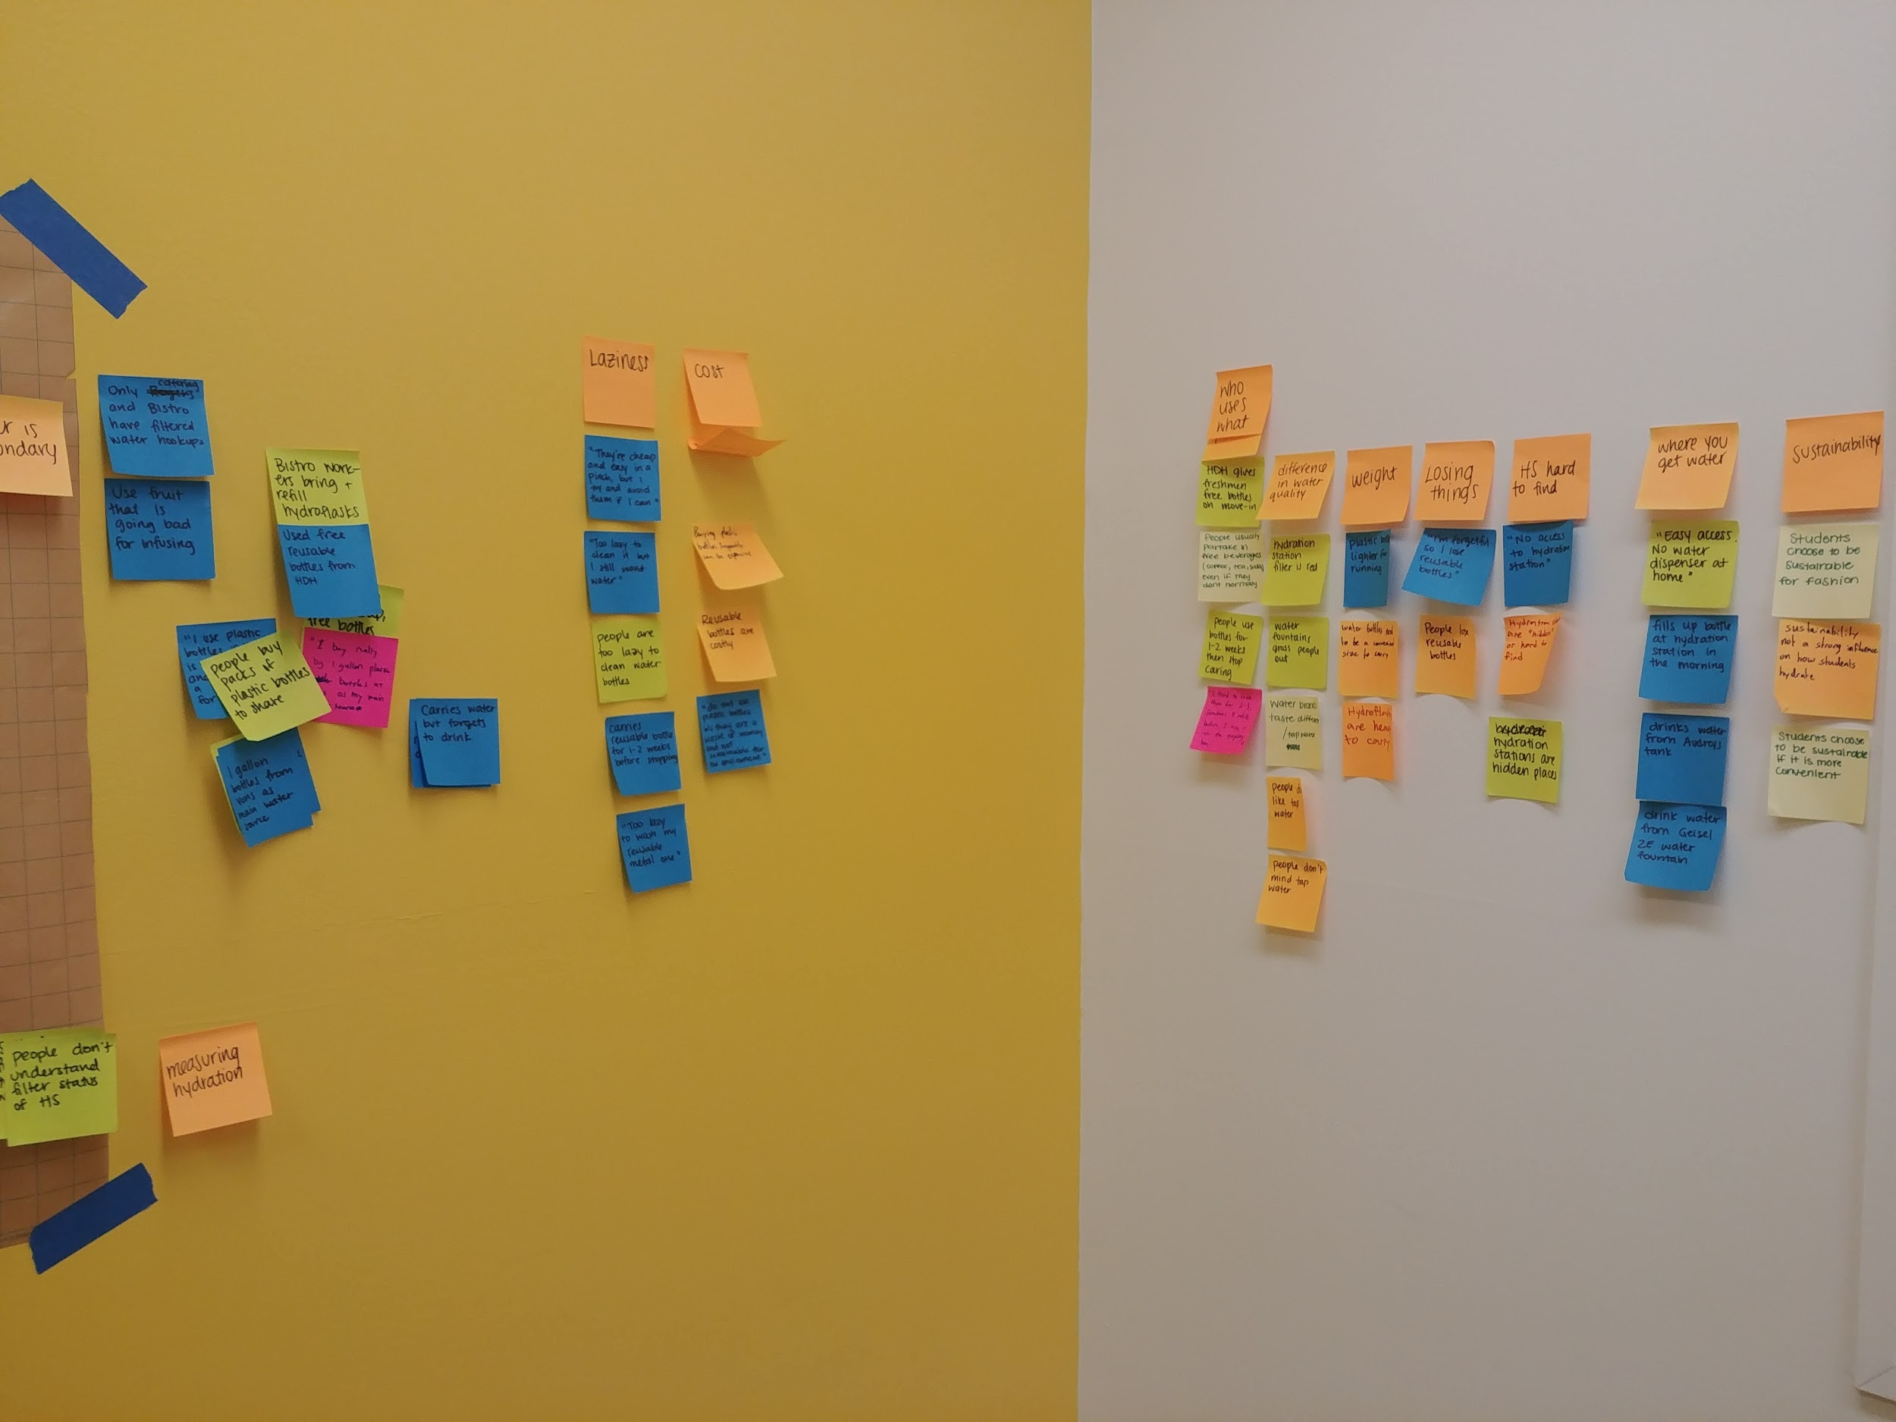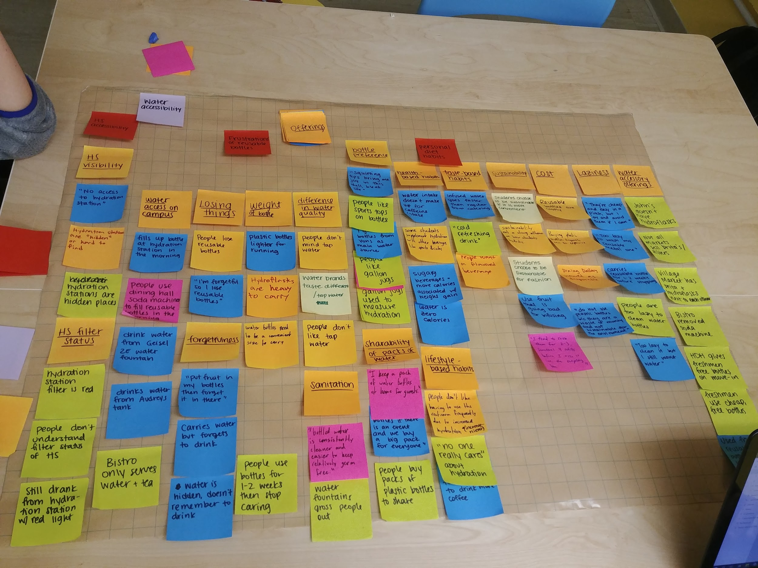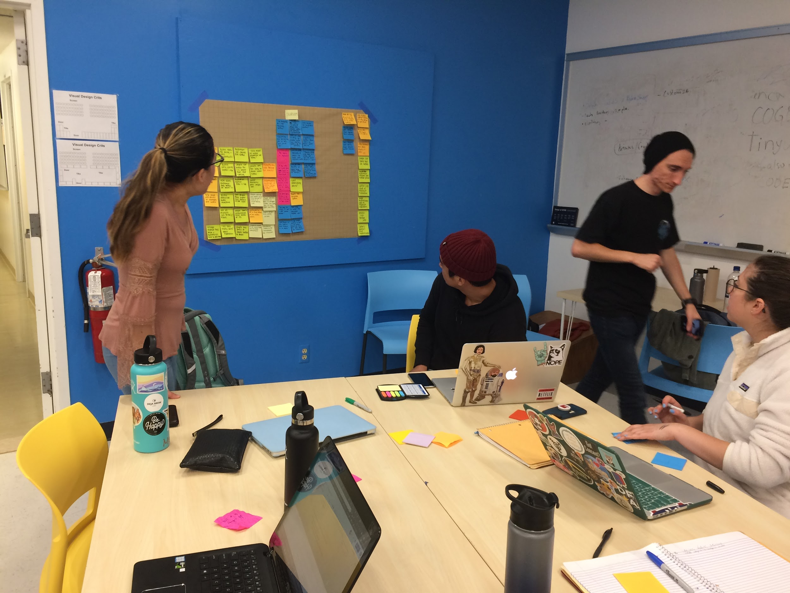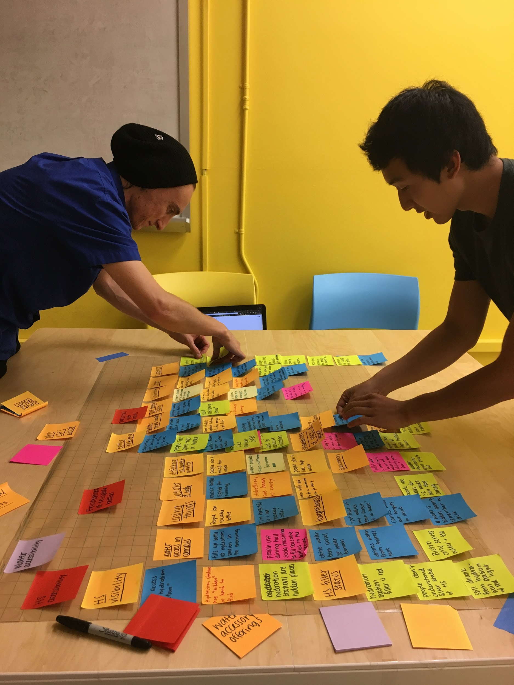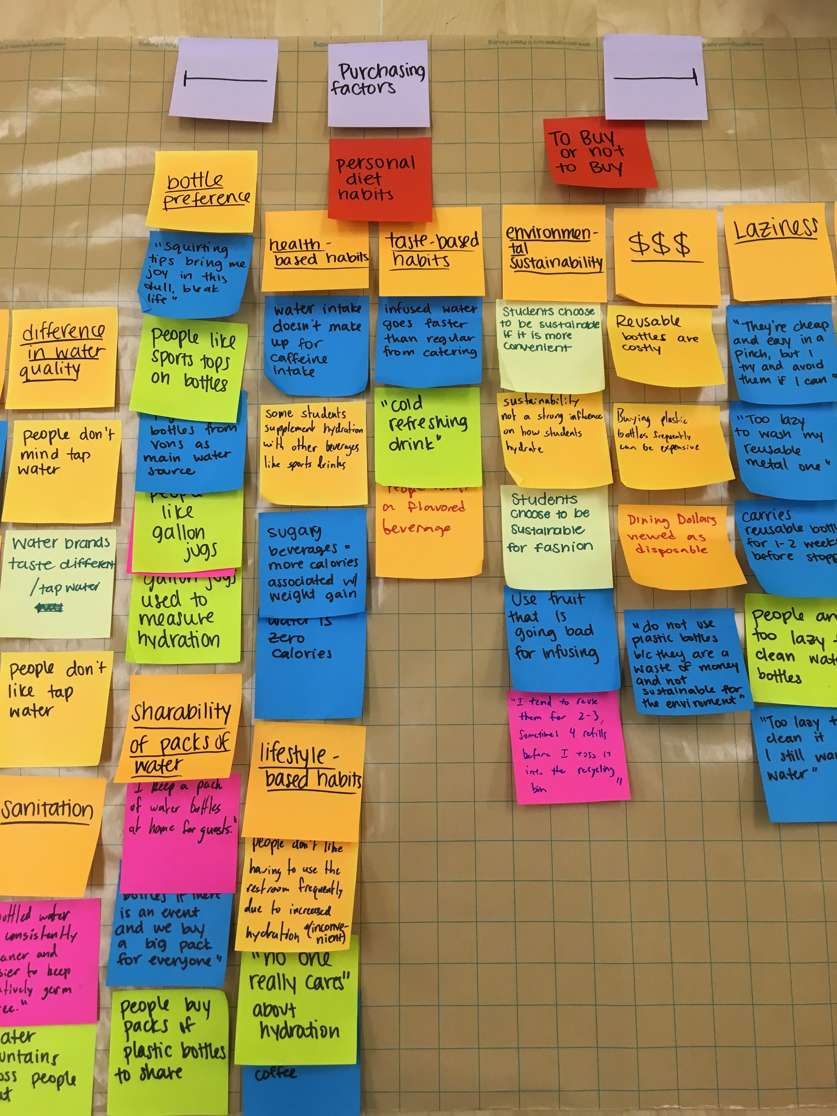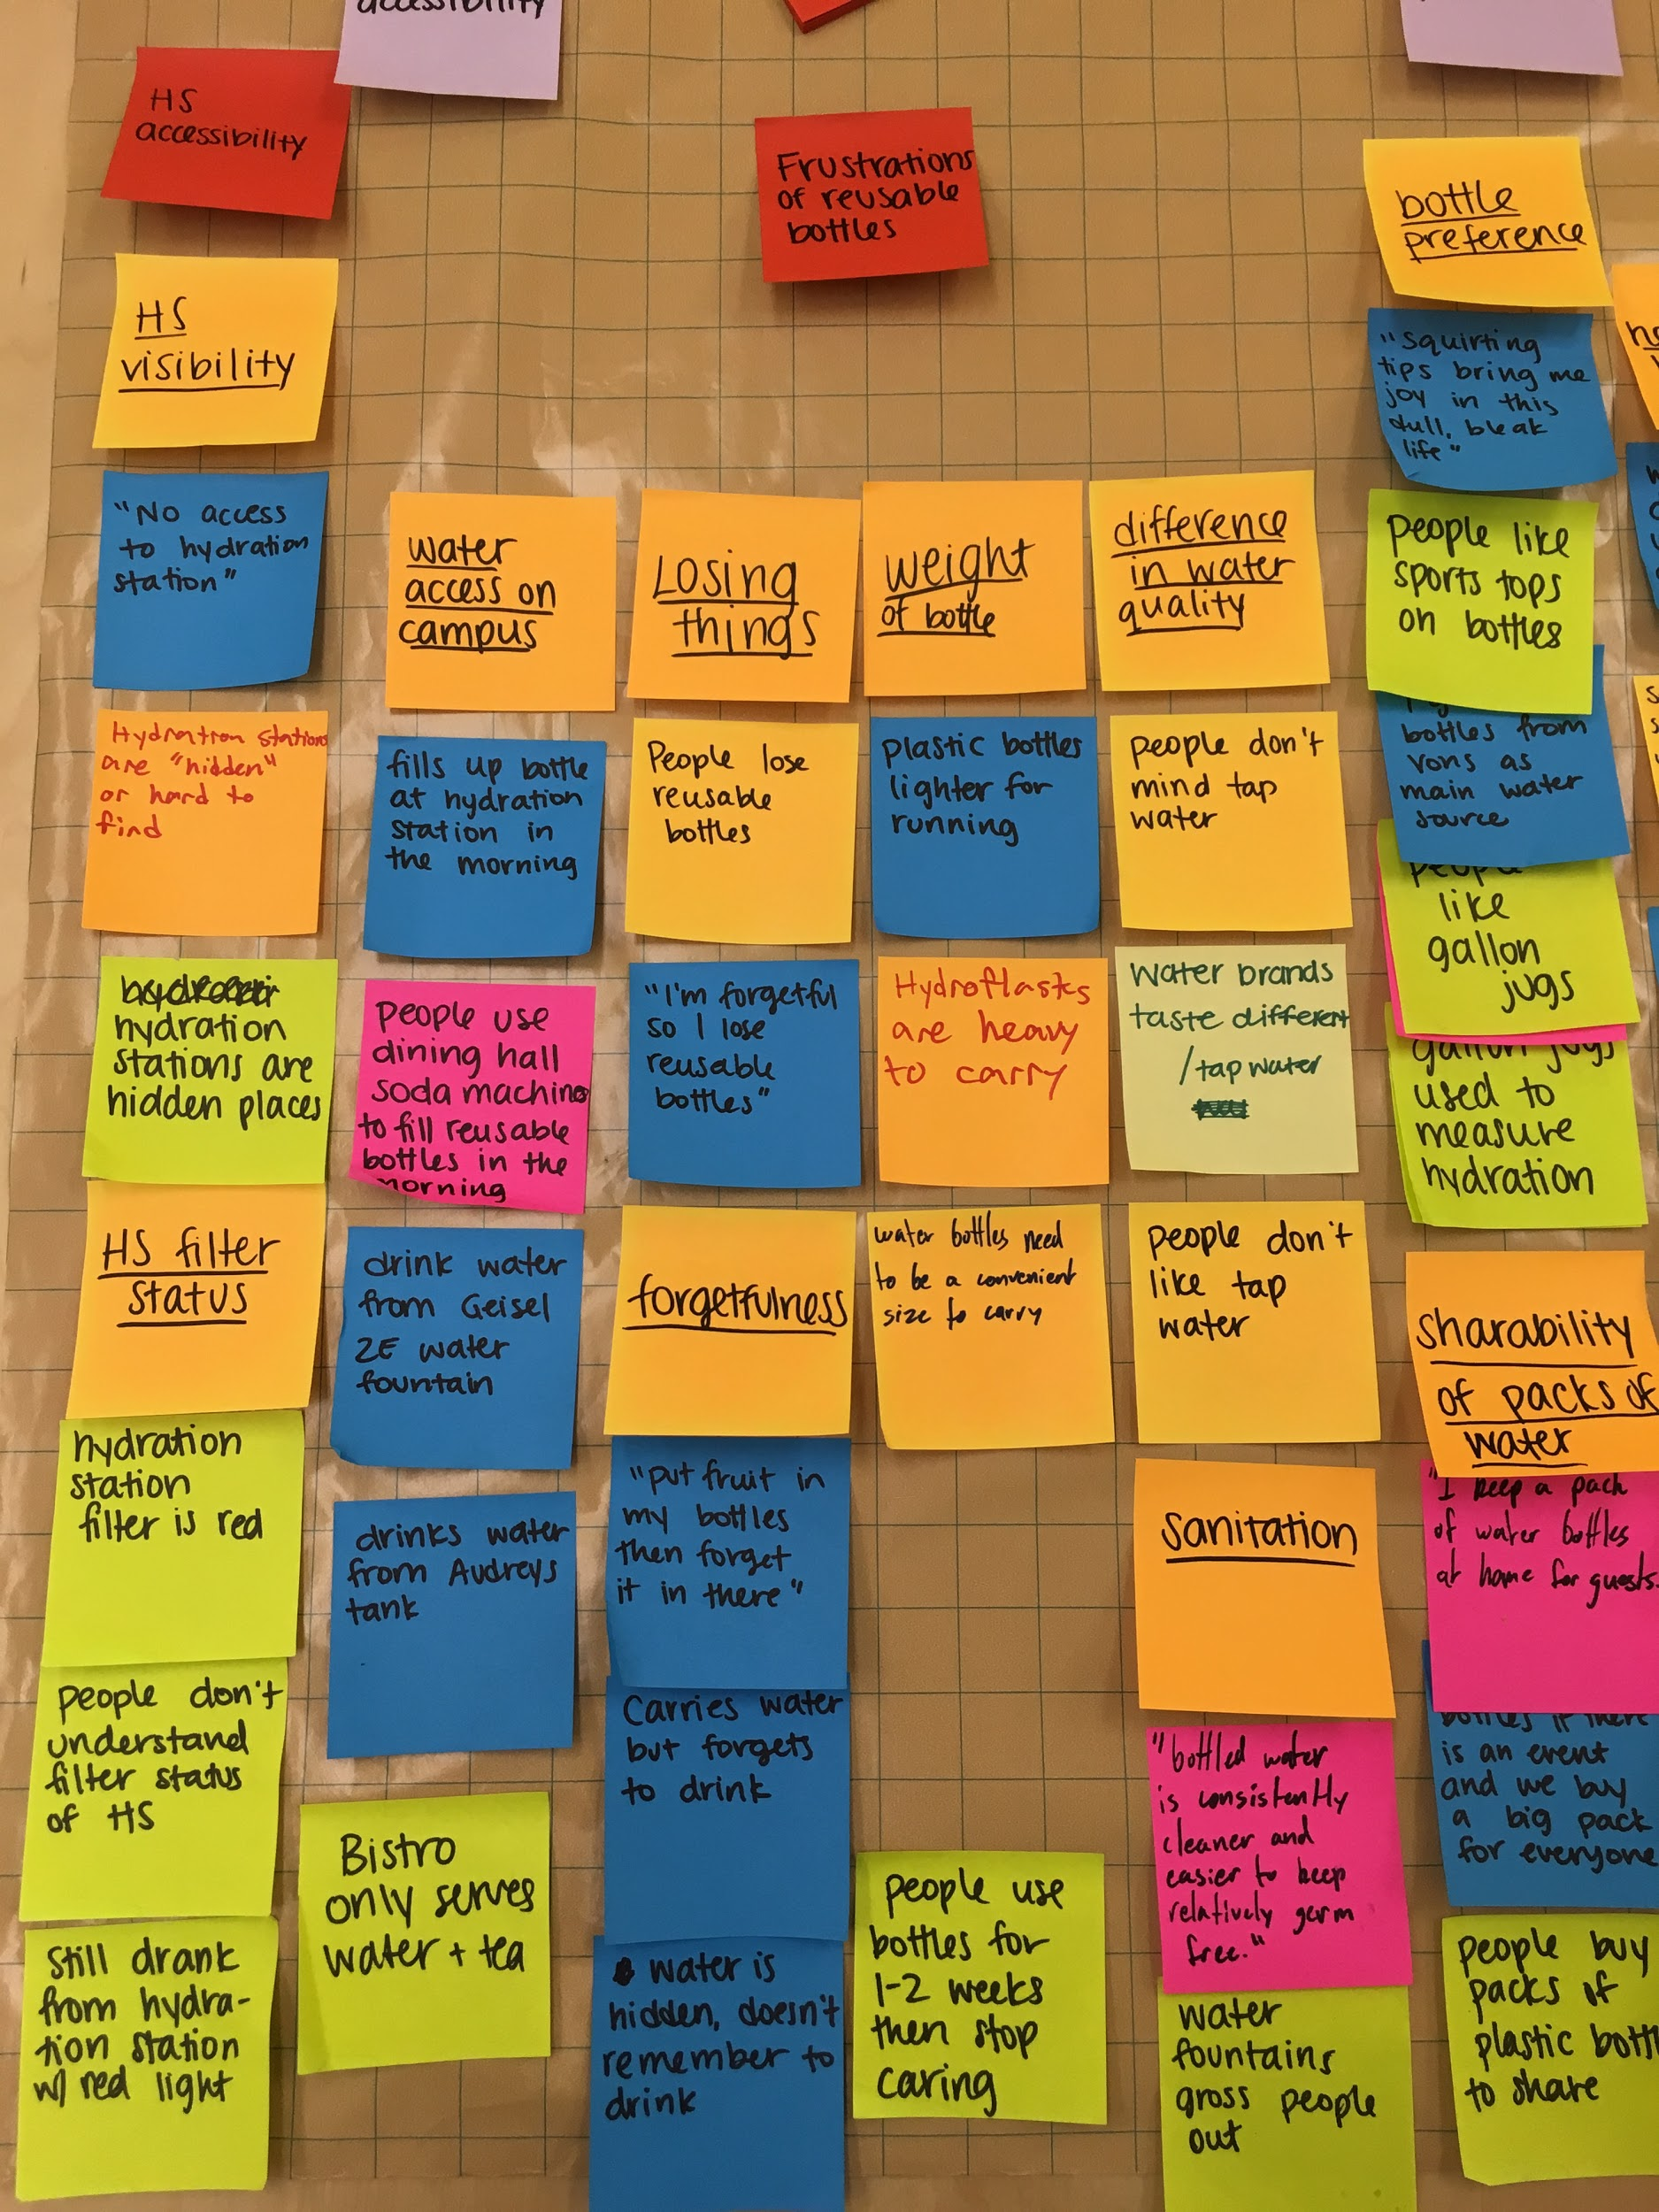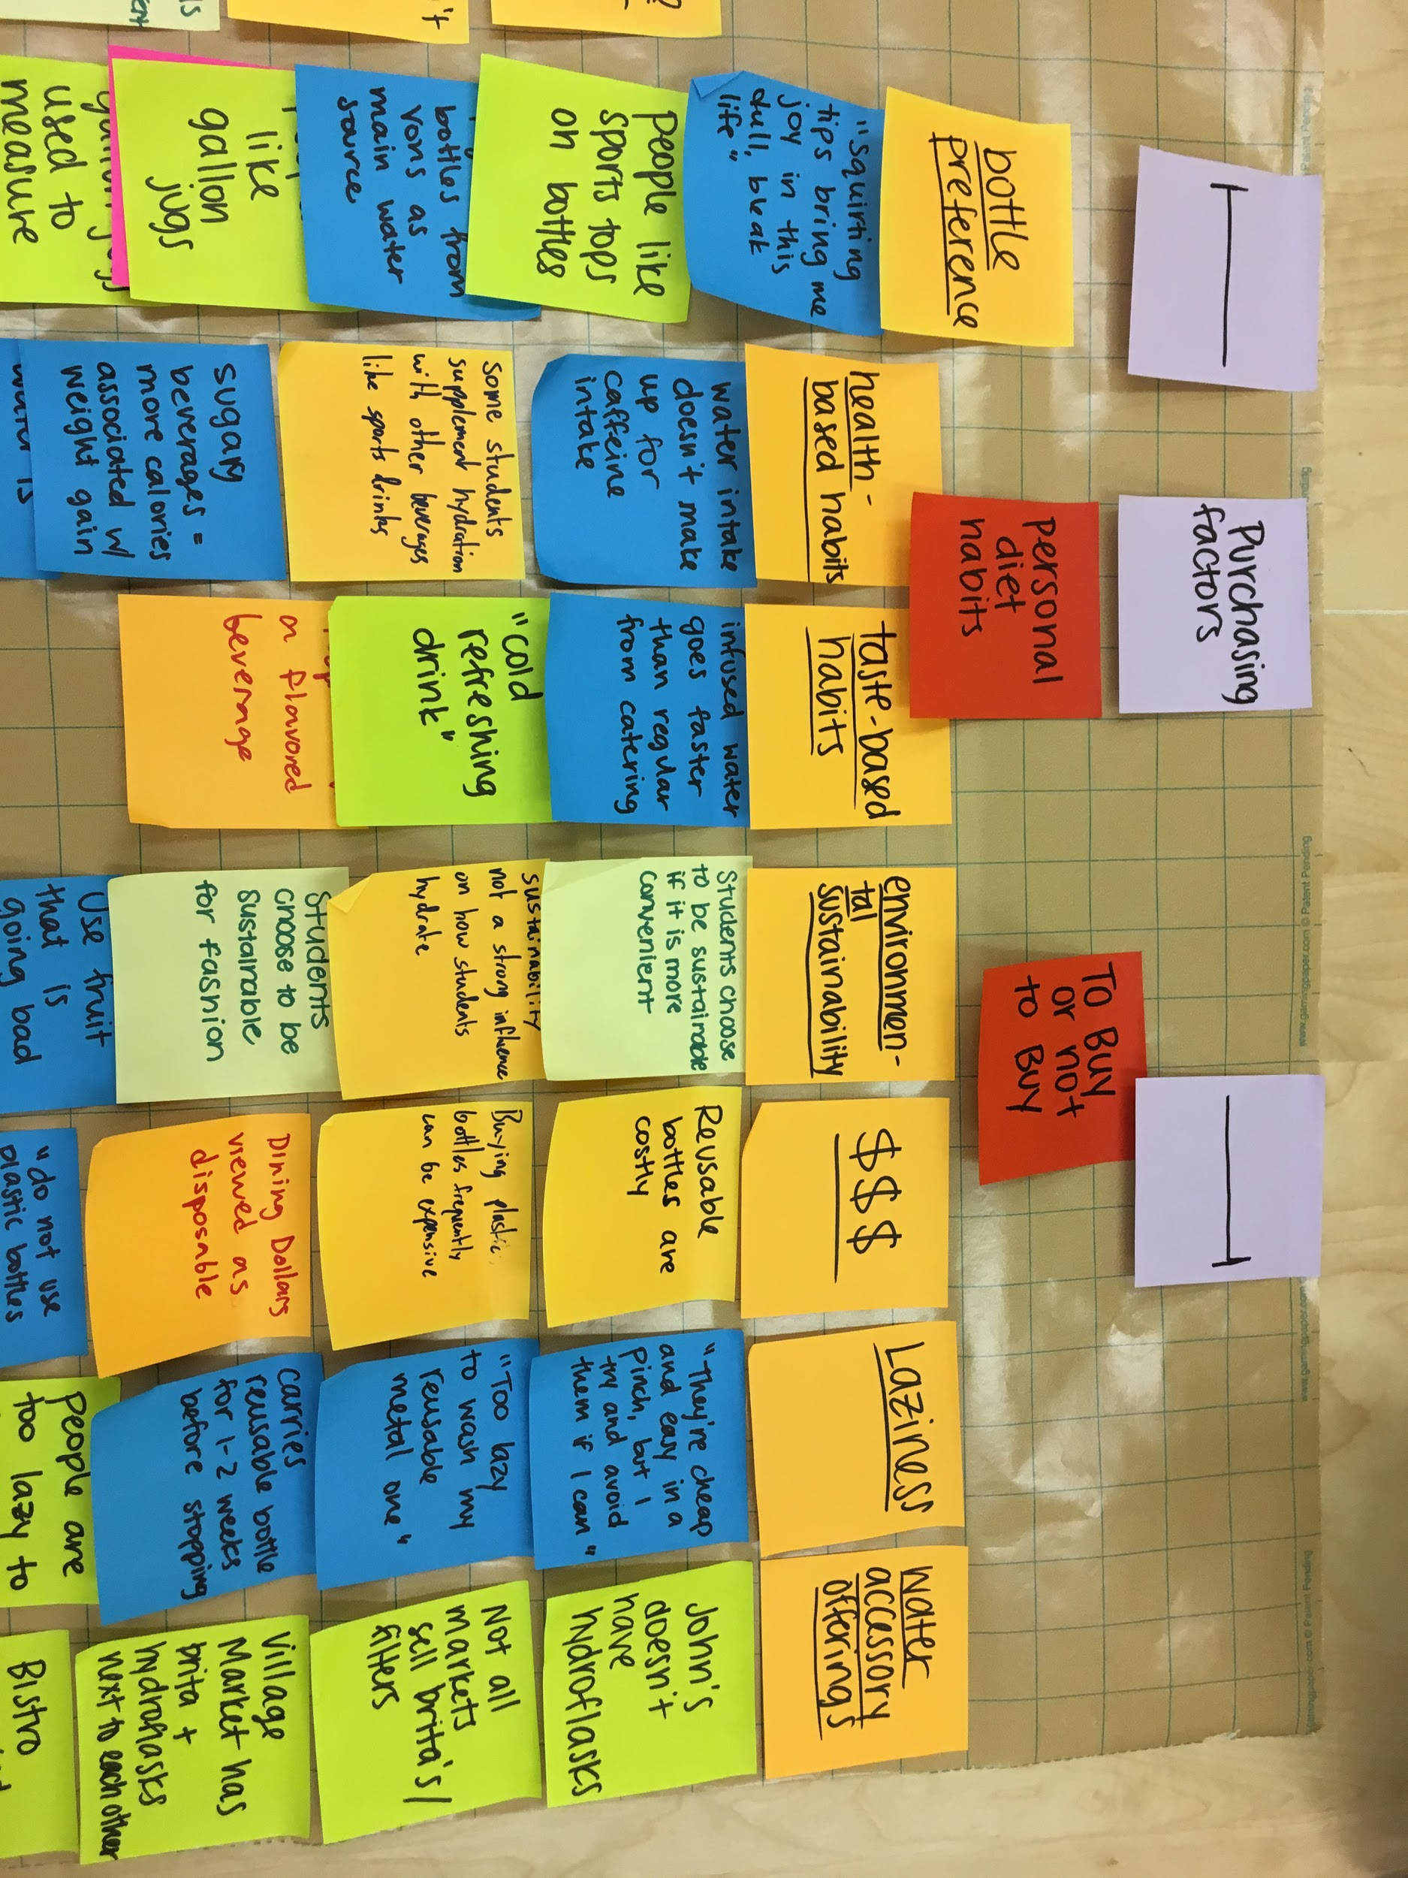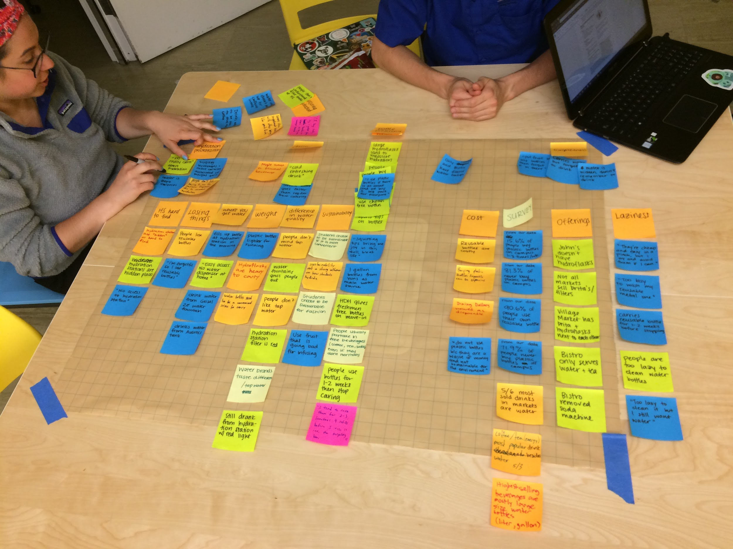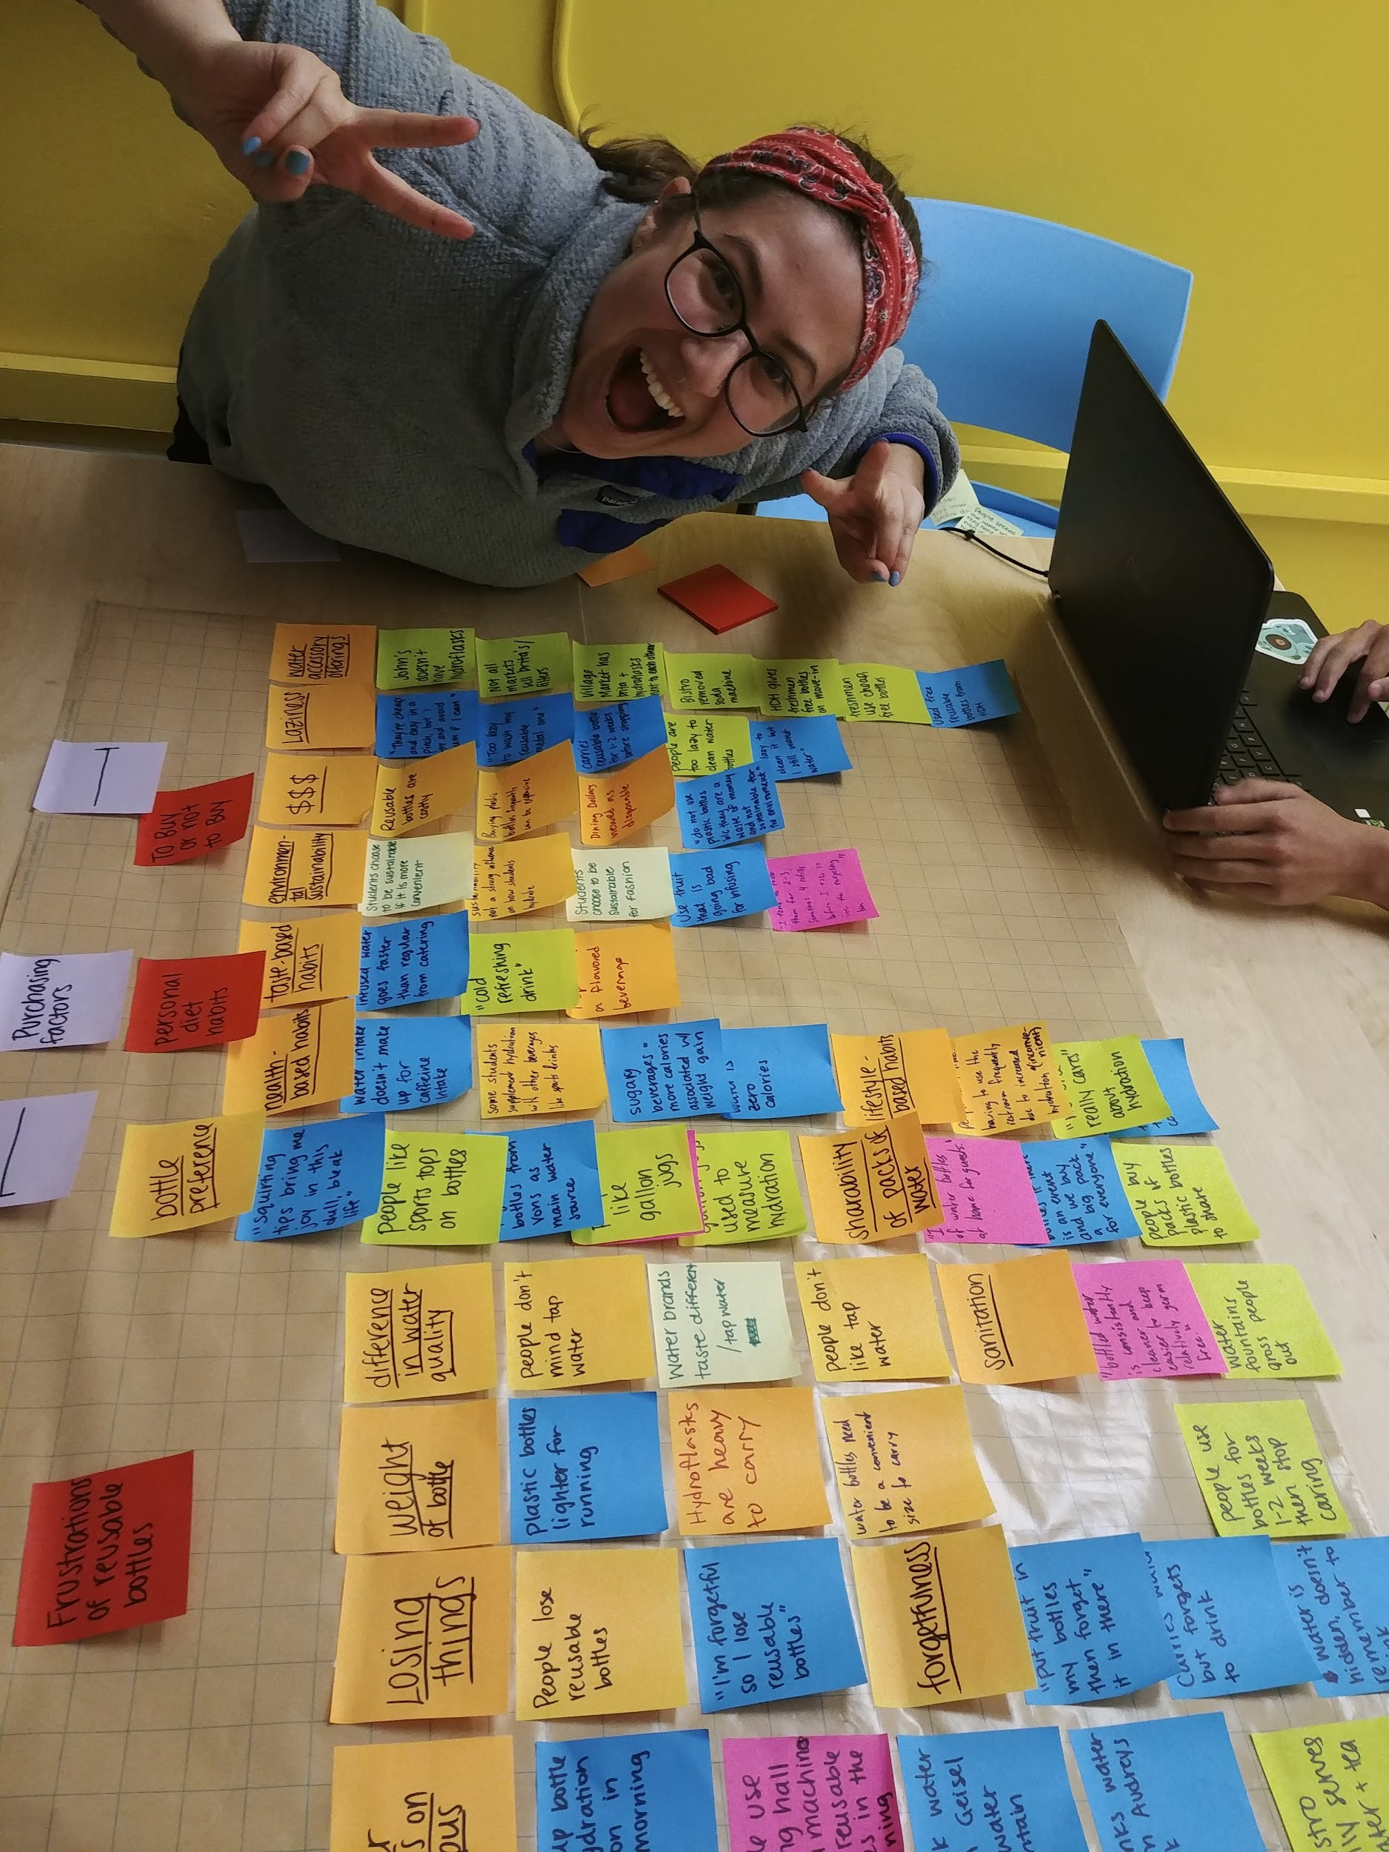



### 

### **Identity Model**

*Figure 14*

### Our model helped us understand the reasons students behave the way they do when it comes to hydrating and deciding to use disposable bottles or reusable bottles. We first made it on a blackboard, then made a virtual expanded version.

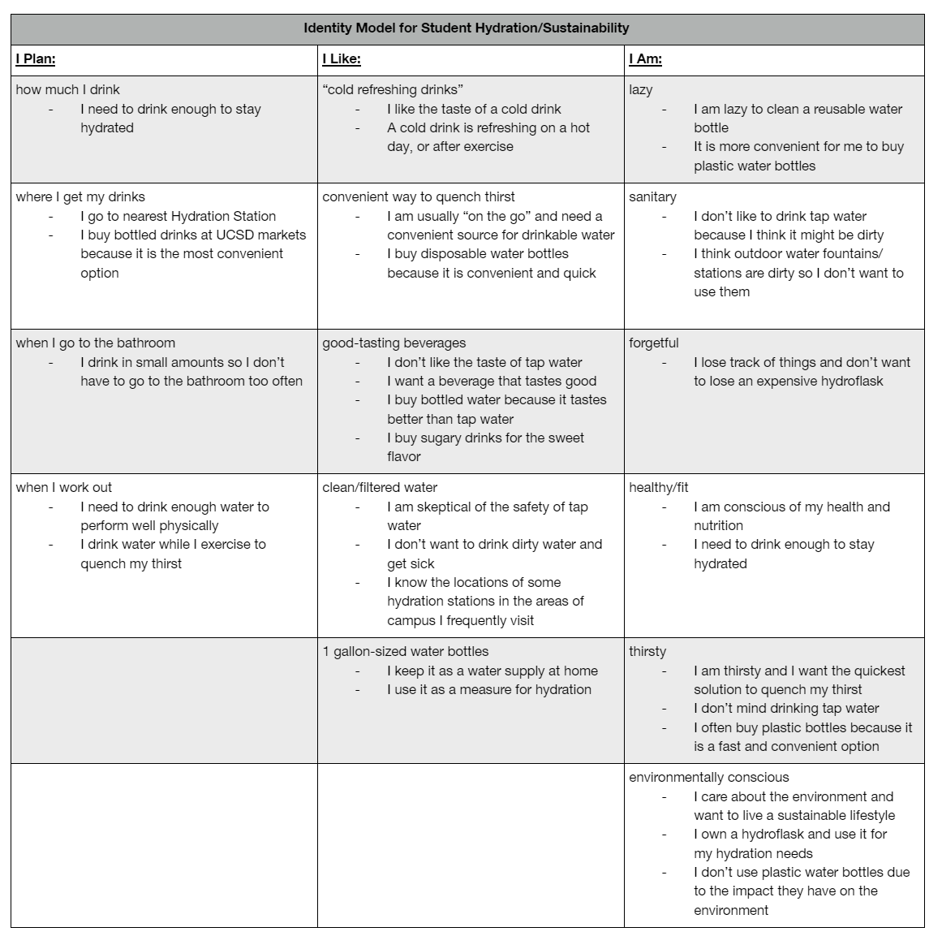

# 

# 

# 

# 

### **Sticker Prototyping**

*Figures 15.1-15.14*

Pictured below are our team’s sticker design ideas. We provided free stickers during the second week of our pilot-program as an incentive for students to use our water towers and provide feedback through our surveys



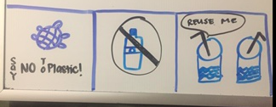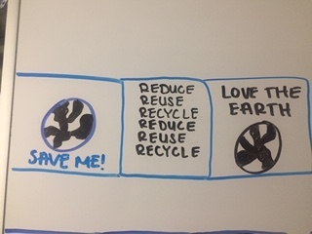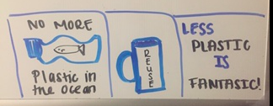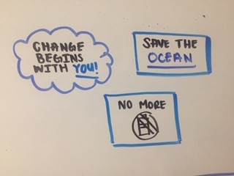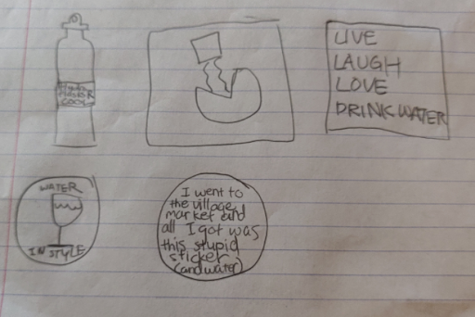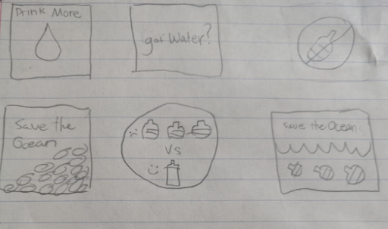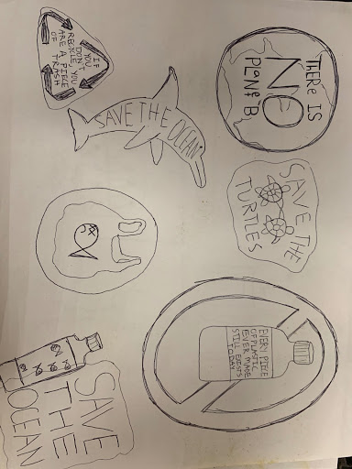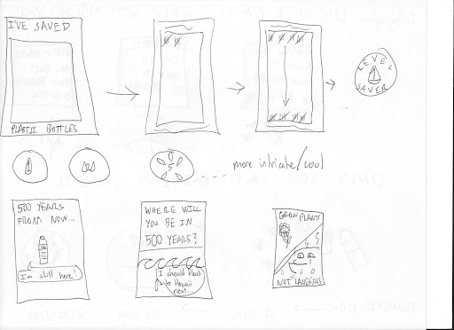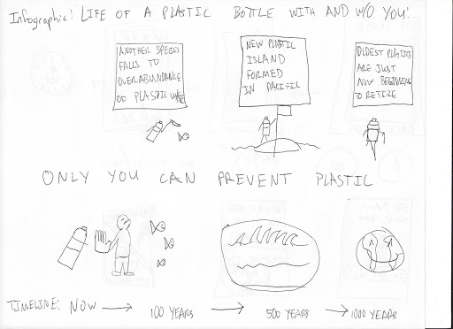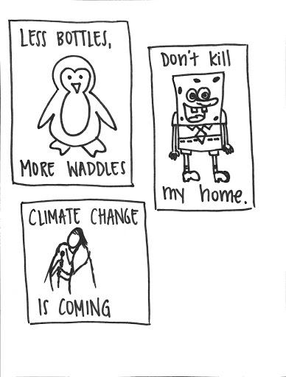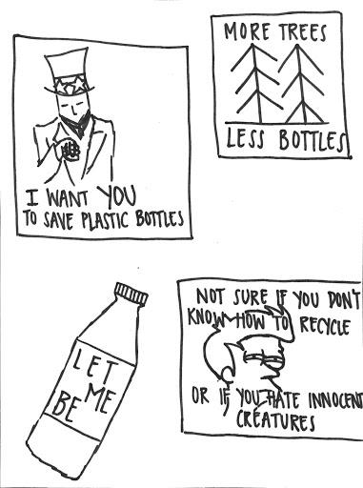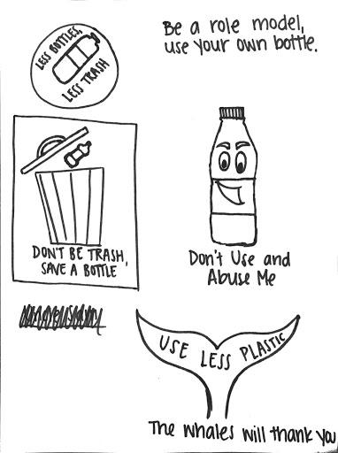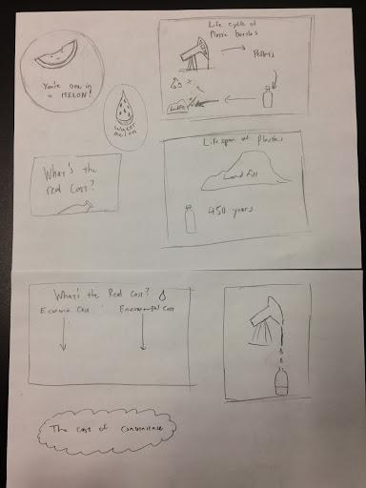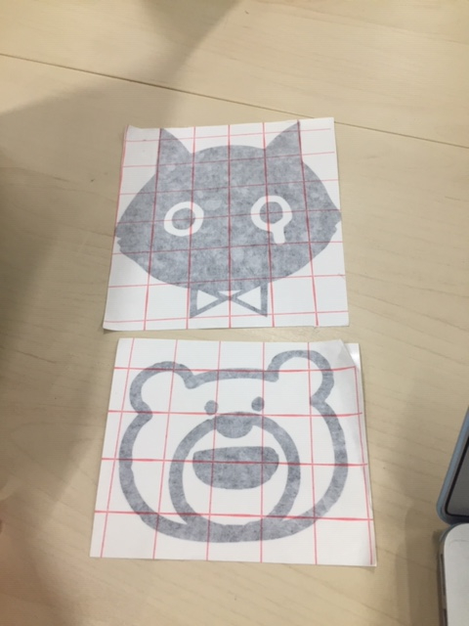

# Pilot-program

## Photos

The photos below show our design prototype and how it evolved over the 2-week testing period. Teammates are pictured collecting field data and observations

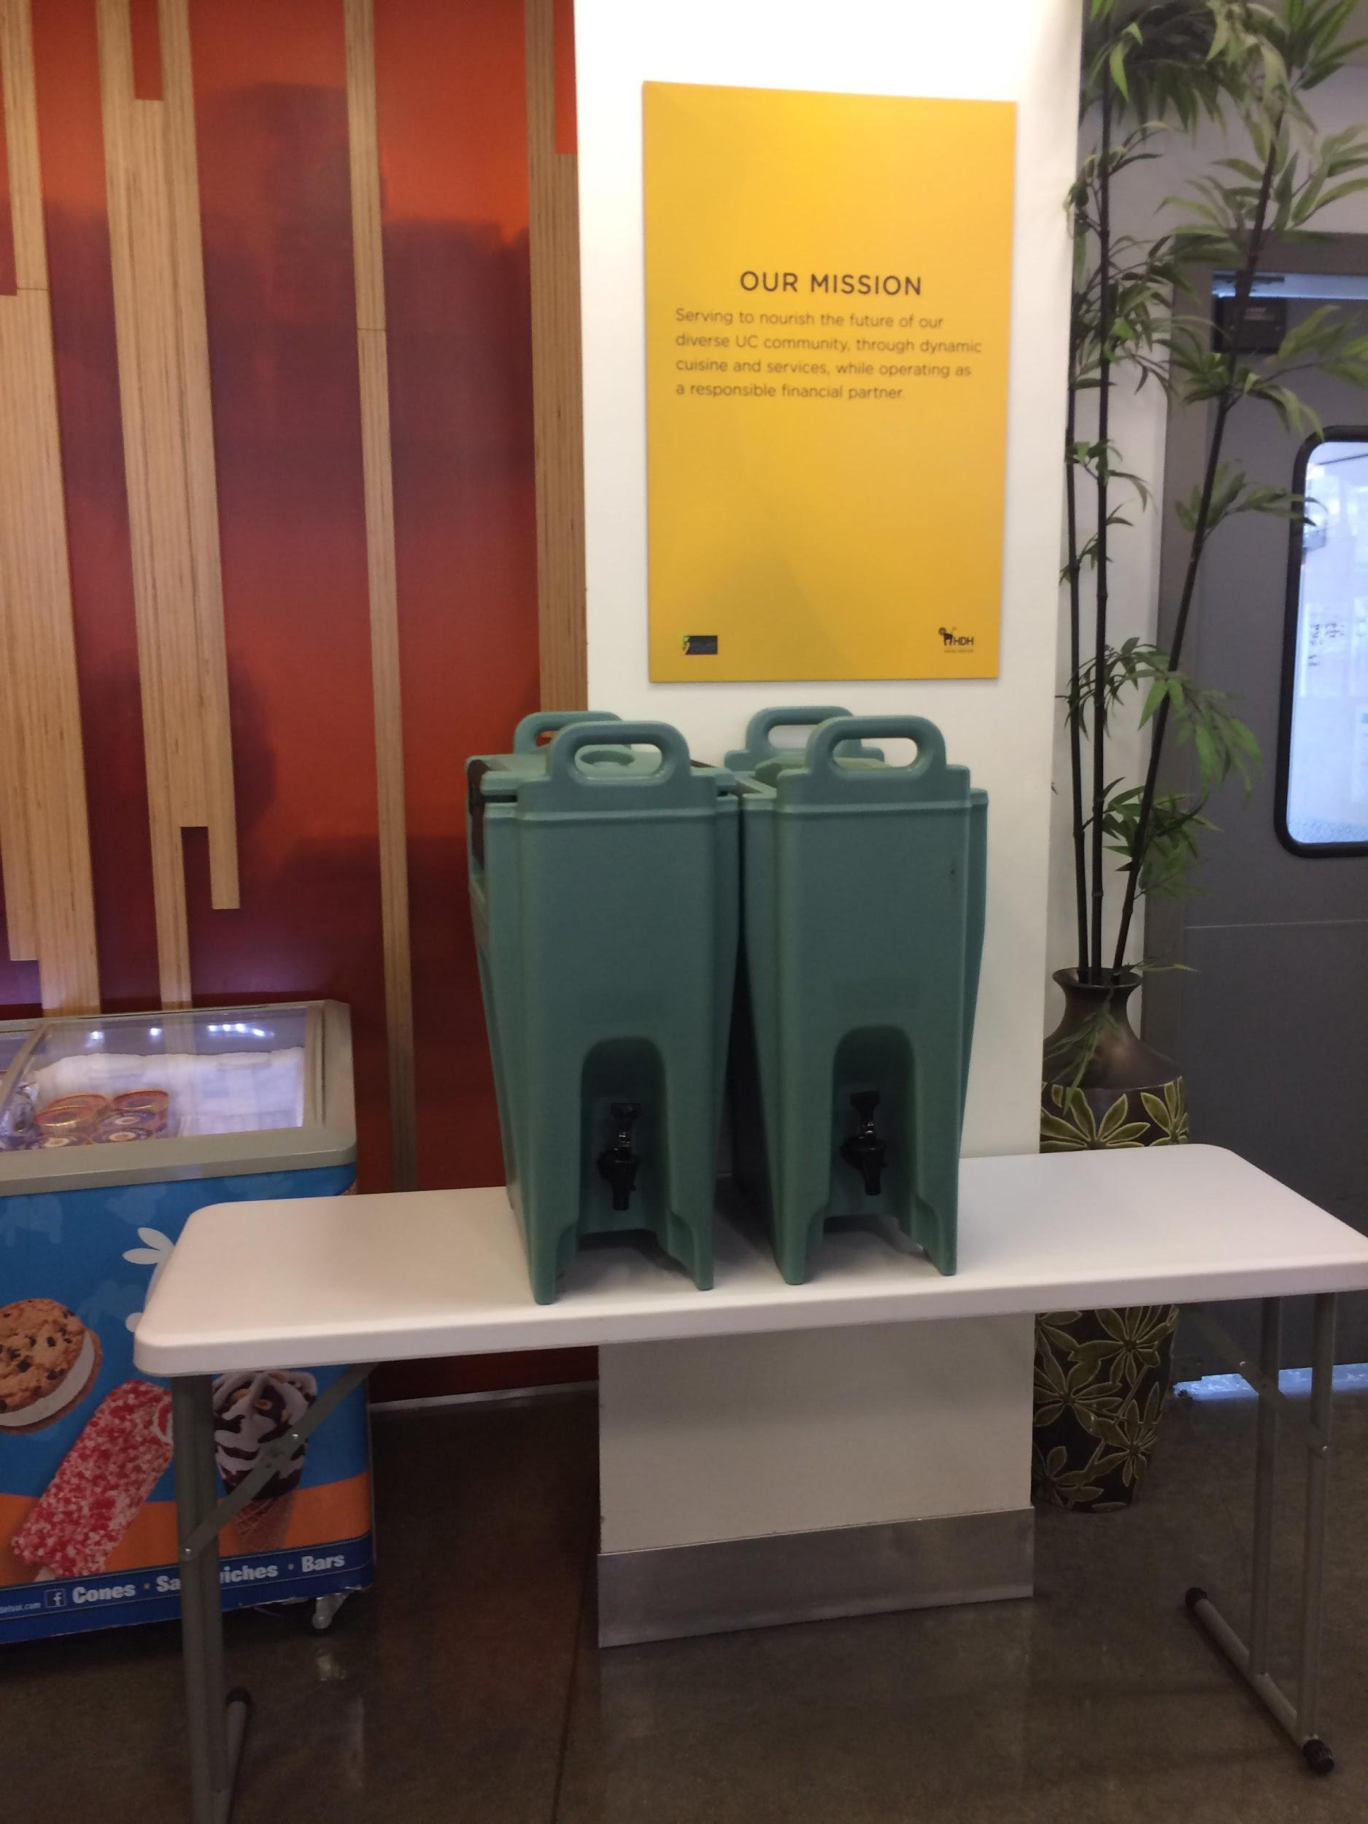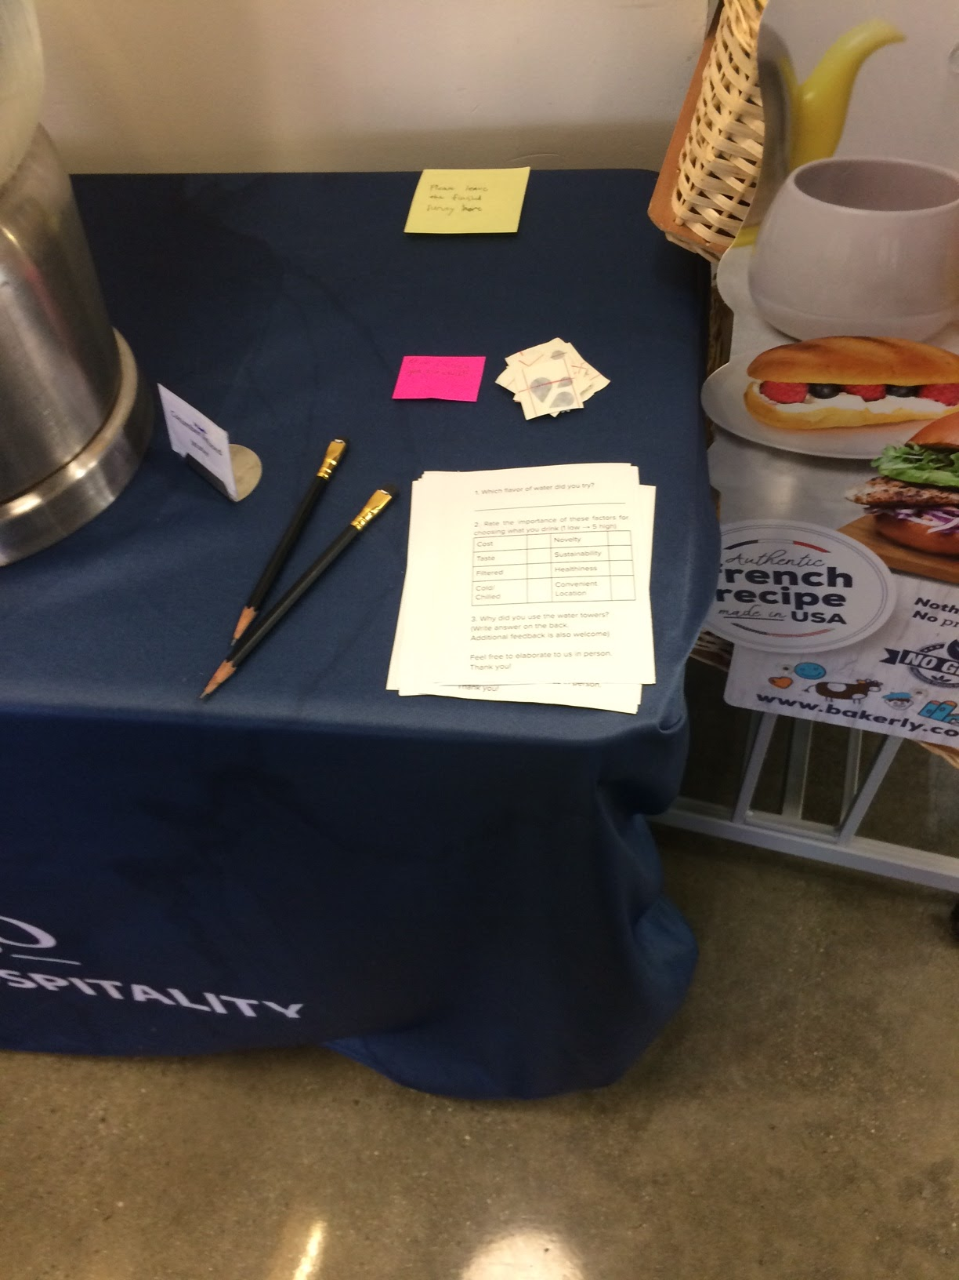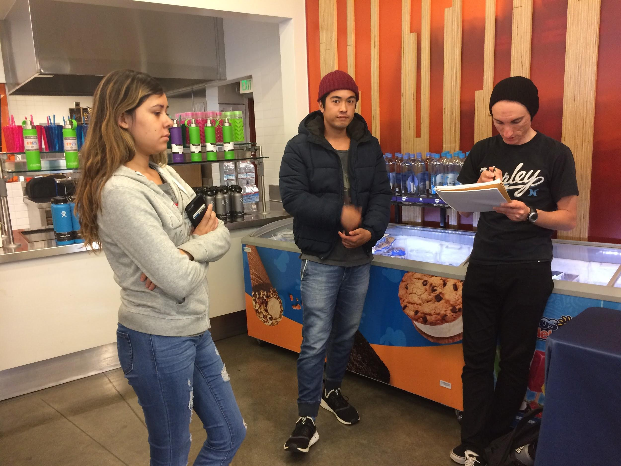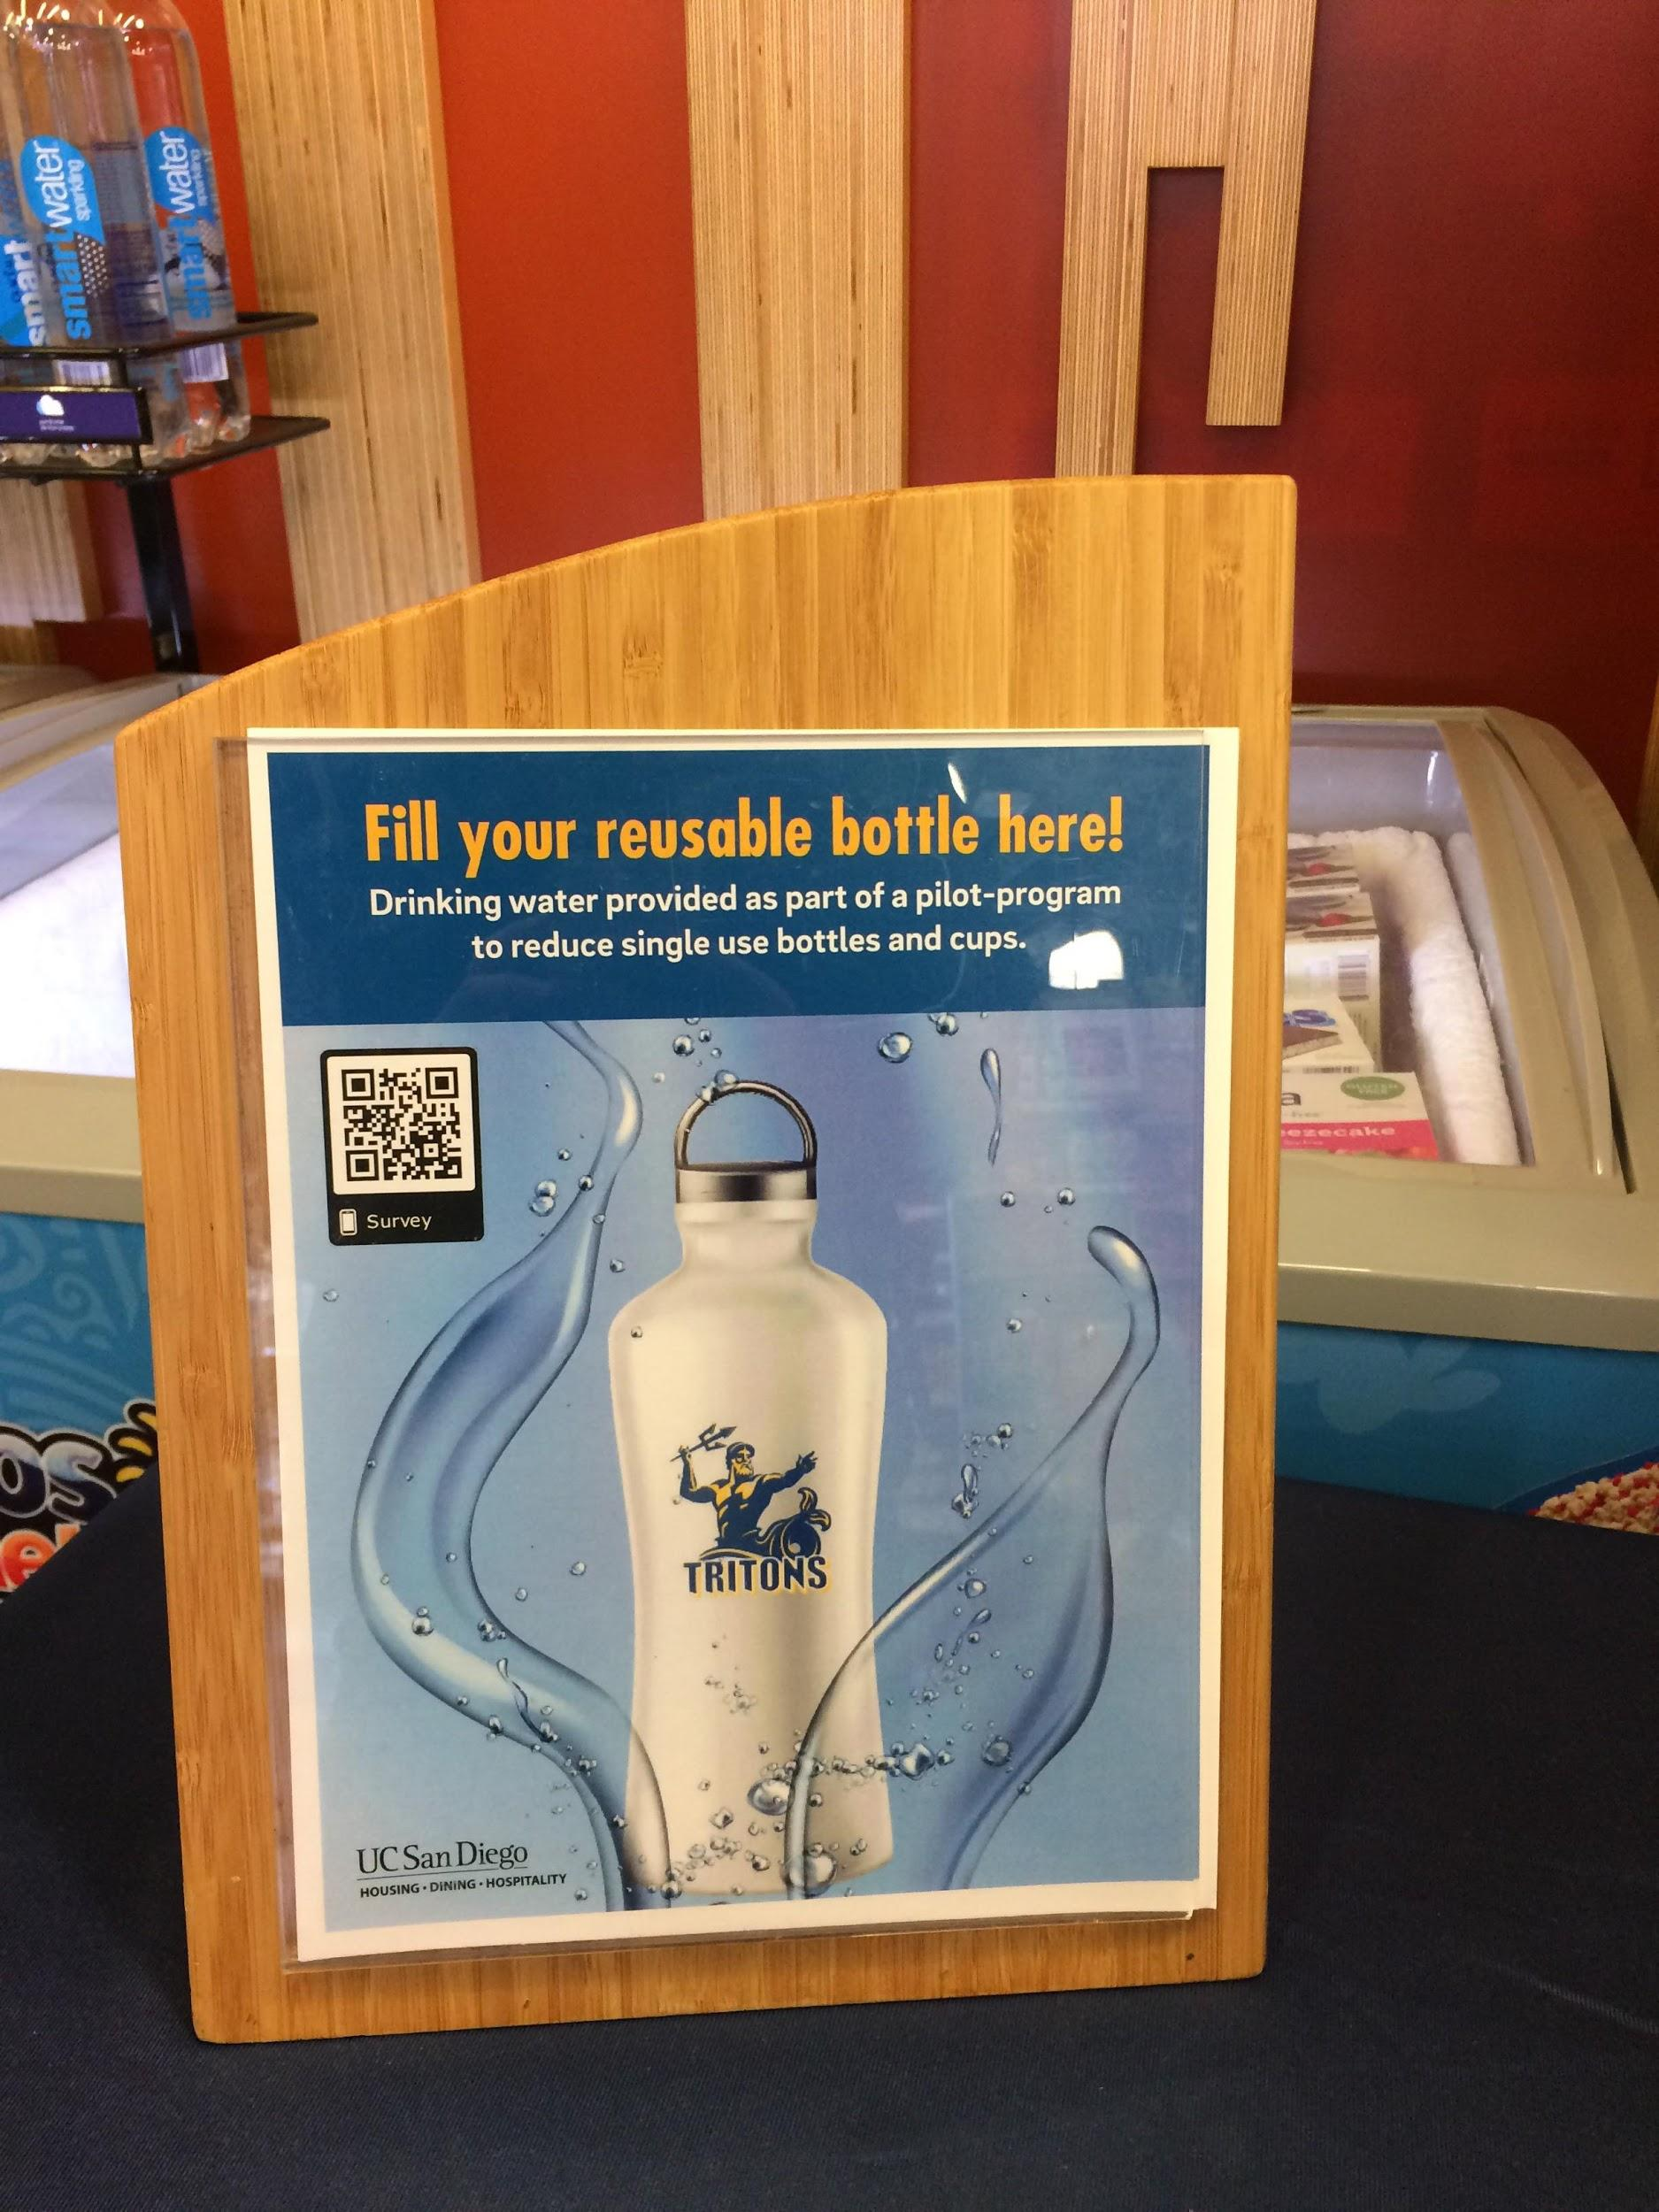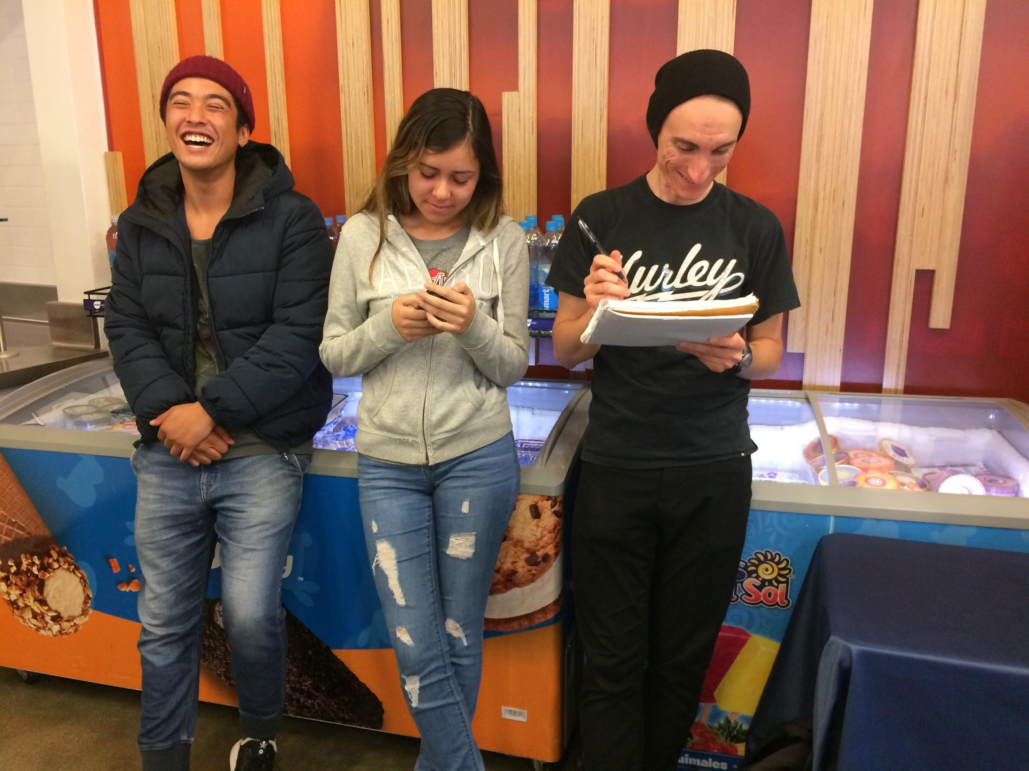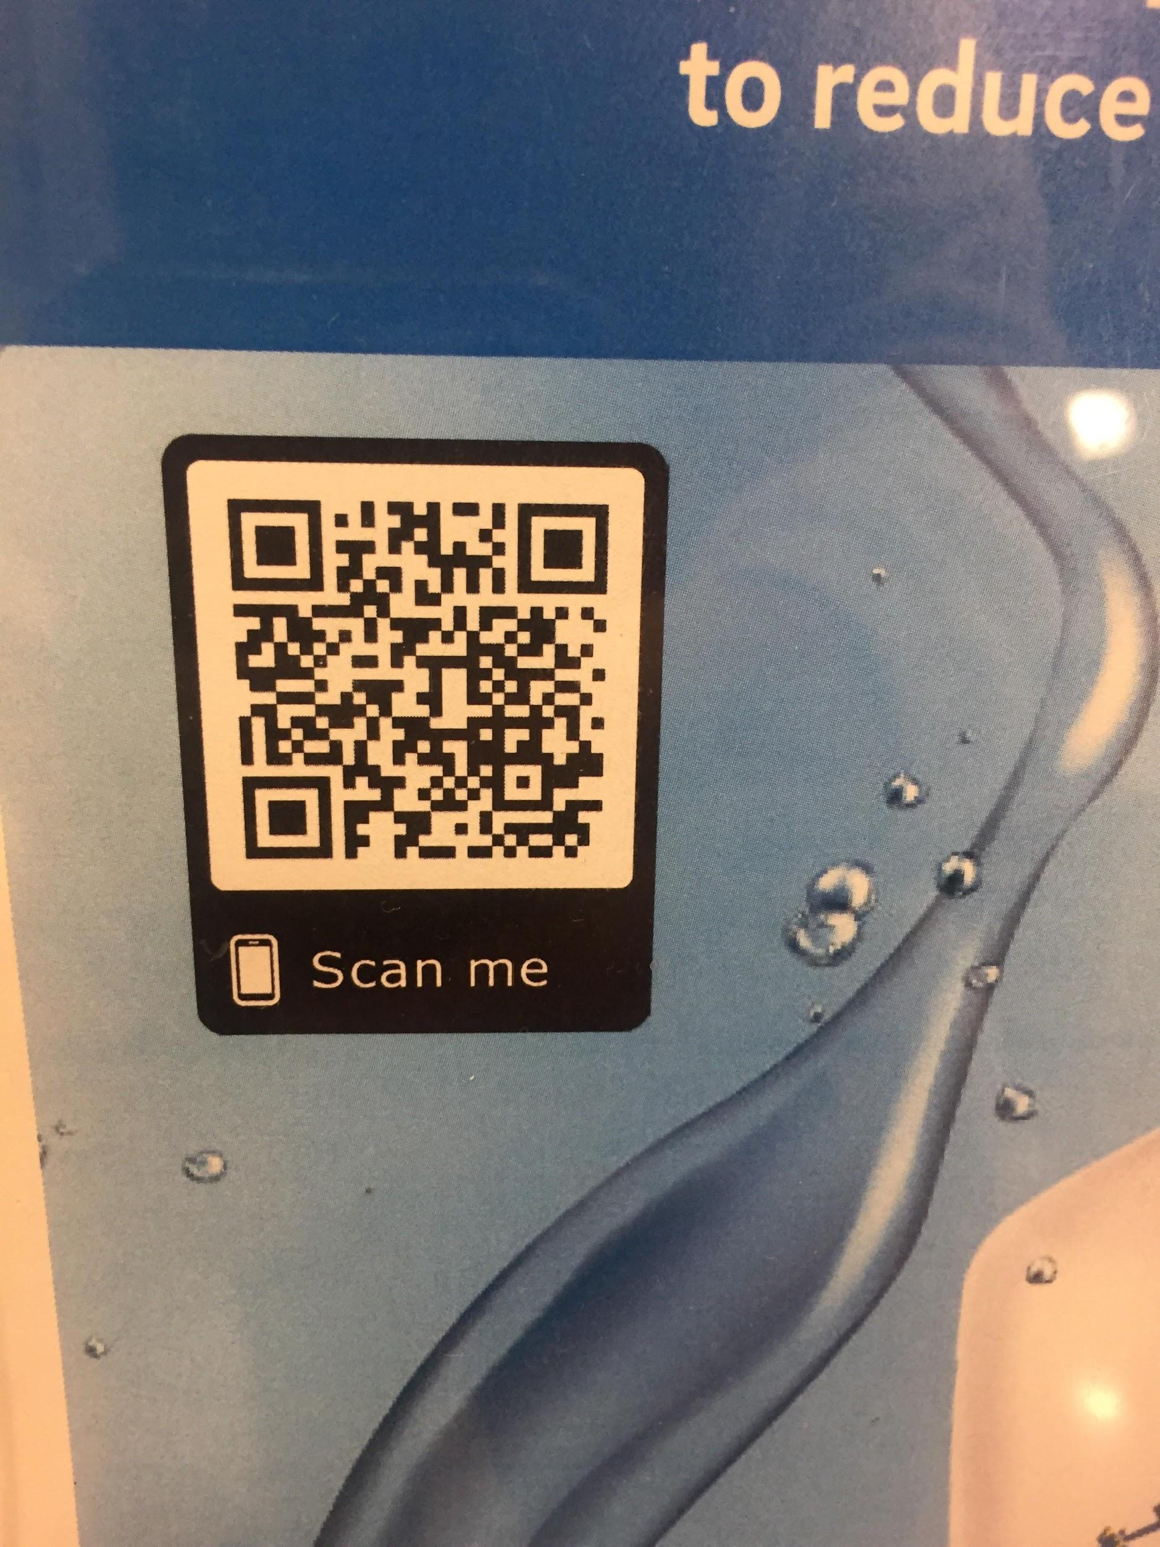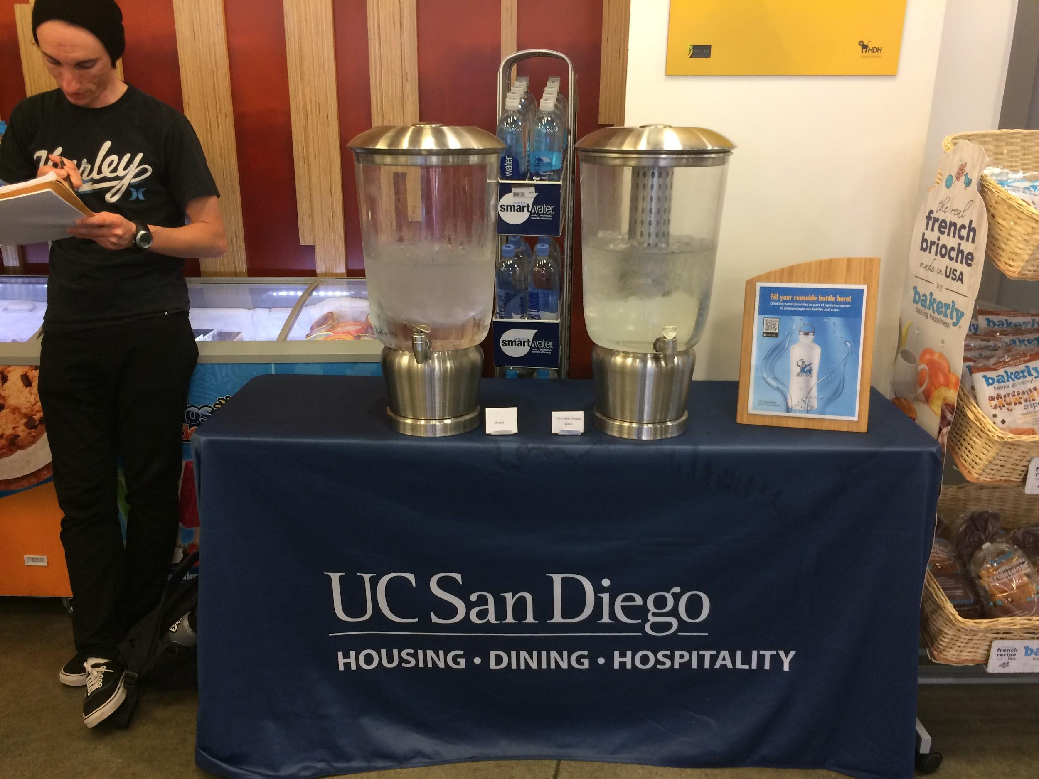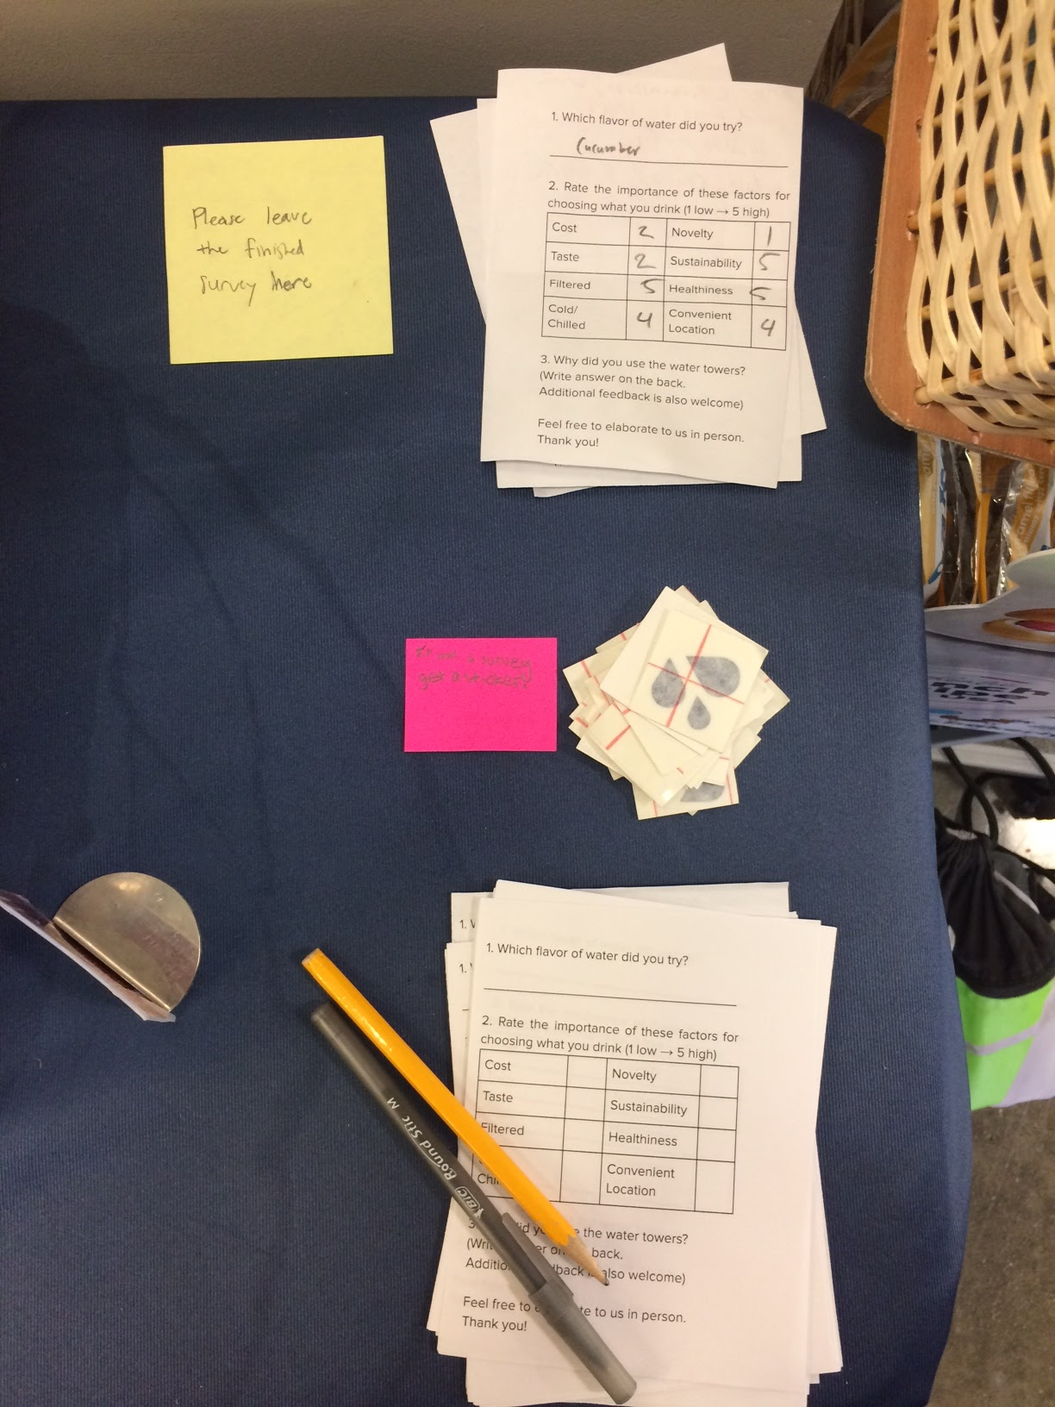

(*Figure 5.1)* (*Figure 5.2)*

## HDH/SSC Partnership

## *(Figures 3.1-3.4)*

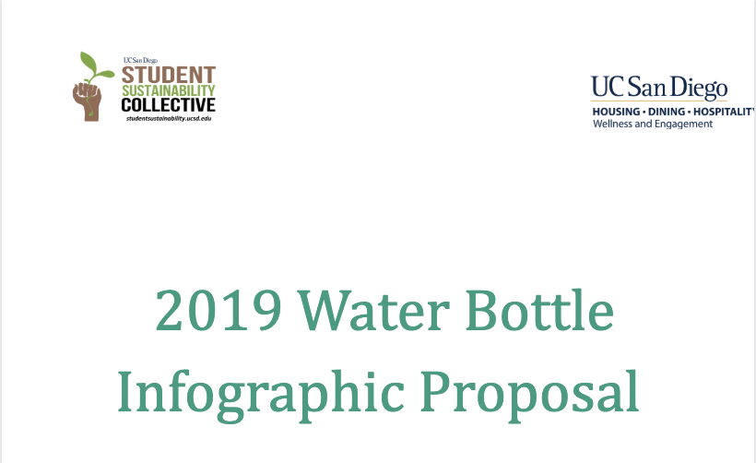

### 

### 

### 

### 

### [Water Bottle Infographic Proposal](https://docs.google.com/document/d/1SxIEFBycEKDp36kfRqW88LSHTv-gXBglOYN4zXaf9oQ/edit?usp=sharing)

### **Pilot-program Logistics**

## 

## Survey Iterations

**Hydration Habit Survey**



*Figure 10*

**Water Tower Pilot Program Survey**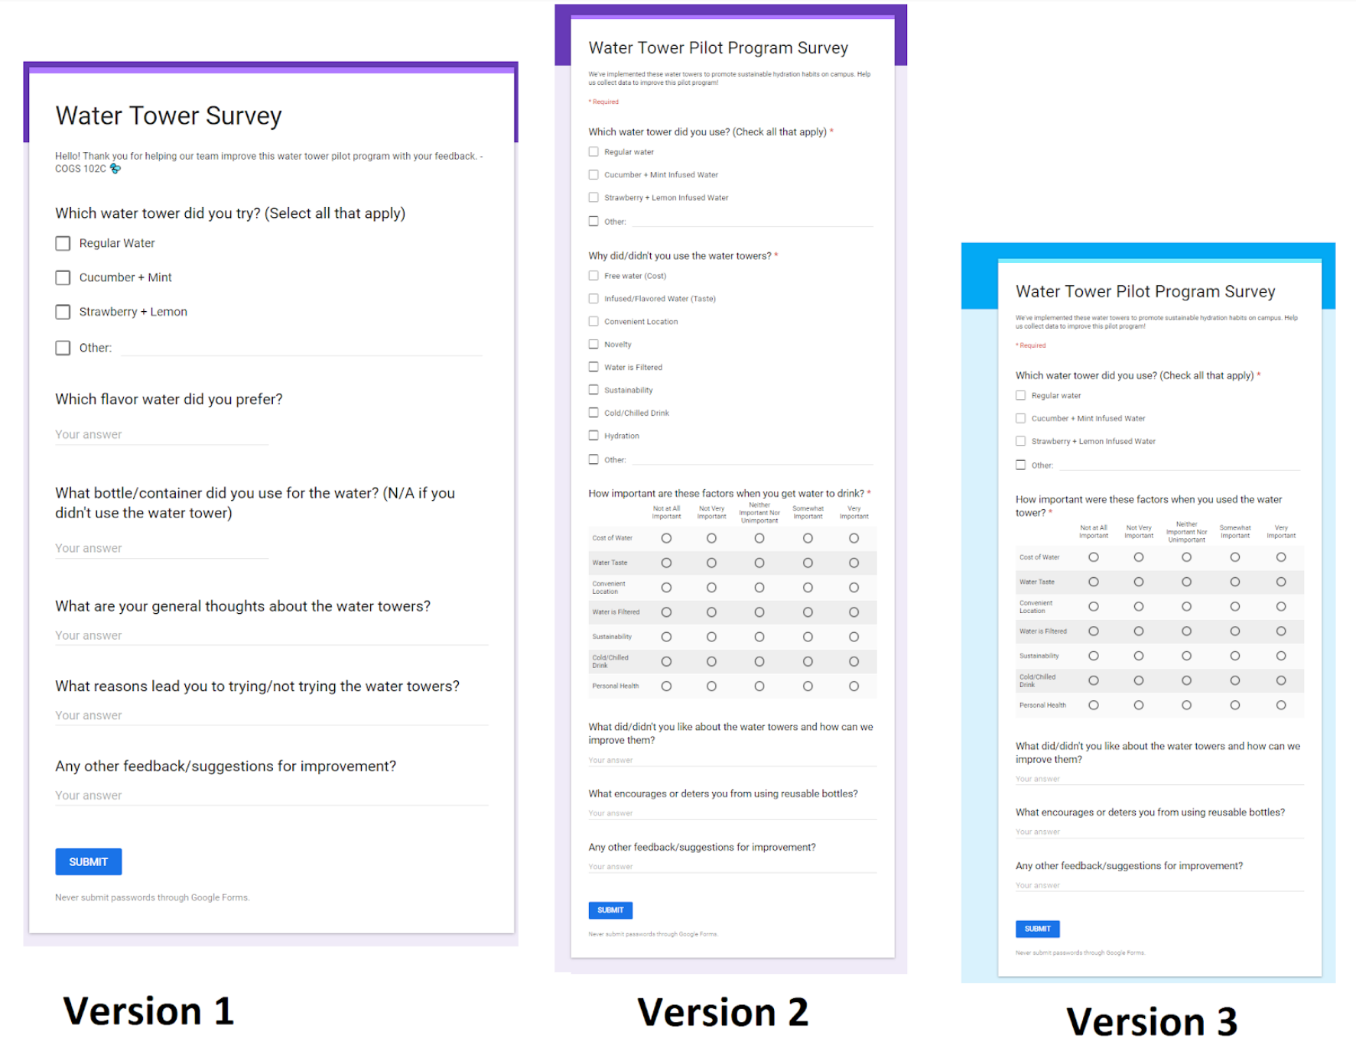

*Figures 11.1-11.3*

**Paper Survey**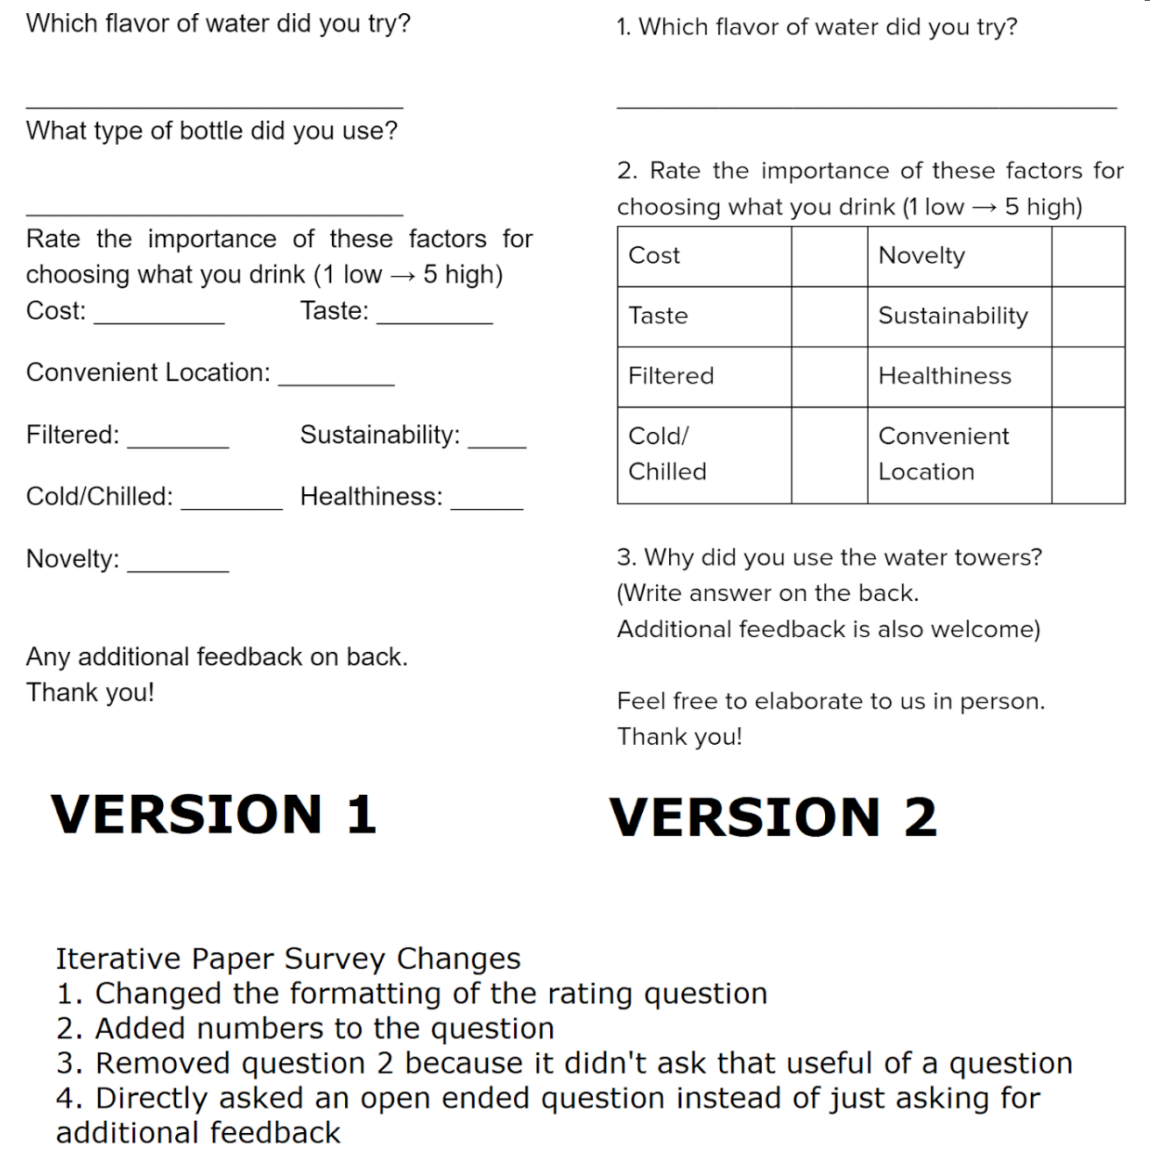

*Figures 12.1-12.2*

## Data

### **Pilot-program Bottle Sales Data**

The table below shows total unit sales of bottled drinks for 5 weeks (3 baseline, 2 testing), as well as the total unit sales from the top 6 selling water bottles. We observed an upward trend in bottle sales for the first 3 weeks, then a dramatic reduction in sales in the last 2 weeks, after our pilot-program was introduced. Causation can’t be determined but the data seems to point toward a correlation between our pilot-program and reduced disposable bottle sales.

### 

# 

### 

### **Survey Response Data** (*Figure 6)*

These responses came from the paper surveys that placed at the water tower pilot program table. The first table calculate the top factors using only forms that correctly filled out the rating in the right format. The second table shows the rating adjusted based on how we interpreted the comment and ranking of incorrectly filled out forms. Regardless, we found that the top 3 factors were: 1. Convenient location 2. Taste 3. Cost.

## 

## 

### **Water Tower Record Sheet**

The table below details how many times Village Market employees had to refill our water towers each day during our 2-week pilot-program. We used this data to gauge the usage rates of our water towers.

## 

## (*Figure 7)*

# Misc. Data/Field Observations

* Miscellaneous photos/data/field observations including:
* Current sustainability initiatives on UCSD campus
* Survey response data
* HDH market sales data
* Hydration Station usage data
* Availability of reusable bottles at HDH markets

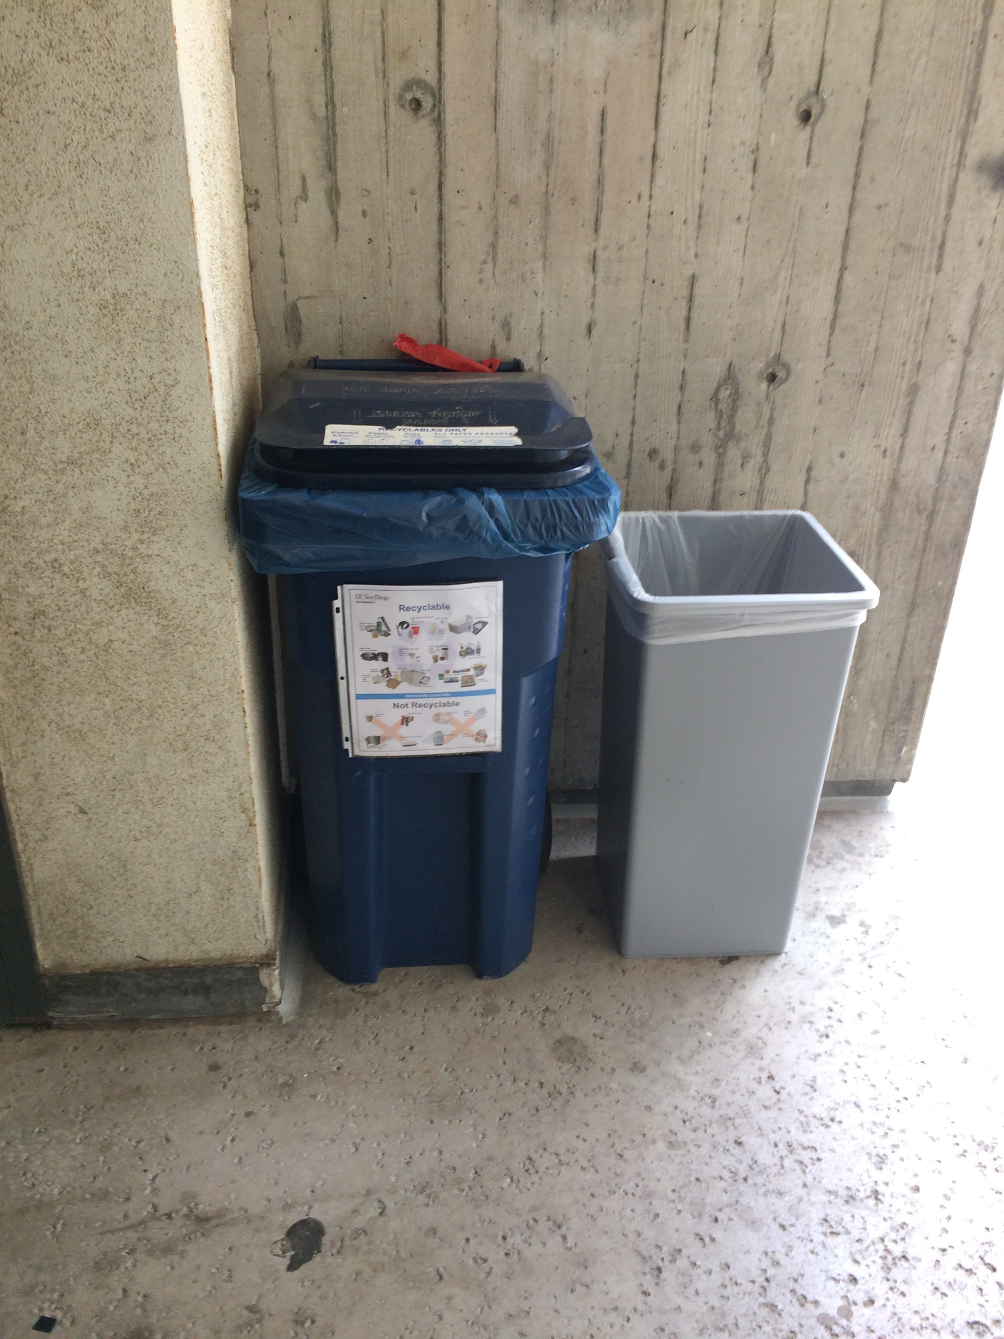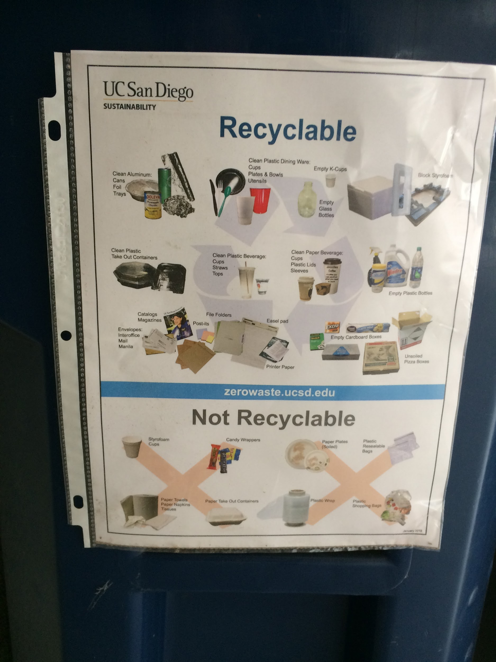

### **Hydration Survey Response Data** (*Figure 1)*

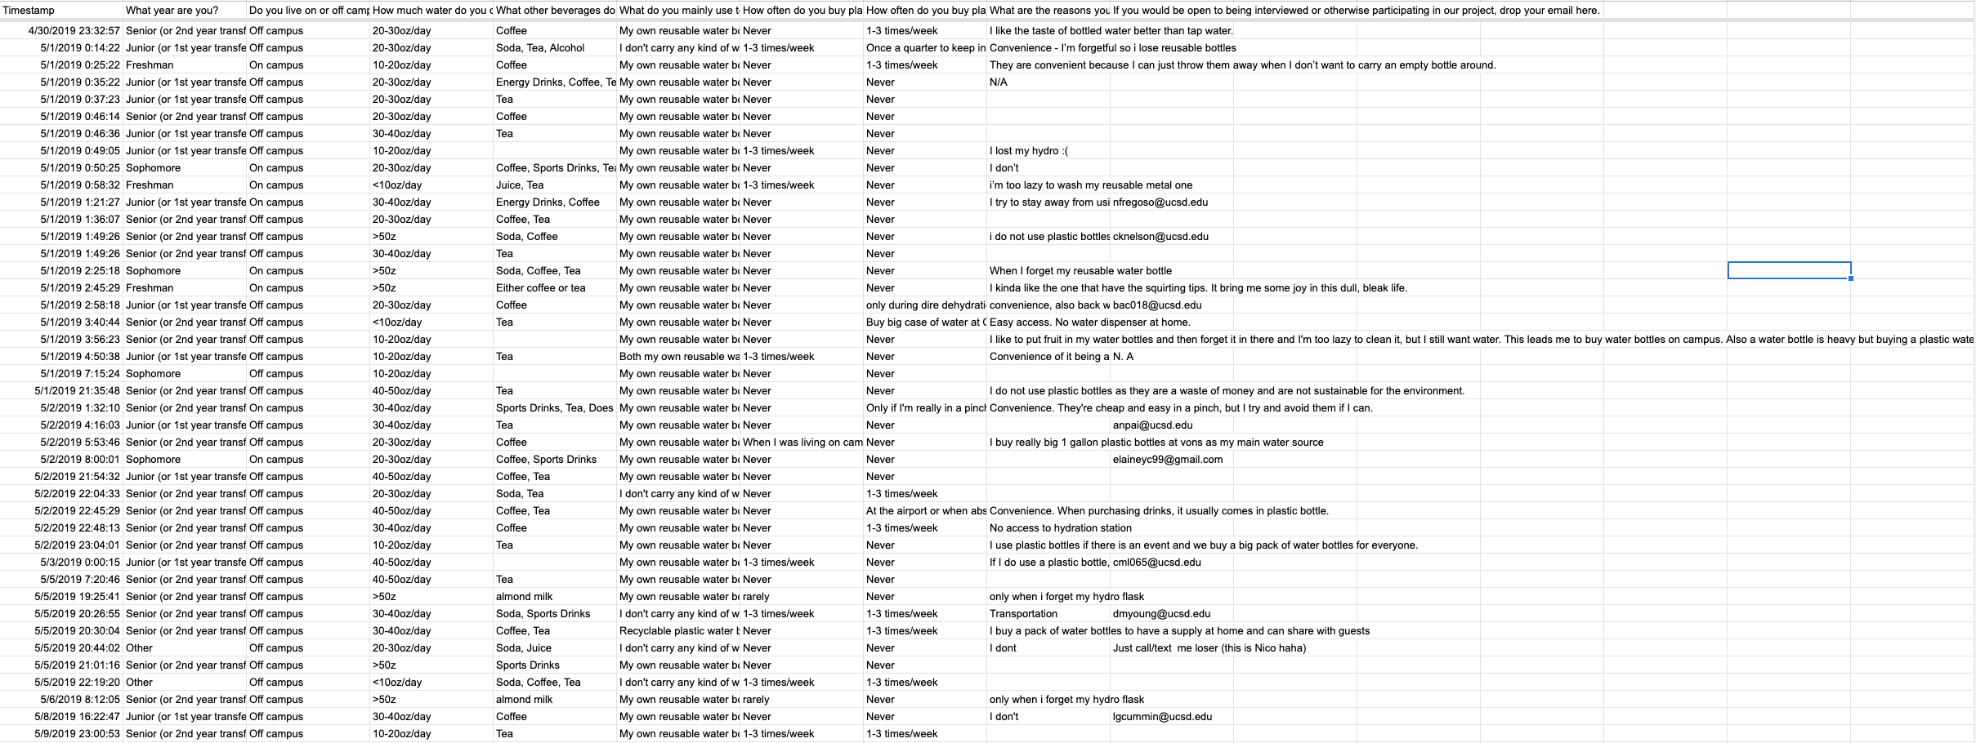

### **Village Market Bottle Sales Data**

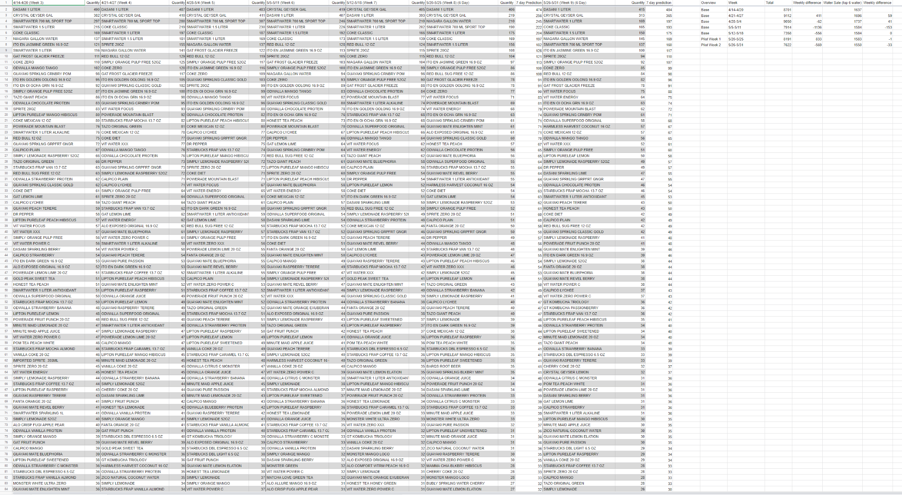

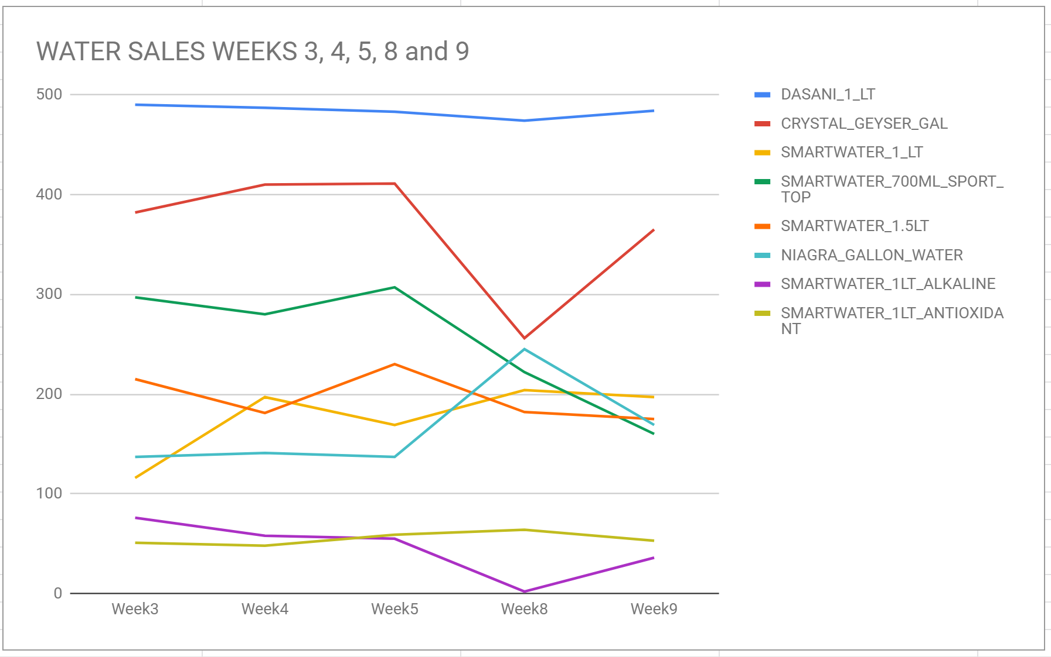

*Figure 8.1*

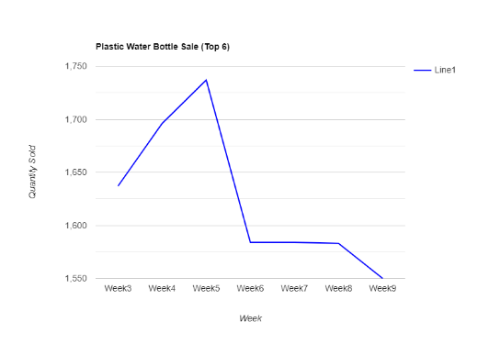

*Figure 8.2*

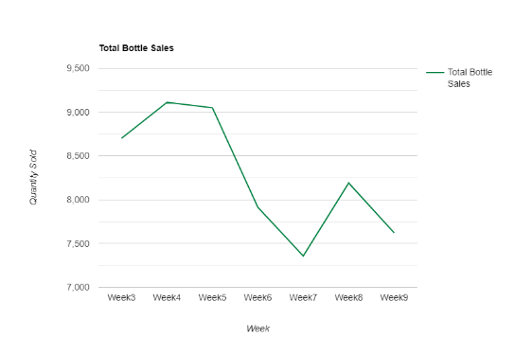

*Figure 8.3*



### **Hydration Station Usage Data**

### **Hydration Station Usage Numbers** (*Figure 2)*

### **Village Market Reusable Bottle Stock**

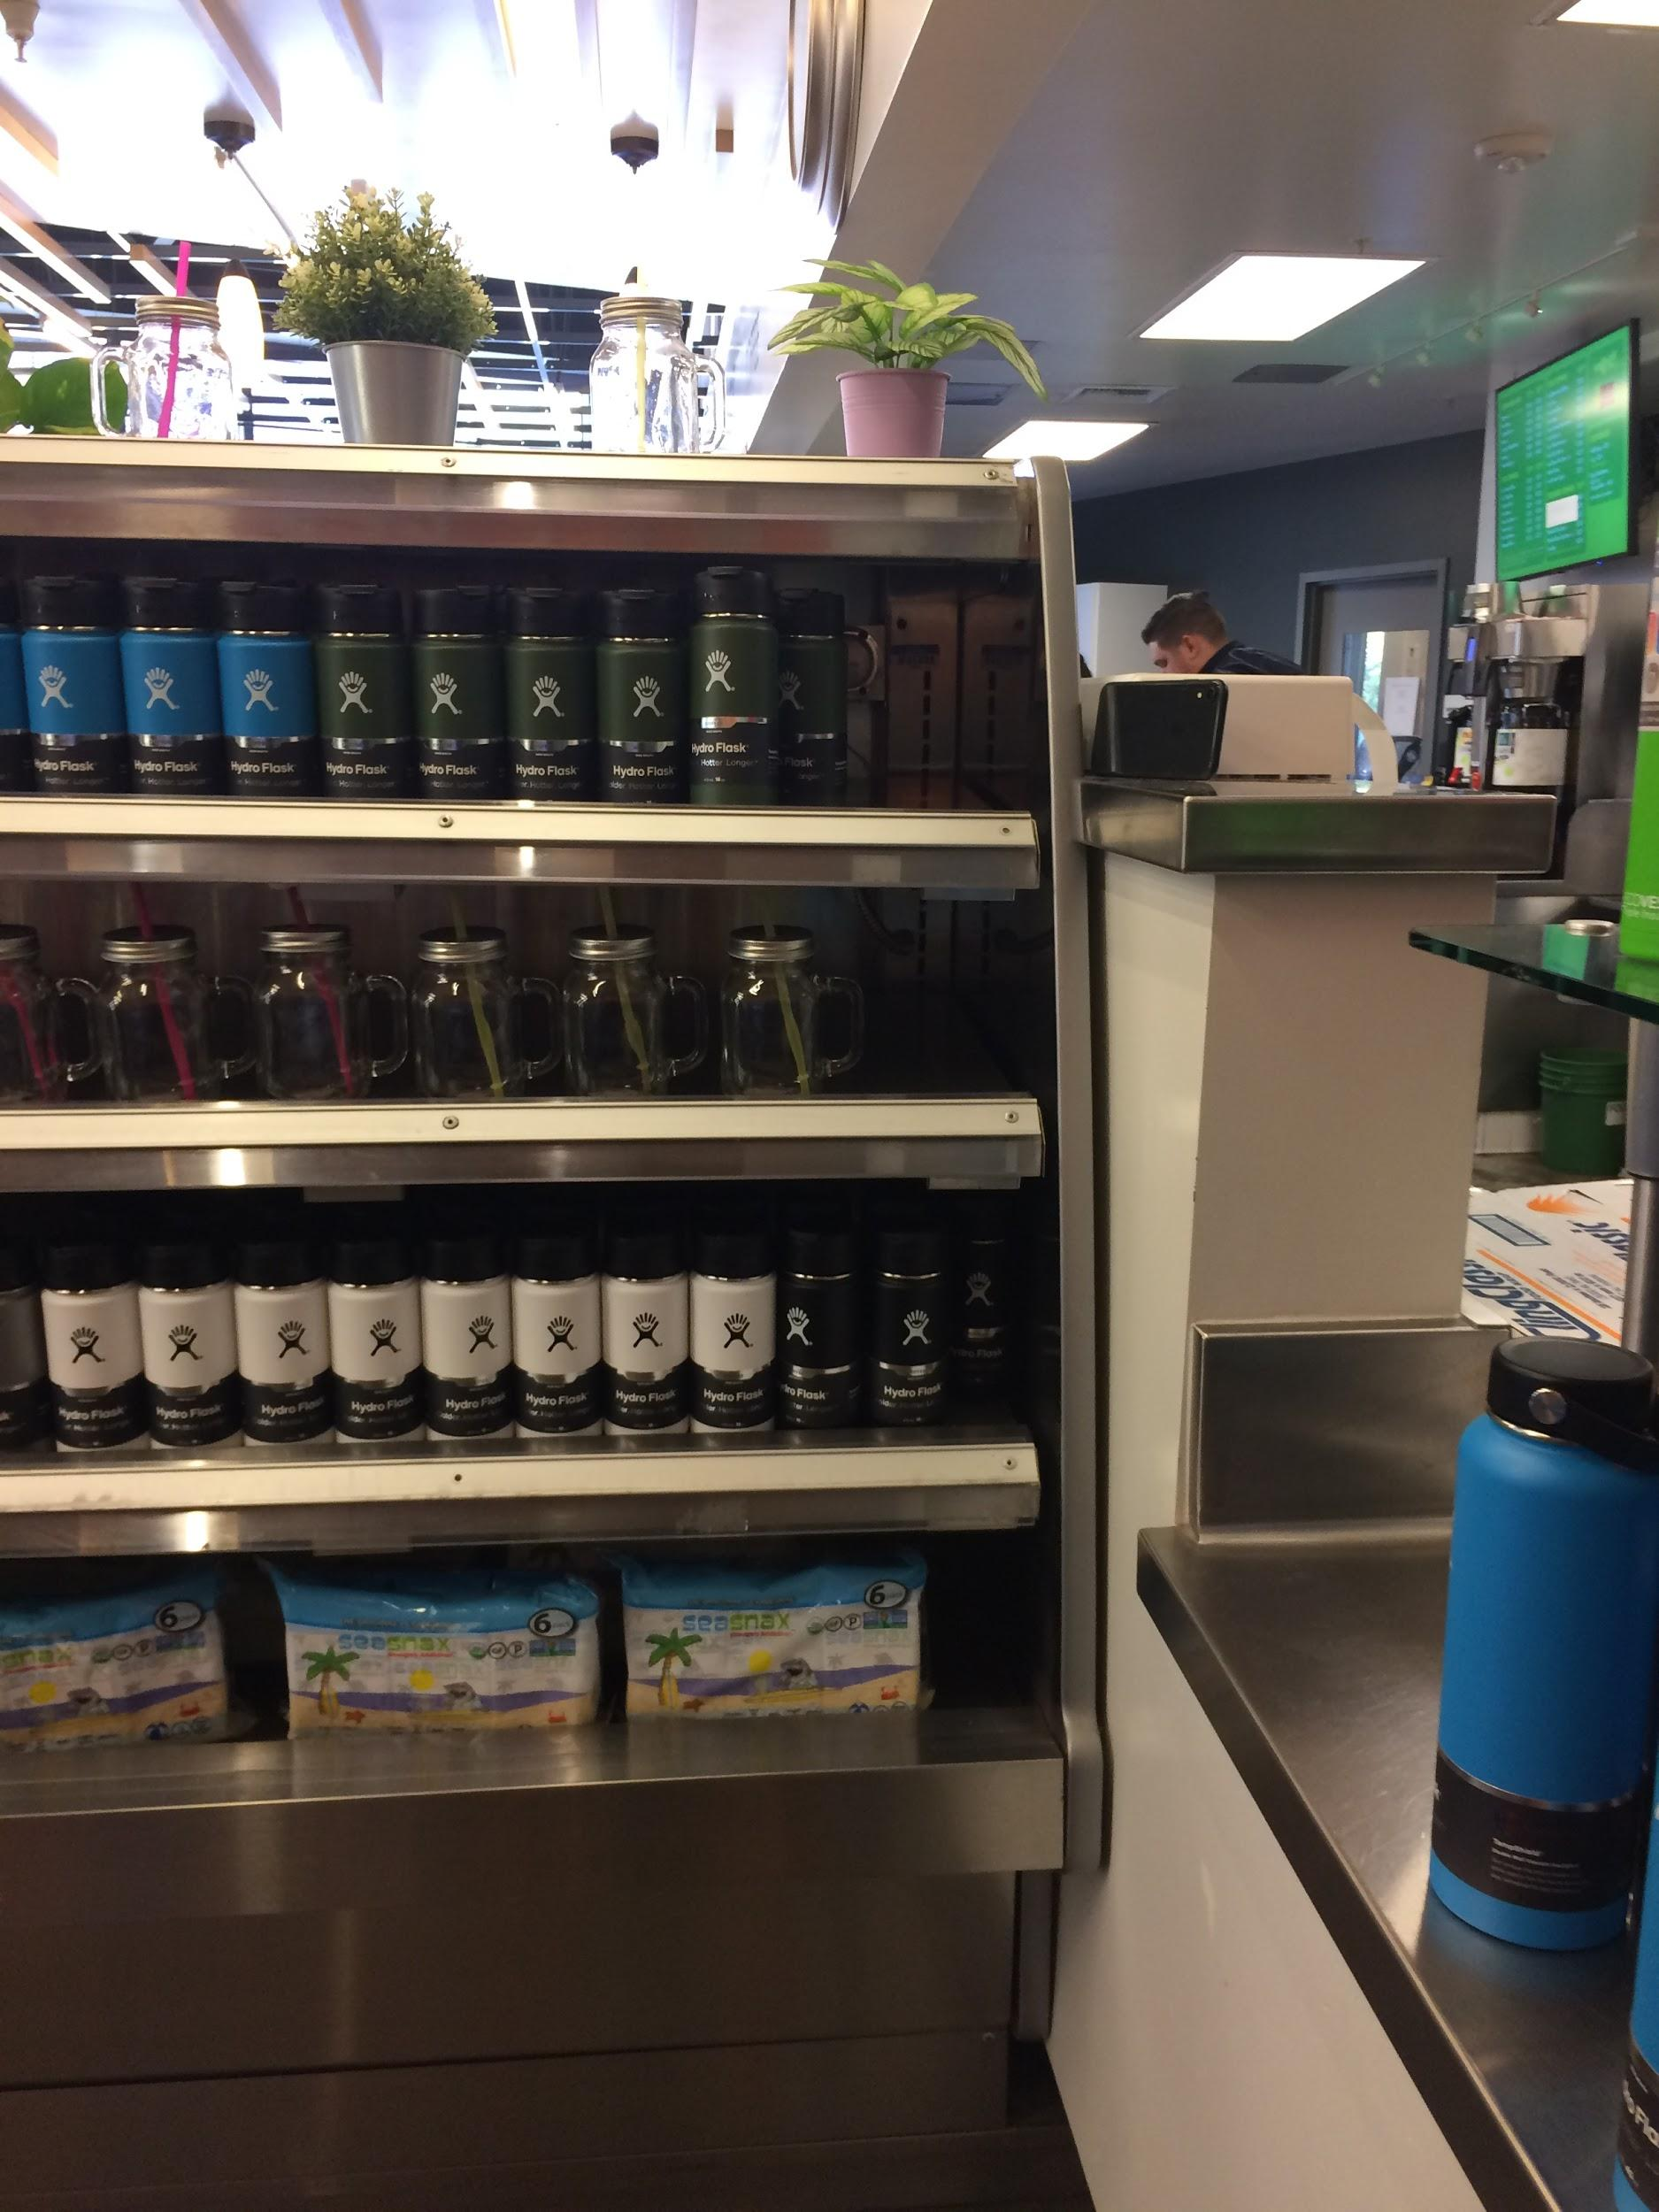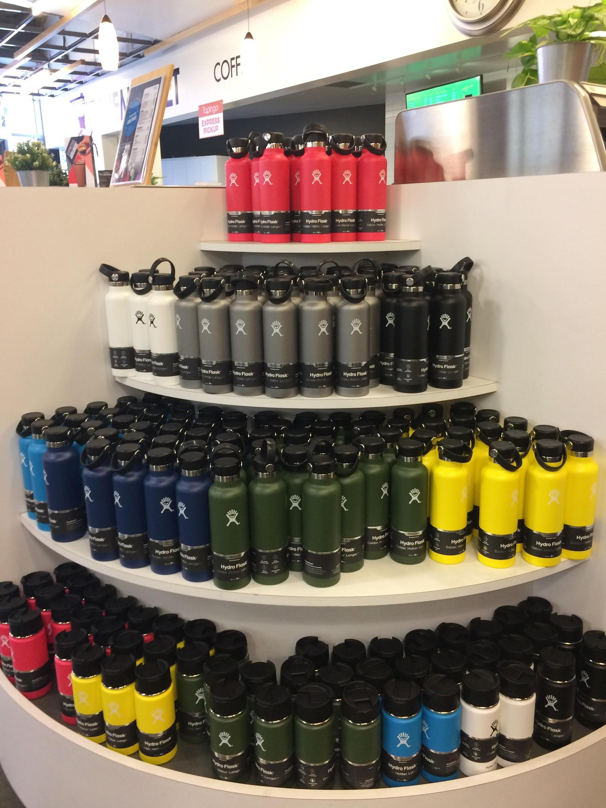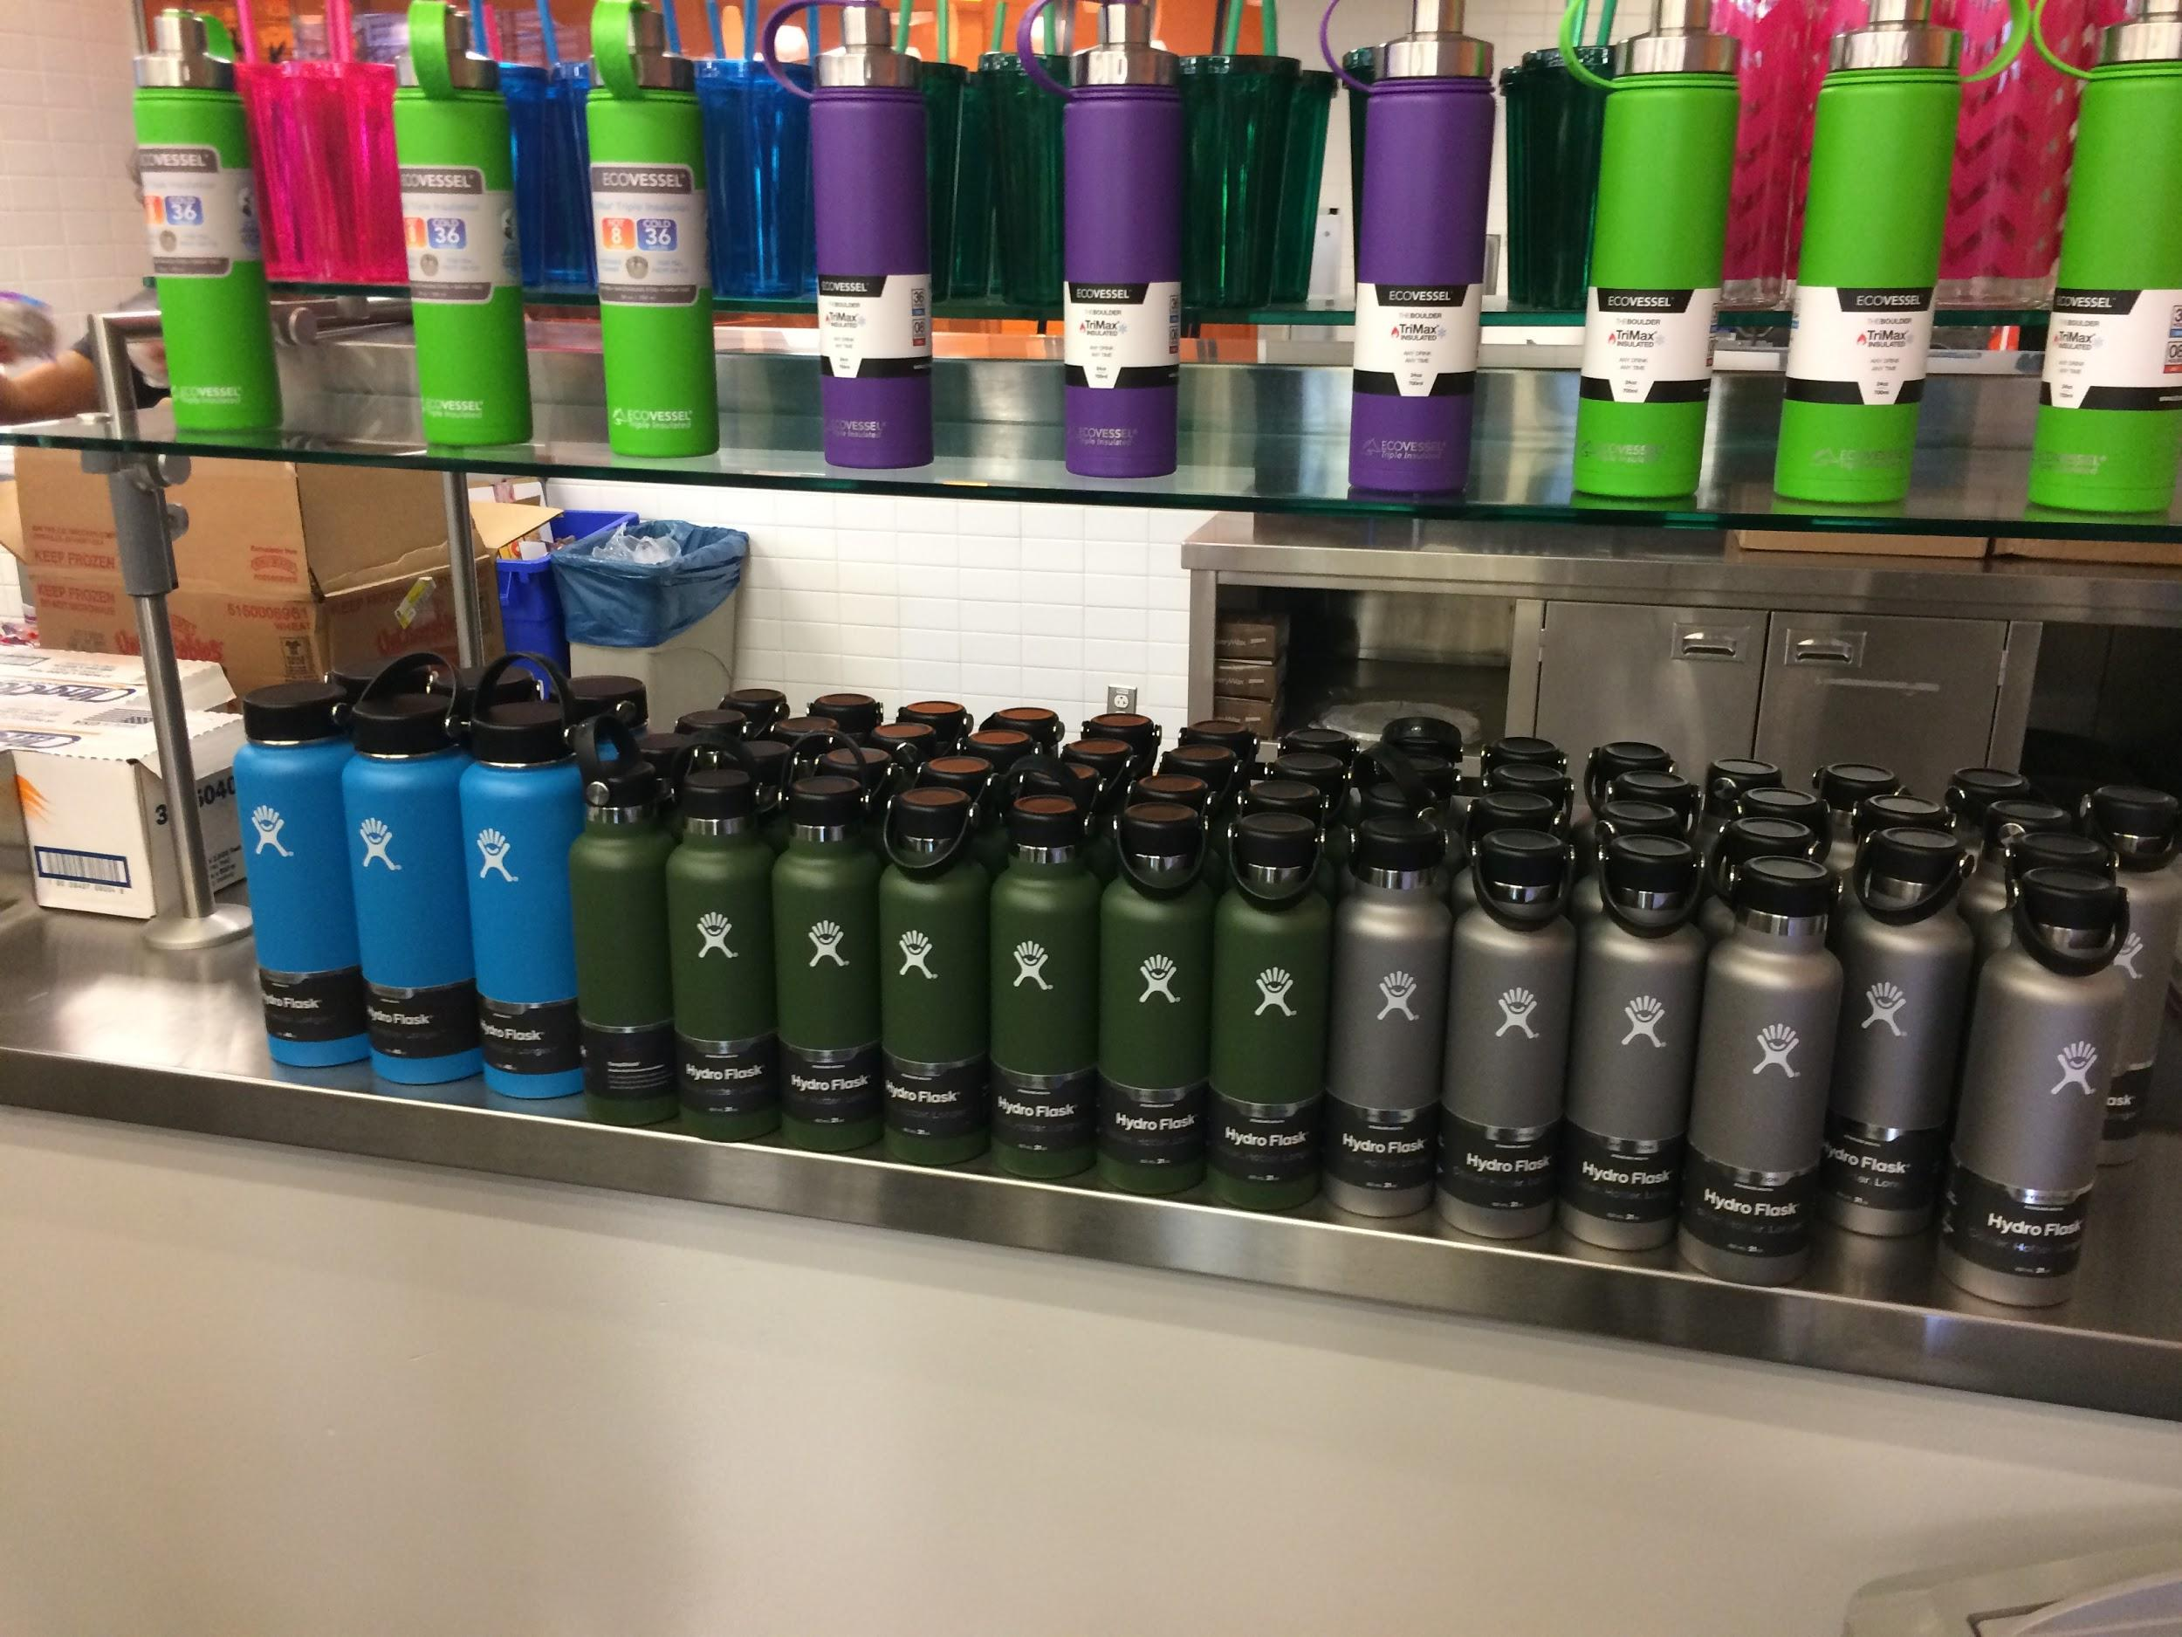

# Notes

## Interview Protocol

Students:

What are we trying to learn: What students prioritize and how they pick their beverages. We also want to know how much students use plastic water bottles.

Questions:

* What are you drinking on a regular basis and why?
* What factors decide what drink you pick, both at a dining hall and throughout the day?
* Is there anything that can be done to encourage you to drink more water?
* Why keeps you from drinking more water?
* Where do you normally get water?
* What drinks catch your eye first and what do you usually pick from dining halls?
* What would you want out of a new drink? **Maybe a question for later?
* What do you prioritize when picking a drink?
  + Taste
  + Cost
  + Hydration
  + Other
* Does that affect your beverage choice?
* Drink log?
  + Did that affect their drinking habits
* What do you use to drink throughout the day? Specifically for water?
* How often do you use buy plastic water bottles on campus? Off campus?

Why these questions: We included these questions because we are trying to get a general understanding of what the drinking and hydration habits are of students on campus. We are considering changing our scope to better fit the stakeholders that we have been able to get in contact with, so we are asking questions both about nutrition habits and sustainability. We want to know what people drink throughout the day, how they drink it, what they use to drink, and what their decision making process is for all of these choices.

HDH Administration:

What we are trying to learn: We want to know whether students are hydrating enough, and whether they think they’re hydrating enough. We also want to work with HDH to see what programs or efforts they make to improve hydration as part of their nutrition education.

Questions:

* What is your role as ___?
* How are the drink options at dining halls and markets chosen?
  + Why are the ones that are offered chosen?
* How does HDH keep stats of drink usage?
* Does HDH keep track of how much individual hydration stations are being used?
* How were the locations of hydration stations decided?
* Does good nutrition affect the soft drink options available at dining halls?
* What role does hydration play in HDH nutrition education?
* Do HDH nutritionists discuss hydration with students as part of the nutrition curriculum?
* What steps does HDH take to promote sustainability in dining halls? Outside of HDH facilities?
* Does HDH have any goals for increasing sustainability or improving student hydration?
* Why does HDH sell hydroflasks instead of other reusable water bottles?
* What problems have been identified, if any?
* Would you be open to working with us on a way to improve/promote student hydration?

Why these questions: We chose these questions because we are curious about the current programs and initiatives that HDH has to promote hydration and sustainability among the student population. We hope to have the HDH administration as a stakeholder in our project since they are one of the biggest overseeing organizations that make hydration and nutrition based decisions on campus, including the location of most hydration stations, the food and drink options available at dining halls and markets, and overarching nutrition curriculum that students are taught.

## Meeting Notes 4/26

Mona Powell the Wellness and Engagement manager for HDH

Oversees

* Works with sustainability department
  + ⤷ part of HDH
* Has wellness coordinators

Sustainability or Hydration

* ⤷ rescoping

Campaign that encourages students to use reusable water bottles

Issue of Infographic

Issue: A lot of people are just buying plastic water bottles from market

5 of the top 6 are water bottles

Don't assume the reason for why people buy water bottles

Specific Questions

* Why do you use plastic water bottles?
  + ⤷ what factors contribute to your decision in buying a plastic bottle

Survey Question Discussion

* On campus vs off campus student bias
* Scope is more campus based

IA Debrief

* Big thing is that this project is for you.
  + ⤷ own ur own is fine
  + ⤷ working for them (stakeholder) is fine
* Interesting dynamic (who owns hydration station)
* Ppl drink water differently
* Presenter drinking water
* Find a group
  + ⤷ La Jolla half marathon
    - ⤷ different hydration context
      * ⤷ gives insights to how diff ppl use water different
      * ⤷ extreme users
* How to balance looking within/outside the scope?
* Scope: hydration for nutrition for students on campus
  + Little data points
* Choice Paralysis?
  + Right problem to have right now
  + Next week we will do Wall Walk
    - Find emergent things from the overlap of affinity diagram (grouping)
* Only have 1-2 iterations
  + ⤷ front heavy

## Meeting Notes 4/30

Individual interview debrief

Goodys observations:

-Too small to ask questions

-Observed hydration station from afar

-Saw person refilling plastic bottles

-People mostly bought energy drinks and teas

Which reusable bottles are sold

* mostly hydroflasks
* A couple off brand hydroflasks

Individual interview debrief

Kevin: Goody’s observations

* Too small to ask questions
* Observed hydration station from afar
* Saw person refilling plastic bottles
* People mostly bought energy drinks and teas

Water quality/taste difference

* Fiji water
* Tap water doesn’t taste good
* Taste as an indicator of spoilage

Jerry: Interview

* Living in Warren so no more market/dining hall
* Skates to Sixth market
* Carries and fills hydroflask
* Got his hydroflask to put stickers on it (aesthetic reasons)
* Usually got glass bottle lemonade 1-2x/week
  + Now less because doesn’t go to market as frequently
* Has no option but to drink water
  + Not bothered by lack of drink options, bothered by lack of dining hall
* Refills at hydration station in dorm building

Jerry: Event observation

* Mafia Con
  + Event where people play mafia
  + Instructions → don't bring own backpack or water, reusable ones would be given
  + Jerry + many other brought own water bottle
  + Snack station didn’t sell water, only option for people without their own bottles is to use the given reusable ones and refill stations (sold soft drinks + other beverages)
  + Tanks seemed to get used up (not sure if it was refilled)

Grant: Interview

* With athlete (extreme user)
  + Supplemented hydration with sports drinks and protein drinks
  + Not in place of water, in addition to
  + Carried 64oz Nalgene, at least one + post workout
  + Rarely refill on campus, fill at home in the morning and thats usually it
  + Use hydration stations at gym or classroom buildings
  + Prioritized cost, doesn’t want to buy new 1L bottle every day, becomes expensive
  + Big one to help measure amount drinking, and to not have to refill as much
  + Different priorities

Meliza Interview

* Freshman buy anything and everything because they can
  + Not “real” money
* 64 degrees
* As soon as doors open → ppl come in to refill
* Ppl don't know about hydrostation at Roger’s market → kind of hidden
* Try new drinks just to taste

Abby Interview

* Only carries water bottle when it is new → then stops using it
* Mostly drinks water to drink more coffee → uses water to balance out coffee
* Uses geisel hydrostation and audry water tank
* If she could see water location → would drink more water
* Out of sight out of mind
* Lots of replaceable water bottles
  + ⤷ uses free water bottles → doesnt go out of her way to buy one

Running out the door → grab a plastic water bottle

Grab and go reusable water bottle that people can take from dining hall

* ⤷ issue is ppl returning the bottles

Don't have any reusable utensils

* ⤷ metal utensils cost 50cents

Reusuable metal utensils

* ⤷ idea is to reuse

People love to be sustainable when it doesnt take any effort

* ⤷ people don't want to go out of their way

Design solutions where people can’t not be sustainable

Scope

* Making hydration sustainability on campus more convenient
  + ⤷ education
  + ⤷ infographic
* Even more general scope: **Improving hydration sustainability on campus**
* Possible factors that matter
  + Taste
  + Convenience
  + Not having to refill

To do

* Field observations
  + Everyone observe one place on campus where students converge
    - Sunshine Market
    - Geisel
    - Dining halls
    - Lecture halls/classrooms
    - Price Center
* Get market drink numbers
* Get survey results

## Meeting Notes 5/7

* Reviewed what happened at the meeting with SSC
  + Need to make survey questions
    - Goal: Determine whether water towers are popular with students and whether they are effective for deterring disposable water bottle purchases
      * Multiple choice:
      * Open-ended:
        + We’ve implemented these water towers to promote sustainable hydration instead of purchasing disposable water bottles -- What did you like about this and would you use it again? Is there anything you didn’t like or we can improve on?
        + What would make you purchase less plastic water bottles?
        + What could encourage you to use more sustainable alternatives to buying plastic water bottles?
  + Need empirical data
    - Control
    - Measuring hydration stations
  + What if people don’t have their own bottles/ask for cups?
* Reviewing affinity diagram
  + Can we assume that most people don’t drink tap water or no?
* Ideas presented
  + Give out stickers to encourage people to use hydroflasks
  + Have cheaper reusable bottle options at markets
  + Tobacco-like stickers on products warning people about effects or pictures of effects
  + Make wells on campus
  + Students build a well
  + Force chem students to convert sea water into drinking water
  + Free reusable bottles
  + Free bottle sanitizer
    - Starbucks/bar style power washer/bar glass rinser for glasses
  + Mason jars
  + Show people math of how many plastic bottles = 1 hydroflask
  + Water bottle holder to make it convenient for carrying
    - Fanny pack style?
    - Carabiner
* Meetings
  + Wed 3-4: Review meeting with John, getting testing materials ready
  + Wed 4-5: Continue previous meeting if not done, otherwise keep collaborating on insights/models
  + Decide from there if meeting Friday morning

## Meeting Notes 5/8

3 Water Tower

* **For the duration of both of the 2 weeks → 2 infused + 1 regular water tower**
* Water Tower
  + ⤷ 1 fruit
    - Strawberry
    - Blueberry
    - Watermelon
    - Pineapple
    - Raspberry
    - Orange
    - Lemon
    - Lime
    - Kiwi
    - Grapefruit
    - **Final Flavor: Strawberry + lemon**
  + ⤷ 1 “savory”
    - Cucumber
    - Mint
    - Rosemary
    - Asparagus
    - **Final Flavor: Cucumber + Mint**
  + ⤷ 1 Regular Iced Water

Measurement

* **Tally/Track individual towers (A/B/C)**

Survey

* Which flavor did you like/choose? Why?
* Flavor Suggestions

Prototype Infographic

* Mainly for logistical things
  + Free infused water
  + Reusable bottles
* Are we promoting the alternative aspect of it?
* Advertising elements
  + List of benefits
    - Free
    - Reusing
    - Calories
    - Hydration
* Are we allowed to design/promote our water towers → part of the signage

Future Suggestion

* Experimental flavors of the week/month

## Meeting Notes 5/28

To Do List Week 9:

-Poster and video for final showcase -

-Trifold Presentation - **Meliza**

-Video - **Abby**

-Design brief - **Grant**

-Design portfolio

-Make paper surveys - **Grant**

-Conduct sticker tests - **Miguel, Jerry, Kevin, Abby**

**⤷** Friday: Abby + Miguel 11-12

**⤷** Wednesday: Kevin 2-3

-Validation interview (Mona/SSC/Jon) - **Everyone**

**⤷ Miguel** email (By wednesday night)

**Next Meeting:**

**Sunday → Room 630 booked: 6-9pm**

**Tuesday → Room 631 booked: 5:30-8:30pm**

Looking forward:

-Setting up survey for after the towers

## Meeting Notes 6/6 (Validation Interview with HDH and SSC)

Saw a reduction in water bottle sales. Could be due to dining dollars.

1346 HSS 1-2pm

Before pilot program there was an increase in sales.

A paper survey was put out. One of the most important is to get open ended data.

* Causation can’t be determined but the data is valuable.

Verbal feedback was overwhelmingly positive, and that people want to use it. The stats are showing sustainability component.

Visuals on graphs would help.

Brian: Do we know how much the sales fluctuated from last year?

Overall sales would be possible, but unit sales might not be possible that far back.

Could there be a calculation on percentage?

9.5 percent decrease from 4/21-4/27 to 4/28-5/4

10 percent decrease from 4/28-5/4 to 5/21-5/25

The 5 percent was additional, from the previous years.

Also, what are the measures of success of the sales after the towers.

Only 4 people filled out the QR code so paper fill out

Put the stickers on the proposal to see if it would be enough of an incentive.

More than half liked infused water.

Cost analysis of how much hdh spent. (overhead? Materials? Vendor sales? Department?)

* How much times we needed to service the towers.
  + Filled out tower beginning of day and refill as needed.
  + Only refilled once a day. In beginning of day people didn’t drink but after people got used to it was used more.
* People have a hard time seeing what the fruits are and people could be allergic to the fruit. Need labels

For cleaning, it could be added to the nightly tasks.

People would try to chug water before filling it up.

Approachability? Tablecloth is way too much and makes it looked staged.

One of the feedbacks is to expand to other markets

The water bottle unit data is JUST THE VILLAGE. :O

**Moving Forward?**

Healthy Campus Challenge. Same thing is being done at UCLA and Davis.

Get the names of everyone on the project and write a report. Part of the COGS final is a report of the pilot.

Who’s going to be in charge?

# 